Snowflake:

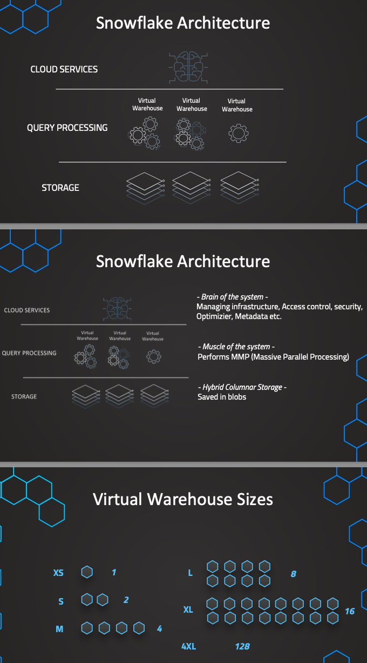

SF consists of 3 layers, we have here this Storage layer. This is the layer where we store the actual data, that data is not actually stored in Snowflake itself, but we use an external cloud provider depending on what we are selecting when we set up our account. So we have selected as external cloud provider AWS. So therefore for the storage we use AWS S3 buckets. This is all done under the hood. We don't have anything to do with it, so we don't need to maintain this. But this is just done under the hood for us where the actual data is saved. And here the data is also stored in a so-called Hybrid Columnar Storage. So this means that instead of saving the data in rows, it is actually stored in columns and it is also compressed into, so-called blobs. So this is how the data is stored in the cloud providers. So we are using this for an analytical database. So we want to have a high performance in getting the data out of the database. And this is what this is optimized for. So therefore we have this storage layer and you see we have a separate layer, which is then the so-called Query Processing layer, or for short, sometimes also just the processing layer. And this is also sometimes called the muscle of the system because this provides the actual compute power to execute the queries. So this is the layer where the queries are processed, and this is where the very important, so-called warehouses come into play. So they are not to be confused with actual warehouses or data warehouses in the context of ETL processes, but they are just basically virtual compute resources that are used to process the queries and all of the operations that we are executing. So therefore we call this layer the muscle of the system. And these warehouses, they can also perform Massive Parallel Processing, which makes them more efficient in this case for handling large amounts of data or very compute intensive or complex queries. And we can like this also combine multiple queries and process them all in the same time. So this is the layer where we get the compute capacity for the execution of the queries. And then on top of this, this needs to be all orchestrated. And this is done in the so-called Cloud Services layer, or sometimes this is also called therefore the brain of the system. So this is what we use, or this is the layer where we manage the infrastructure, all of the access control. So basically all of the things come together here. Also, security metadata, query optimization, this is also all done in this cloud service layer. Alright, so this is the three layers of Snowflake. And now we also want to talk a little bit more in detail about the warehouses. Because those warehouses, as we have said, they provide the compute capacity and basically they are just virtual compute instances or servers that are used to process the queries because we need to have compute power. And they do come in different sizes. As we can see in here, the size is extra small, which just consists of one single server. And if our queries are not very complex, then we can use the smaller size. And if the queries get more complex, it would be more beneficial to have faster or to have faster queries of course. And to get those faster queries in those more complex queries, we would have to have higher amounts of servers. So we basically have larger warehouses. So for example, we have a warehouse of the size as this consists of two servers or two virtual compute instances, and therefore it is more powerful. So when we don't want to wait very long and we have more complex queries, it makes sense to then use a larger size of our warehouse. So you can see here, each size always increases the number of servers and it always doubles them up to 4XL, which consists of 128 servers. So here, of course, large warehouses are then also more expensive. For example, an extra small warehouse consumes one credit per hour when it is active, this is exactly how we are built. So we are built based on the time a warehouse is active and of course one server in this case. So XS is consuming one credit per hour and this is built by seconds. So here, if we just run it for half an hour, it would be, for example, half a credit. And of course here then when it's getting larger, so for example L, this is then consuming eight credits per hour. And in this case we would then pay for the credits. So we convert basically the Euros or dollars into credits, and then we consume the credits and pay by dollar. So this is all done automatically. We have just this consumption basically of our credits. And it also depends on the external cloud provider that we are using and the region that we are using and the addition that we are using, what the actual price for the credits is. But here we see always two credits, for example, for the warehouse as for one hour. So this is how it works. And then we also have the Multi-Clustering. So Snowflake offers this Multi-Clustering. This means that if one warehouse, for example, of the size S can't handle the query load, additional clusters can be activated and they can be clustered together into one warehouse or one cluster of warehouses. And then we just have here basically six servers. And this can be now depending on the workloads or depending on the number of queries, which makes it more dynamic. So if there are too many queries for one warehouse to handle, then they just get queued the queries, the additional ones, and this would cause delays. So therefore we have now those additional warehouses that are then added. So here we have more compute power to process this simultaneously. So like this, we can make this just more efficient. All right, so this was a high level overview over the architecture and I hope that this helps in the understanding and also it will help when we are working with Snowflake practically in the next lecture. So now let's dive a little bit deeper into creating the warehouses using secure commands and also the Snowflake interface. Hope it was helpful and see you in the next lecture.

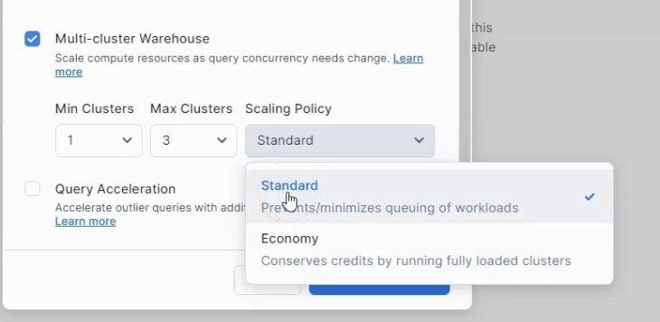

In Standard cluster creation is faster compared to economy

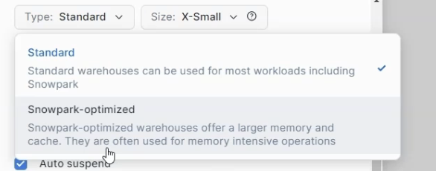

let's quickly, yeah, mention the difference between Standard and Snowpark-optimized. So the Standard is the one that we use actually just in most cases, so this is just the standard warehouse. We, in almost all cases, use this Standard type, but then we also have the Snowpark-optimized warehouse. So here we have a little bit of a different type of warehouse, so it has larger memory and more cache. So if we have very memory intensive operations, it is optimized for this. So this is optimized basically for Snowpark, which can be used for specific types of machine learning workloads, very complex queries, but in most cases we have the better option with Standard. But with this specific machine learning-oriented queries that are maybe very complex and memory intensive, we can benefit again from a better performance

Create Warehouse:

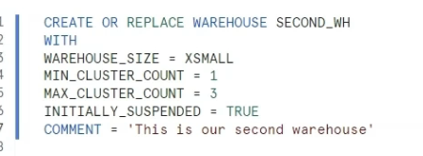

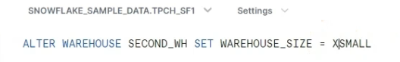

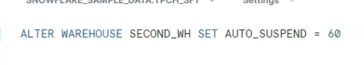

Scaling Policy:

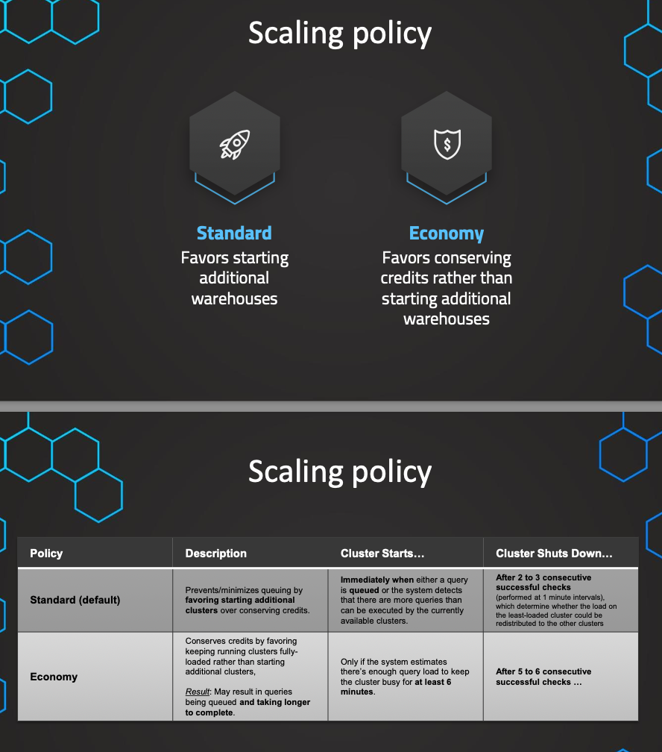

Instructor: So now let's talk about the different scaling policies for scaling our clusters up and down. In the context of a multi-cluster warehouse, of course this is relevant. We've already learned about the multi clusters. So in general, if we have one warehouse, for example, of the size S, at a certain time it can happen that we have more queries than this single warehouse can process. This will cause a problem, because users now will have to wait very long until their queries are processed. So the solution to this is that we can automatically scale depending on the workload dynamically our clusters. This means we can dynamically shut down clusters or start additional clusters in a multi-cluster warehouse. So you can see here additional clusters can be added to our multi-cluster warehouse. So by doing this, we can just redistribute the queries that are basically in queue and that can currently not be processed by the existing single cluster. And like this, we redistribute them, so that we can process them, and the users don't have to wait. So this is what we mean by our multi-cluster warehouse and by the auto scaling. And in this lecture, we now want to discuss how this auto scaling works exactly, and in this context, we need to discuss about the two different scaling policies, we have standard and economy. And before we dive into this in detail, let's also stress the use case of those multi-clusters. So when we have more workload, this means when we have more queries, for example, we have times when we have more users. For example, we have some peak hours in the afternoon, then we have more users, more queries, and this is exactly the use case when we use those multi-cluster warehouses because in this case, this is very efficient for handling more workloads. So more queries, for example, by more users. Good use case is not when we have more complex queries. In this case, if the queries are more complex, and therefore we need more compute capacity, it would be more suitable to increase the size of the existing warehouse instead of spinning up additional cluster. So this out of the way, we want to now understand the different auto scaling policies. So to understand the difference between the two scaling policies, let's see again how the multi-cluster works in detail. So here, if we see we have more queries than an existing single cluster, or single warehouse, for example, of this size is can actually process at the moment. Then there will be a Queue S we can see in here. And in this case, the users have to wait. So here we can now additionally start a new cluster when we have this queue. But the question now is at what moment exactly we will spin up an additional cluster. So this is exactly where the different scaling policies come into play because they have different criteria for when we start this additional cluster. So the standard scaling policy, we have seen that these are the two different options, and the standard scaling policy is the default. So this just favors the performance. Basically it favors starting additional warehouses and like this maintain the performance at a higher level over conserving the credit consumption. So under this policy, a cluster is started basically immediately when a query would be queued, or even if the system detects that there are more queries that can be processed currently by the available clusters. So it will be pretty much starting the additional clusters very quickly, and under this policy, a cluster will be shut down after two to three so-called consecutive successful checks, a check is performed once every minute and the check is done to determine if the load on the least loaded cluster can be successfully redistributed to the other clusters, meaning that the current amount of clusters can be easily reduced, or yeah, can be successfully reduced to one less cluster, and we can still handle the existing workload. So this is how it would be shut down in the standard policy, and in the economy scaling policy, as we know this favors conserving the credits over starting additional warehouses. Here, it would start an additional cluster only if the system detects that there's enough query load to keep the clusters busy for at least six minutes. So in this economy policy, a cluster will then be also shut down after five to six consecutive successful checks. So again, to summarize this, the standard policy just favors performance starts the cluster immediately when it's needed, or even when we detect that there are more queries that can be processed by the currently available clusters, and the economy policy is just favoring conserving credits. So it would start a cluster only if the workload is sufficient for six minutes or more. And we have now seen how those different policies standard and economy works. And in the next lecture, we want to talk about now the basic and most important thing that we should know about in Snowflake, and this is the creation and the management of databases, and now let's move on from the theory and look at some very important and basic thing that is we have to know how to create and manage databases and tables in Snowflake. So that's what we want to have a look at in the next lecture.

//Rename data base & creating the table + meta data  
  
ALTER DATABASE FIRST_DB RENAME TO OUR_FIRST_DB;   
  
CREATE TABLE "OUR_FIRST_DB"."PUBLIC"."LOAN_PAYMENT" (  
 "Loan_ID" STRING,  
 "loan_status" STRING,  
 "Principal" STRING,  
 "terms" STRING,  
 "effective_date" STRING,  
 "due_date" STRING,  
 "paid_off_time" STRING,  
 "past_due_days" STRING,  
 "age" STRING,  
 "education" STRING,  
 "Gender" STRING);  
   
   
 //Check that table is empy  
 USE DATABASE OUR_FIRST_DB;  
  
 SELECT * FROM LOAN_PAYMENT;  
  
   
 //Loading the data from S3 bucket  
   
 COPY INTO LOAN_PAYMENT  
 FROM s3://bucketsnowflakes3/Loan_payments_data.csv  
 file_format = (type = csv   
 field_delimiter = ','   
 skip_header=**1**);  
   
  
//Validate  
 SELECT * FROM LOAN_PAYMENT;

Editions in SF:

Instructor: In this lecture, we want to talk about the different editions in Snowflake. We need to understand what are the different features in those editions. And also it's important to understand the pricing is, of course, different in each of those editions. But about the pricing we'll talk about in the next lecture. So the first edition is the, so-called Standard Edition. This is the edition that is made to get started all of the foundational features are available there. Then if we are a large scale enterprise, we have specific needs and those can be fulfilled with the so-called Enterprise Edition. So all of the features from Standard are also, of course, included in Enterprise plus those additional features. For example, we have so-called Multi-cluster warehouses that really allow us to scale out efficiently and fulfill those needs of large-scale enterprises. And then, if we are a company that deals with extremely sensitive data, we have again, additional features on top of the Enterprise edition in the Business Critical Edition. So here, we can comply with some specific regulations. For example, some financial institutions and if this is not enough and we are dealing with highly sensitive data, for example, some governance or some financial institutions, then we have the so-called, Virtual Private Edition. To set this up, we need to directly reach out to Snowflake. So this cannot be set up just by using the website. So in here in the Virtual Private Edition, we have the highest level of security because in here we have dedicated servers. So this is not shared with other companies, but we have our own dedicated environment, dedicated servers. And now of course, let's have a closer look at the different features because this is very important also for the exam. In the Standard Edition, we have as mentioned, all of the important foundational features. So we have also, all data is encrypted. We have a broad support for all of the Standard and special data types like geospatial data, unstructured data, semi-structured data. All of this is available in all of the editions. We also have the Snowflake specific feature of time travel. This allows us to travel back and query historical data that is not available anymore in the database and this can be done up to one day in the past. And we'll talk about this time travel feature later on as well. On top of this, we have also the disaster recovery that is called Fail-safe. This is a disaster recovery, so we need to reach out to the Snowflake support and we can recover data in some disasters for up to seven days beyond time travel. And we have also the features of network policy, secure data share, federated authentication, and Single Sign On, as well as premier support in all of the editions, so this is available in all editions. But now as mentioned in the Enterprise edition, we have also those, so-called Multi-cluster warehouses that we also talk about in the next lectures. And also we have time travel now up to 90 days. And we have again, some additional features like materialized views, Search Optimization. We also talk about this in the next few lectures. And also we have, so-called Column-level security. So we can show and hide some specific columns based on the roles of the users. So this can be also set up starting from the Enterprise edition. And also we have the weekly releases where we can get some early access. So as mentioned for the Business Critical, we have now these additional security features to make sure that we can comply with some specific regulations. So some features are, for example, customer-managed encryption or also the support for some specific data regulations. So if you want to know all of the exact details, you can go to the Snowflake documentation. And there you find the exact matrix of all of those exact features. I've just summarized the most important points. But for example, if you scroll down to Security, Governance and Data Protection, you will see that some of those specific regulations are only available in the Business Critical edition. So this is only available in here. And here for example, we have support for this PHI data regulations. This is all only possible starting from the Enterprise Edition. So if we have those needs, we can fulfill them with the Business Critical Edition. On top of this, we have some additional disaster recovery. So we have seamless database recovery. So this is just some additional security feature, database failover and fail back also starting from Business Critical. And then as mentioned, if this is still not enough and we need to have dedicated virtual servers and a completely separate environment, including dedicated metadata store, we need to reach out to Snowflake directly to get access to this Virtual Private Edition. So this is a completely isolated Snowflake account that is not sharing any of the hardware that is used with any other customers. So of course this is then also possible. So these are the different editions, I know in the beginning this seems like a lot, but it's important for the exam. And I'm sure that after a while you quickly get the hang of it. And now of course we also want to talk about the pricing in Snowflake.

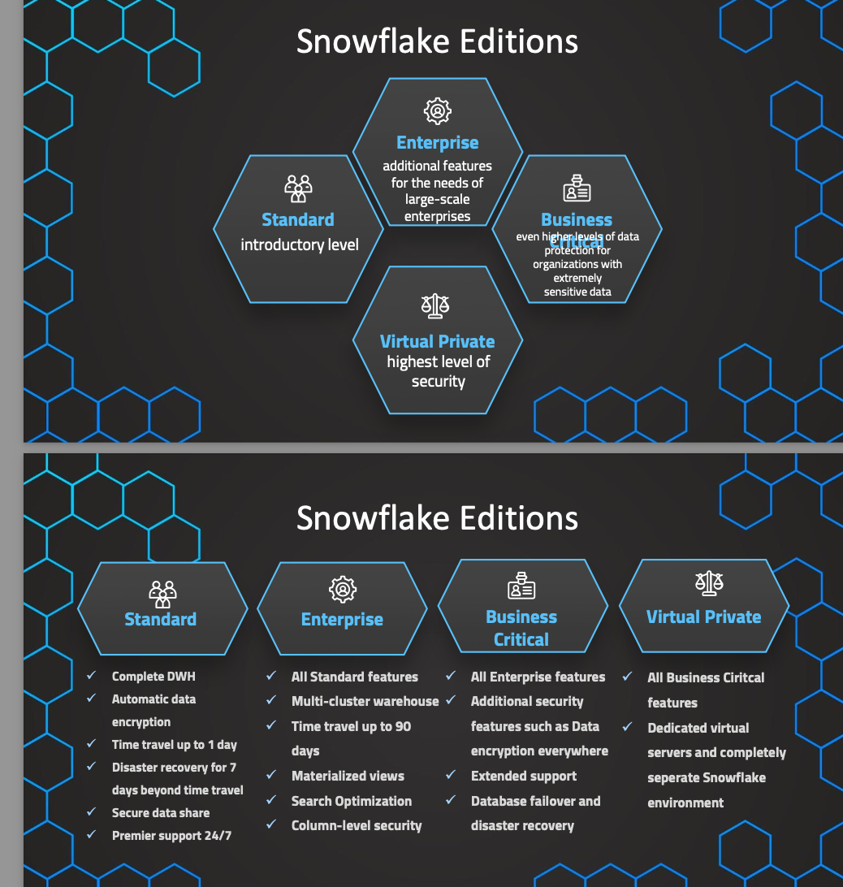

Pricing:

Lecturer: In this lecture, we want to talk in a lot of detail about the pricing to fully understand all of the costs in Snowflake. We have two main types of costs. The first block is compute cost, and then we have also storage cost. The benefit in Snowflake is that those two main blocks are decoupled. This is what we've seen in the different layers in Snowflake, and the benefit is that we can now scale them independently. When we need more storage, we can just increase storage and we don't need to add and pay for additional compute. So like this, we only pay for what we need and we are very scalable and get those compute and storage with a very affordable cloud prices. So Snowflake, as we have already learned, leverages the external cloud providers like AWS, Azure and GCP, and we can benefit from those affordable cloud prices and we can independently scale them up and down. So of course, therefore the pricing depends on which region and which cloud provider our account is based on. Aside to those two main blocks, we also have some data transfer costs in some situations, and therefore in the end we also quickly mention when those data transfer costs occur. But we want to start with the main block, which is the compute cost. The compute is separated into three different parts. So we have, again, here three different aspects. And the main one are the active warehouses. So here we are only paying for warehouses that are active. We can also suspend them and then we are not paying for them. So the warehouse is the standard cost that occurs with compute, and this is used for the standard query processing. So whenever we want to execute a query, we need some compute power, and this is coming from the warehouses. Additionally, we've also learned about the cloud services layer that is needed for some behind the scenes cloud service tasks. And of course, this is managed fully by Snowflake and we also need to pay for this, but usually those costs are quite small and we are not even charged for this unless those costs exceed 10% of our warehouse consumptions. Otherwise, we are not even charged for this. So usually we are actually not even charged for this unless we have really a very low activity with our warehouses. And then we have one last block, which is the serverless. These are also some warehouses that are needed for some specific features like automatic re-clustering, search optimization, and Snowpipe. And here it makes sense for those features that we also need some compute, but that it's managed by Snowflake. For example, with Snowpipe, we have some data that can be automatically loaded when a new file appears somewhere in an external cloud provider, and therefore it can be automatically resized depending on the needs. And therefore it makes sense that this is a serverless feature where we have no control of the warehouses, of resizing them and so on. So this is also then managed by Snowflake. But now let's dive deeper into the main cost, which are our active warehouses. In here, we are charged for the active warehouses per time. We get a price tag per hour, but this is actually built per second. So if we only use 30 minutes, we are also only paying for 30 minutes with always a minimum of one minute when we start a warehouse. So the cost again depend on the time and also on the size of the warehouse. And like this, we have three different factors that affect the cost. This is how much time, how many warehouses we have active, and then also what are the sizes of those warehouses. So in just a second we talk about how this works exactly, but before this we need to understand that we are not charged directly in Euros or dollars, but we are actually charged in credits. So we consume those credits and then those credits have a certain price tag. And therefore we need to understand two things. First, how this consumption works, and then also how much do those credits cost. So let's start by understanding the consumption of the credits. This depends on the amount of time a warehouse is running and the size of the warehouse. So for example, we have the size extra small. This is the smallest that consists of one compute node. But if we have some more complex tasks, some more complex queries, we need more compute power and we can increase the size of a warehouse. So then we have two compute nodes and like this, we also now have two credits consumed per hour. So the number of compute nodes that are needed, this is the amount of credits we are charged per hour. And you can see once we increase the size by one step, we double the amount of servers that are needed and therefore also the amount of credits that are used. So like this, we can choose the size of the warehouse depending on how much compute power we need. And now how much do those credits cost? This is now where the additions come into play. We have for the standard edition, the lowest price. And then for the higher additions, we have a higher price per credit. But now this is, again, depending on which region and which cloud provider our account is based on. So they have different prices and different regions and different platforms. So therefore we have also different prices. And in here we can see, for example, the price of US East in AWS. And if we have another region, for example, in Frankfurt, the prices can differ. And also if we want to know more details on this, we can go to just snowflake.com/pricing. And in here we can choose, for example, let's say AWS and US East. And we can see here these are the prices for those different editions. But now we see that there's also storage cost and therefore we want to dive deeper into this in the next lecture.

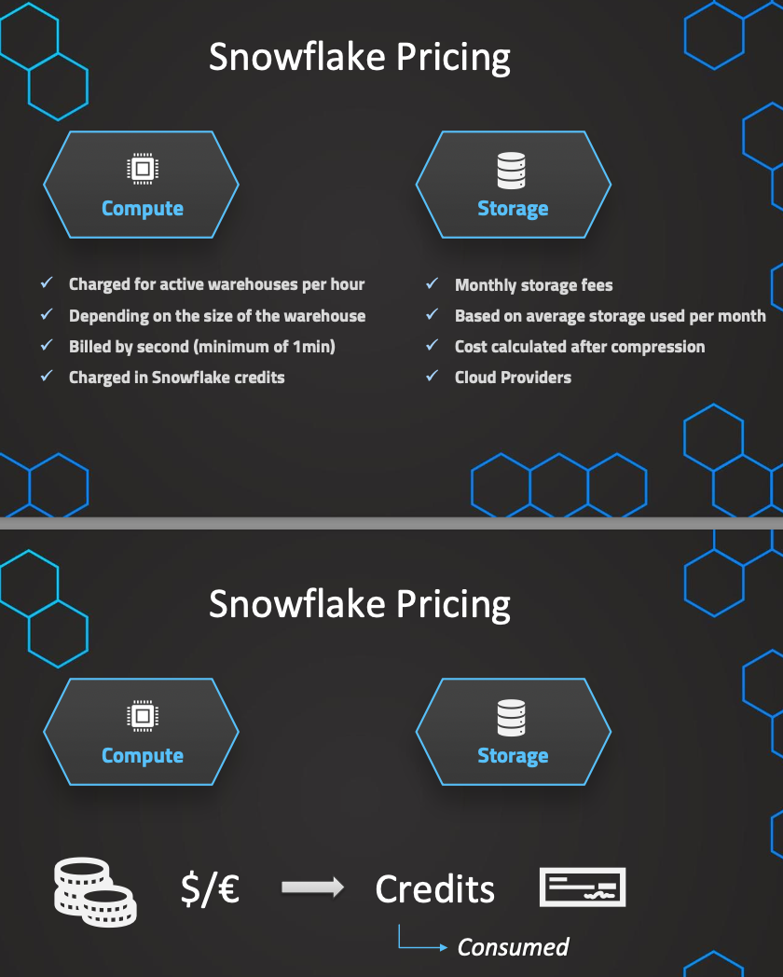

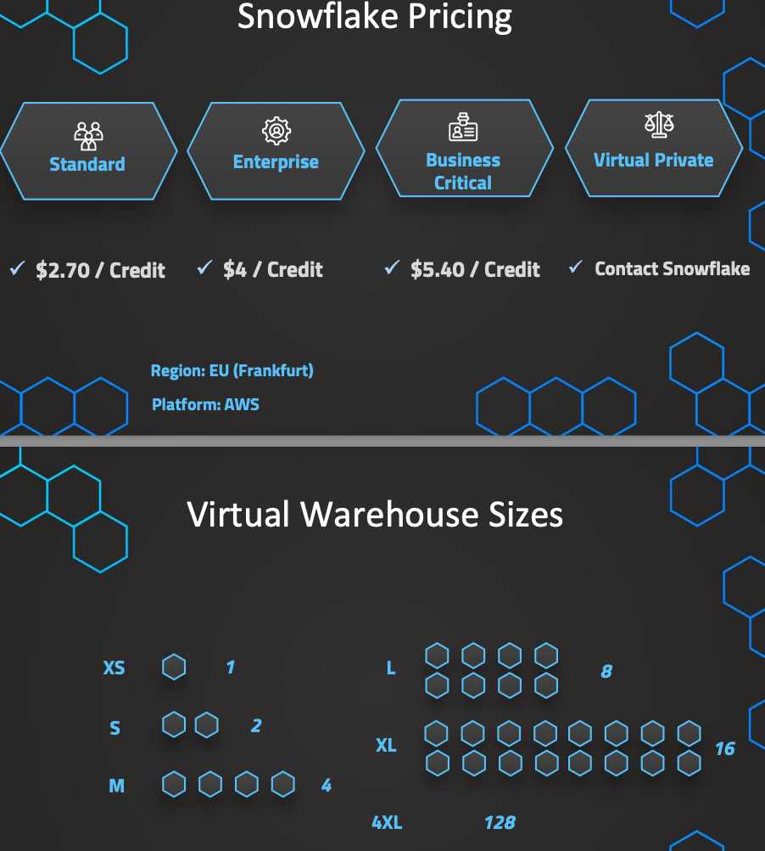

Instructor: Now that we've already talked about the compute cost, we also want to discuss the data transfer and data storage costs. There is a monthly fee depending on how much data we have stored on average in a given month. So this is calculated on a daily average basis, and again, since our account is leveraging the external cloud providers for the data storage, this depends on which is the cloud provider and the region that our account is based on. So for example, if this is based on US East and AWS, we have a cost of $40 US per terabyte per month. So this is based on the cloud providers cost, and also the cost is calculated after the data compression. We know that Snowflake compresses the data into blobs, and this is therefore important that this amount of data is calculated after this data compression. Now in regards to the storage, usually the default is that we pay on demand what we are using. So we pay for what we have used in a given month once the month has been ended, and then again, depending on the region, we have a specific price so this can differ again on the different regions. So, for example, if we choose another region, for example, Frankfurt, we see the prices can differ. But now there's also another way to save on some cost, and this is to reserve some capacity storage. We can also see that in here where we have to pay upfront for a defined capacity, and then this will be a lower price. But of course, we should have a good understanding of how much we need actually. And to demonstrate this, let's have a look at the following scenario. We assume that we need one terabyte of storage, and in this case we would have to pay upfront $23 for the capacity storage. But of course, now let's assume the following scenario. We have only in fact needed 100 gigabytes so we needed much less. We still have to pay the full $23 that we have paid upfront, even though we just used a lot less. And therefore, in this situation, if we don't have a good understanding and we actually needed much less storage, we would have been a lot cheaper with the on demand storage. But now in another scenario, when we actually are close to what we have estimated, we can see in on demand, we now would have to pay more than in the capacity storage. So like this, we can easily see that it's smart to start on demand, and then once we have a good understanding about our usage, so after a while we should get a actually pretty good understanding for how much we need. We can then still shift towards the capacity storage just to save on some additional cost. But now that we have discussed the compute and the storage, there's still something left for the data transfer. So this is something that I also quickly want to mention. In general, data ingress is free. So we are not charged for getting data into Snowflake. This is also because the external cloud providers, they also don't charge for data ingress. So this is free, but once we want to get data out of Snowflake, the cloud providers charge, and therefore, we also have costs for this. So this is based, again, on the different cloud providers. We can have a look again into the website under the pricing guide. And now if we scroll down, we can choose the on demand, so based on what account and so on, but we can also see the pre-purchase capacity, and there we also see the data transfer cost. You can, for example, see for AWS if this is just within the same region and the same cloud. So still, AWS we would not pay anything. So if we want to transfer data to another Snowflake account, but this is the same region and the same underlying cloud provider, we would not be charged for this. But once we want to send it to a different region in the same cloud, it is getting more expensive, and if we want to even send this to a completely different cloud provider, this will be even more expensive. So you can see all of the prices for Azure, AWS, and GCP. This is important to understand. Data ingress is free, but once we want to get data out of Snowflake, this will be charged. So when does this occur? This occurs when we want to transfer data or replicate data to another account that is not in the same region, or that is not the same cloud provider. So if it's in the same region and the same cloud provider, then this would be also still free. So this is what we need to know about compute costs, storage cost, and data transfer cost.

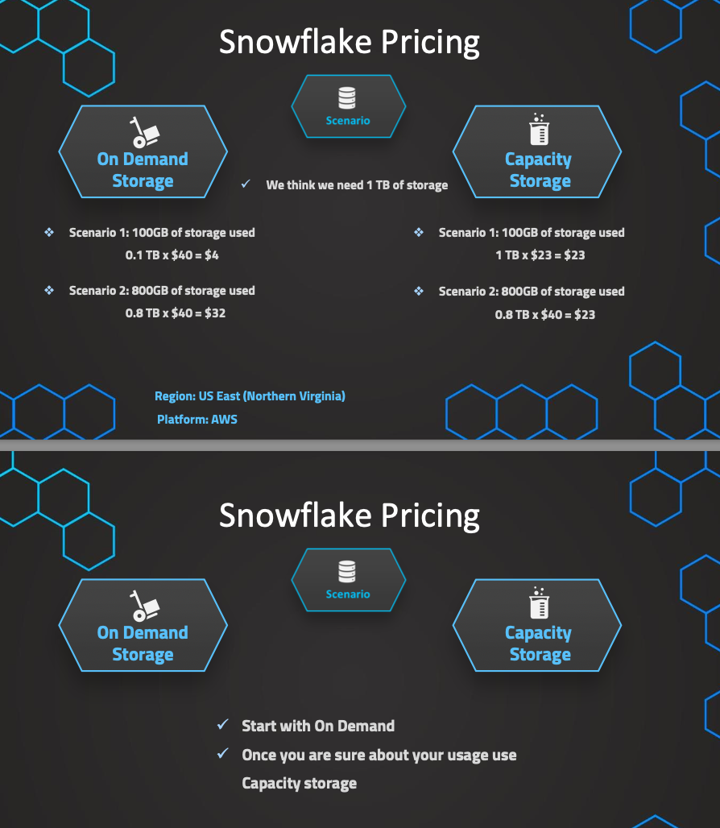

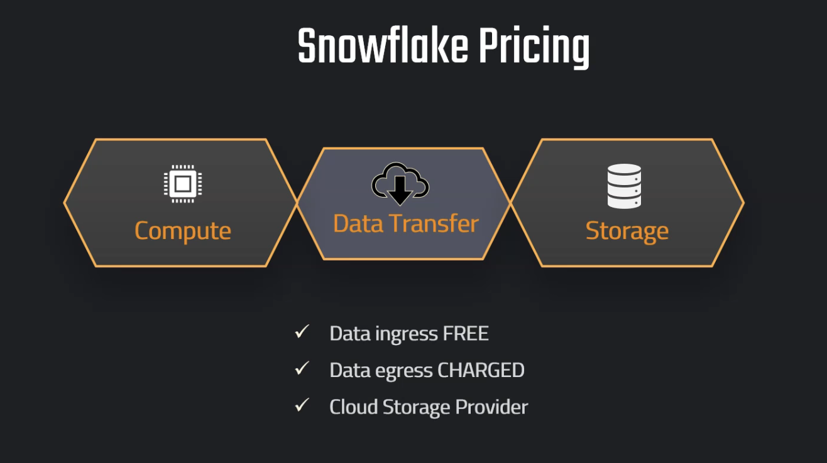

Resource Monitor:  
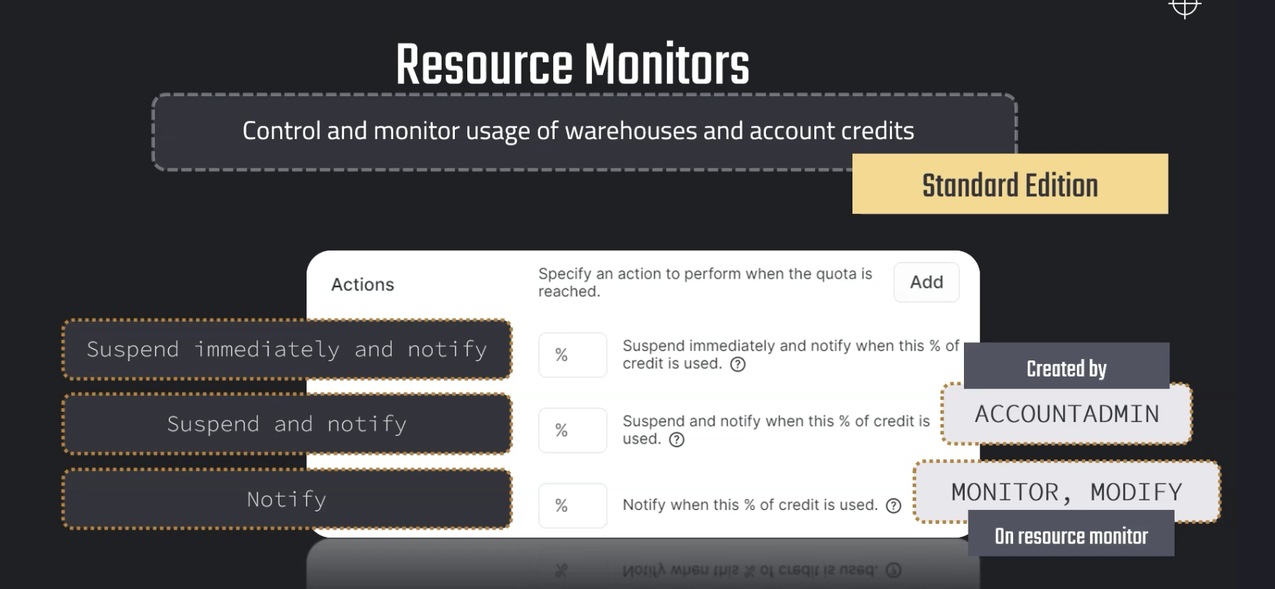

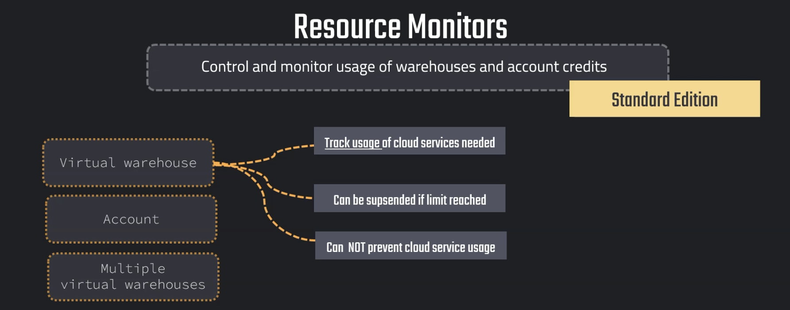

Instructor: In Snowflake, we can create so-called resource monitors. Those are objects that we can use to control and monitor the credit usage of both warehouses and also our entire account. This is a feature that's available for the standard edition and higher editions. So basically for all of the editions and all of the accounts. And in these resource monitors, we can set a so-called credit quota. This is like a limit that we can set in a defined cycle. So, for example, every month we have a limit that is just then reset every month. We can of course also customize this schedule, but the default is just that this resets every month. And those resource monitors we can set for the account level and also for individual warehouses. And on top of this we can also set them up for a group of warehouses. So we can select multiple warehouses and put one resource monitor, so one limit on these multiple warehouses. And then based on the quota that we have set, we can define specific actions. So we have three type of actions and we can say at what percentage of the quota this action should happen. And these three actions are first just notify us when, for example, 50% of the credit is used. Then we have the next action, which is suspend now the warehouse and always notify me. So all of the actions always include notify, but this will then also suspend the warehouses. But it's important that suspend here means that it will still continue the ongoing workload. So the queries that are still being processed currently, they will be completed, and only after this current workload has been finished, this will then suspend, so this means that we can exceed this limit. And then if we want to be a bit more rigorous, we can also use the action Suspend immediately and notify. And this will then suspend the warehouse, or the warehouses, immediately, and this will also abort the current queries. So if we have some queries that are currently running, this will also immediately stop those queries. So they will be aborted, and they won't be completed if this limit is reached. And also be aware, you can also use here percentages that are above 100%, this is also possible. So those resource monitors can be created to control and monitor the usage of our credits. And they can only be created by users with the account admin role. And later on we'll talk in more detail also about the different roles. And even though this can be only created by the account admin, we can delegate some tasks. So we can just grant privileges of Monitor and Modify on specific resource monitors. And then those people with those privileges, they can also view and monitor the existing resource monitors. And lastly, I also quickly want to mention that these resource monitors can be used to track the usage of the cloud services that are needed to execute certain queries related to a virtual warehouse. So we can, of course, set a limit in which then a warehouse should be suspended, but we cannot prevent entirely the usage of cloud service. So, we cannot necessarily prevent cloud service usage that is related to a warehouse. This is just something that's a little bit specific, but I also wanted to mention this. So, this is what we need to know about resource monitors, and now we want to just put this into practice and create such resource monitors hands-on in Snowflake.

Roles:  
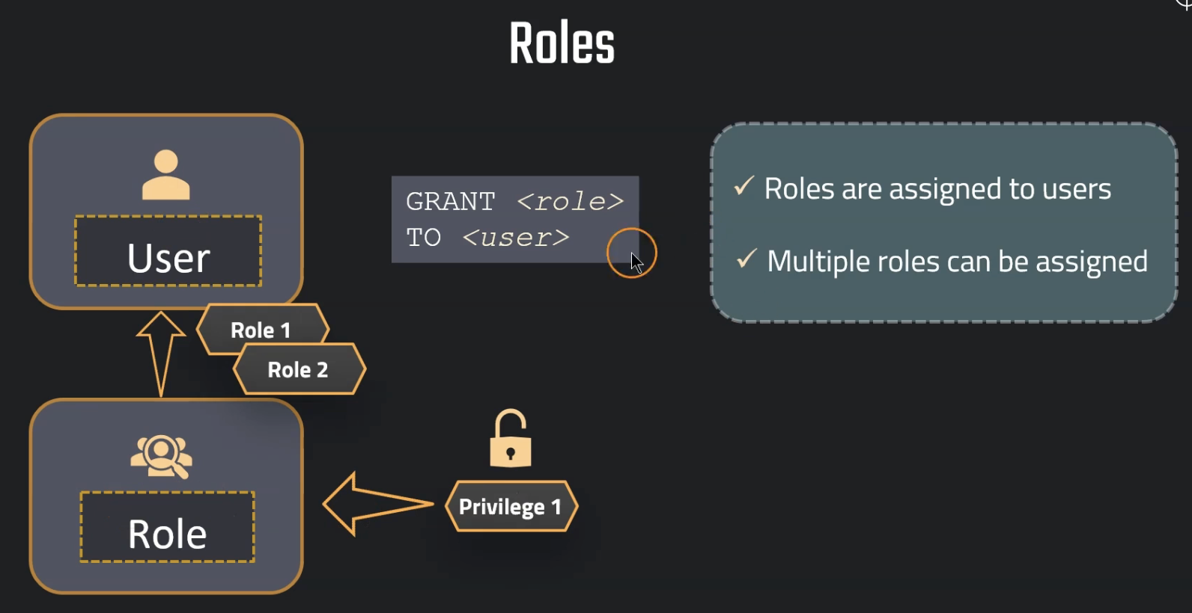

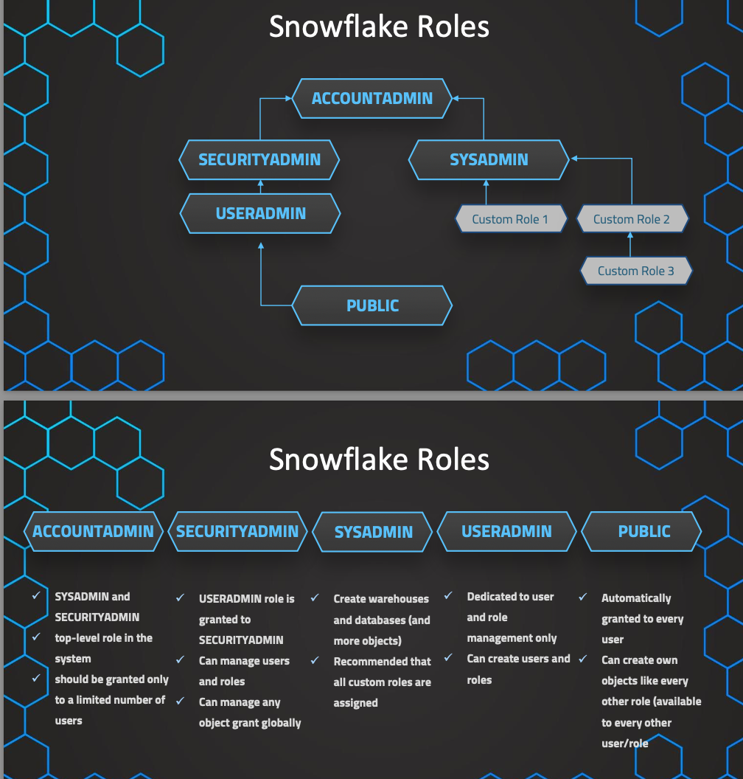

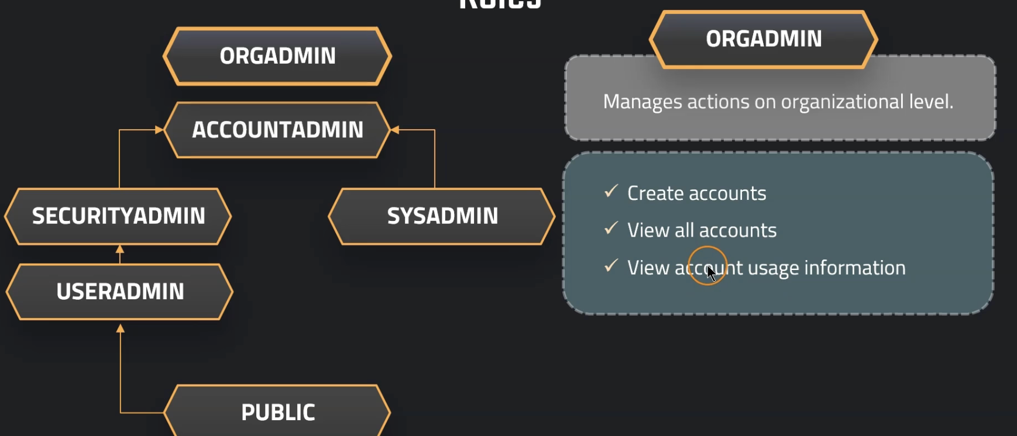

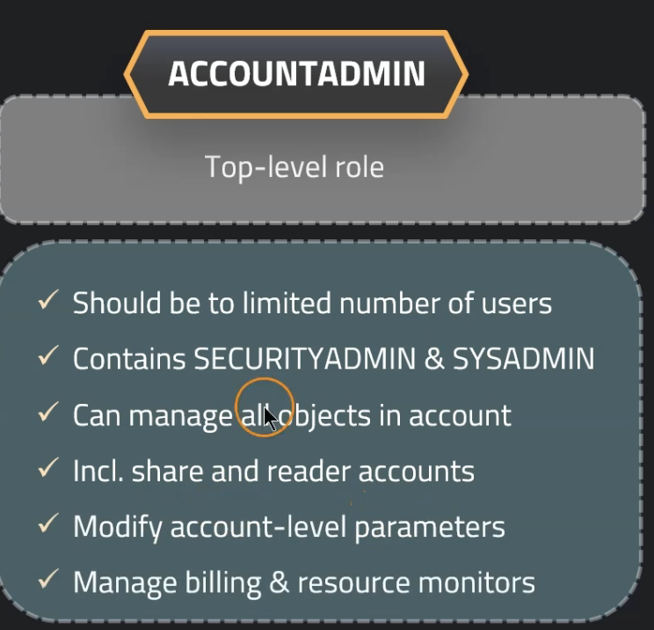 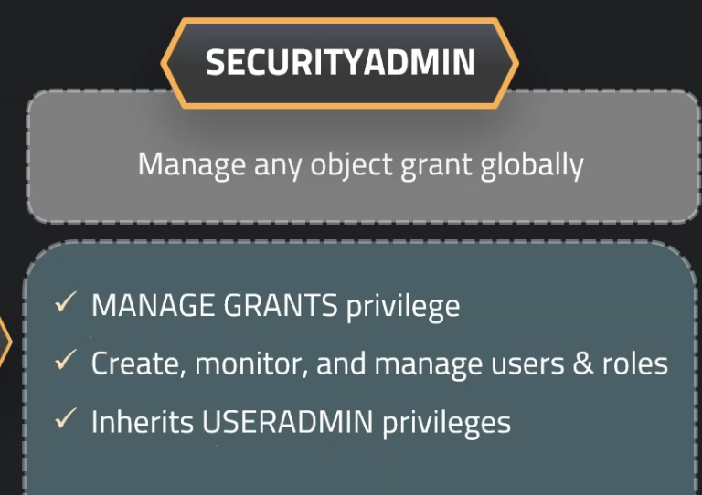

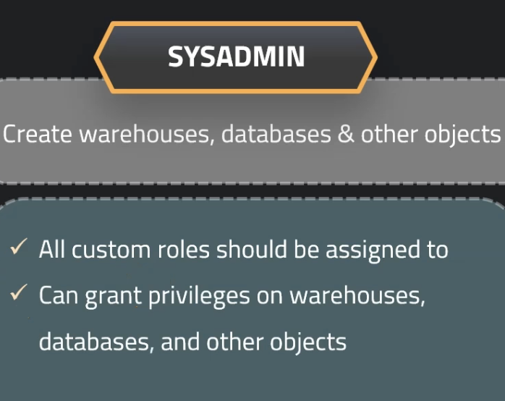 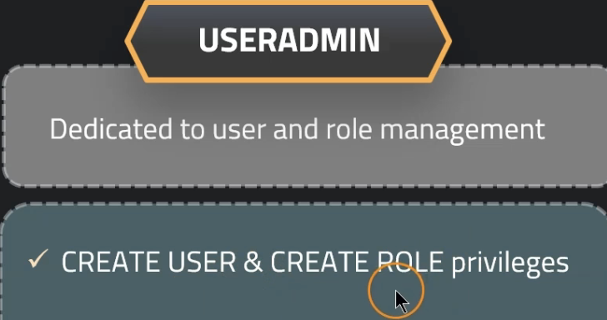

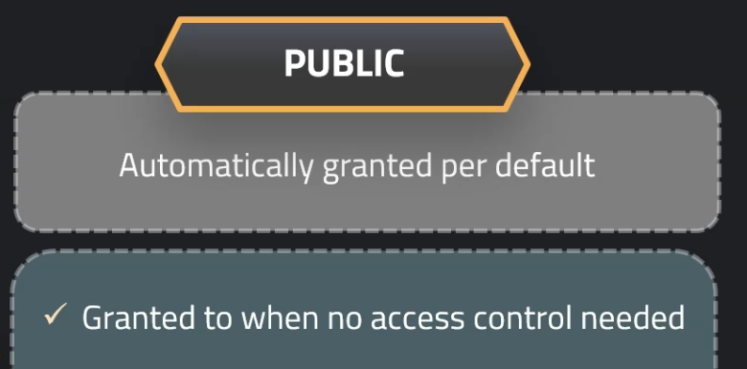

Presenter: Now let's briefly talk about the roles, and the purpose of this lecture is basically just to get an overview over the roles because we will use them and you will see them so you have a brief understanding of how this works. And later on, we will have also a dedicated section about access management privileges, roles, and so on. So don't worry, we will dive deeper into this later on. But for now, let's first of all have an overview over this. So you can see that we have those system roles, and also, we have the role orgadmin, that is a bit outside of this hierarchy, but this is basically the hierarchy of roles in Snowflake. So here, you can see that the public role is assigned always actually to every user that is created. And then, when we assign privileges, this is what we are doing, how this works, we have roles, and then we assign privileges to the roles. And this will be inherited up the hierarchy. So here, you can see how this works. We have a role, this can be a system role or also, a custom role that we have created. And note, when we create a custom role, it should be as a best practice assigned to the sysadmin because the sysadmin is managing the warehouses and the databases, mostly, this is the purpose. And then in this case, it makes sense to assign the custom role as a best practice to the sysadmin, and why this is exactly the case, we also talk about in the dedicated section for the access management. So in general, as we have said, we assign privileges to roles using the GRANT command, and then afterwards, we can also grant and revoke those privileges. For example, I select on a table so that a table can be seen. And then every user that is having this role assigned is now able to then do this what the privilege says. So again, we can then also grant the roles, also, using the GRANT command to the user. So we grant permissions to the role privileges, and then, the role will be granted to users. This is basically how it works. And one user can have multiple roles assigned to them. So we talk about this later on in more detail. And every user always needs to have also a current role in the session. So if we jump into our account, we can see if we go into a specific worksheet, then, also, every query will be also executed using a specific role. And then always when we, for example, create an object, the owner of this object will be the role that is, has created this object. So we have also this concept of ownership. This is also important because every object is usually owned by a role. So when we created per default, this is the owner. So this is basically how it works. And then as we have said, we have those system defined roles, they can't be dropped and we can add privileges to it, but we cannot revoke privileges. But again, we talk in more detail about this later on. For now, we just briefly want to mention we have the custom roles should be assigned to the sysadmin. And outside of this hierarchy, we also have the orgadmin. So this is something that you might notice, and this is basically managing actions on an organizational level. So if you have multiple accounts, this is the role that can create additional accounts. We talk also about read accounts and so on. So this is something that can be done here also for the orgadmin to do those organizational level. And this is therefore, a little bit outside of the hierarchy. Then we have the accountadmin. So this is the actual top level role of our hierarchy. And everything will be always inherited, all of the privileges up to the accountadmin. So this is a very strict role because it's a very powerful, the most powerful role. So we should be very careful because this has a lot of privileges, including also, managing the share and reader accounts. So we can create those share and reader accounts. And we talk about this later on. For now, we just briefly want to mention the overview. So securityadmin is managing the grants globally. This means that we can manage the grants of the privileges, so we can create and monitor the users and the roles. So here, of course, the useradmin is able to create the users and the securityadmin is able to manage the security part of that. So here, also, all of the user admin privileges will be, therefore, of course, inherited. And then we have also the sysadmin. So basically, they are doing all of the warehouse management and the database management and the object management. And this is exactly the reason why we have to assign the custom roles to this role, because then otherwise, it could create some conflicts when the sysadmin is creating a database. And then with access, we would get some problems, but we talk about this in more detail as mentioned later on. We have also the useradmin, basically, creating the users and the create role. So create users and create roles. So this is the management of the users. And finally, as we have said, we have also the public role. So this is the role when we, yeah, when we need no access. This is just the default role. So every user that is created will have this role assigned. And this is, yeah, therefore, somehow some kind of a pseudo role. So it will always be assigned. And then again, we can create those hierarchies, which don't worry about it now too much. This is something more for later. So, of course, this is just the brief overview so that you have heard a little bit about those roles, what are the broad differences and into the details, we will dive in later on. So hope it was helpful and see you in the next lecture.

Loading Data:

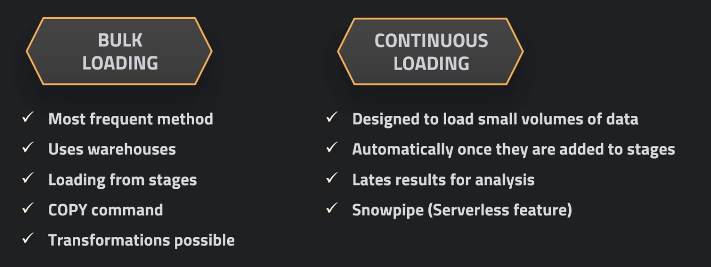

Instructor: Now let's talk about one of the most important concepts in Snowflake, and also when we talk in general about data warehouses, which is loading data into our tables and databases. So this is a primary task that we have also in Snowflake, and therefore we want to cover this in really great detail. So in general, when we talk about loading data, we have two main methods basically of loading the data into our databases. The first one is bulk loading. So this is the most frequent and also the most important method. This uses the compute power of our warehouses, so we have to use our own warehouses for this, our own capacity is used here, and this involves also so-called stages, which we talk about in more detail in the next lecture. So this is what we use, and here we use those stages where we load the data from, which we, again, talk about in the next lecture, how we create them, how we use them, and so on. So then we will also learn about the COPY command, because this is the command that is used for this kind of loading. So this is just a secure command to load data from the stages into our table. So this also allows for data transformations. We can maybe clean the data, or do some little transformations. So this is something that is also possible with bulk loading. And then we also have continuous loading. And as opposed to the bulk loading, which is, yeah, like the name suggests, we load the data in bulk, this can be periodically, but usually it is a more higher volume of data also. Continuous loading is, yeah, data that is needed very quickly, so it needs to be up to date, we need to have access to it immediately, but usually it's more smaller amounts of data. So here this uses the Serverless features. So it will use not a dedicated warehouse that we have created, but it will use the Serverless feature. So the Serverless warehouses that are managed by Snowflake. So this is Snowpipe, the feature that is used for continuous loading. We talk about this in more detail later on. For now, we want to focus more on the bulk loading, which is the most important one, using the COPY command, and stages, and our warehouses. That's what we want to focus on first, because it's the most important one. And of course, later on we also talk about continuous loading using Snowpipe. So in general, we now want to understand what are stages? How does it exactly work with loading data? What are the stages now, how we create them, and how we can work with them. That's what we now want to answer in the next lecture.

Stages:

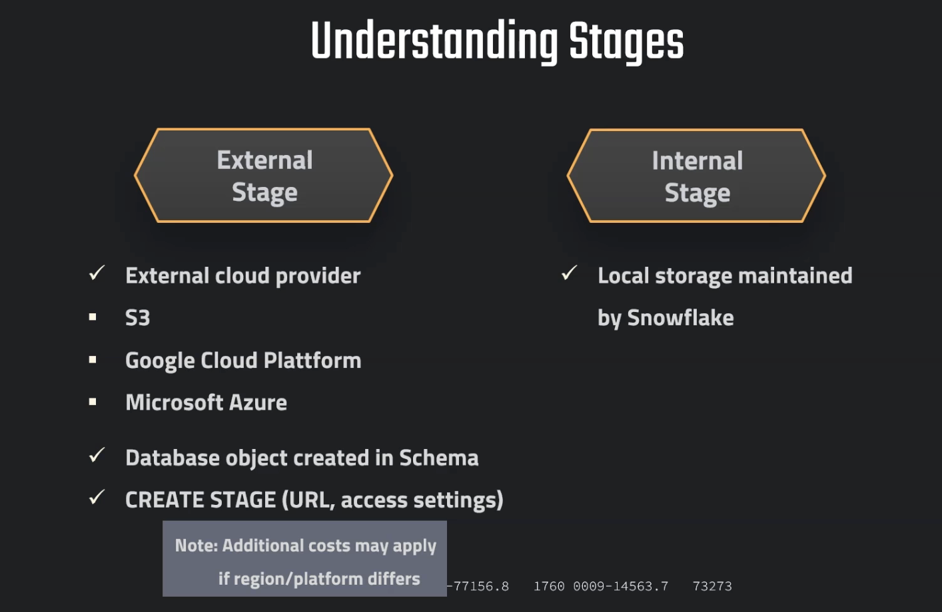

Lecturer: When we want to load data into Snowflake using the copy method, which is the most frequent method, we need to know about stages. So, before we can dive into practice, let's briefly understand what are actually those stages. First of all, I want to say that those stages are not to be confused with the staging area or sometimes also called stages in the general concept of a data warehouse. So, the stage as a general concept in the, yeah, field of data warehousing, usually it's called staging, is not to confuse with this object in Snowflake. So, the stage is basically an object in Snowflake. This is something that we create, and this is basically the location of the data files where the data can be loaded from. So, here, the stage object that we create basically contains the location from where we load the data. This can be, for example, an AWS bucket, and in this stage object, we just store the location. So, this database object called stage has properties associated to it. And one of those properties is, for example, the location. There can be also other properties like the credentials, so access to this location, so that we can easily load the data from this external location. So, this is basically a database object with different properties and we use it to load data. Basically in some way, you can think of it as the location of the data and all of the located or the associated properties of the location, so that we can load the data from there. So, this is what we are using this for. And here, we have two types of stages. The most common type of stage is the external stage. So, this is referring to the location such as, for example, an AWS S3 bucket, or Google Cloud storage, or an Azure Blob Storage. So, all of those external cloud providers where we store data. This is the most frequent type of a stage in Snowflake. And here, we, yeah, basically the external cloud providers. Here, this is the external stage, and this is created within a database schema using the create stage command. So, we just created like for example, also a table, and then this is an object in our schema in our database basically. This is why it's a database object and it includes properties like the URL, some access settings, and some additional settings that are also relevant to the connection. In regards to the cost, we have to consider that if the external stage is in a different region or a different platform that the one that is selected for our account. For example, let's say we have an AWS account selected for the Snowflake account. So, we use the cloud provider AWS, and we have maybe the region US-East, and then we have now a stage that is associated or that is for a different region or a different cloud provider. Then, this can occur additional data transfer cost, because we load data from or to another location. So, here, this can occur of course in data transfer costs either in the cloud provider or also in our account. So, depending on where we want to get the data out. So, yeah, this is something that we have to just keep in mind that there can be additional data transfer cost. For example, if you use an Azure account and you want to load the data from there, then of course you don't pay any incoming data in Snowflake, but you always pay for the outgoing data. So, data that is transferred out of your account. So, maybe in your Azure account, you have to consider that there might be additional cost associated with that. Additionally, we also have the internal stages. They are used when there is no access to an external cloud provider. So, this can be, for example, a local file destination such as, for example, an on-premise server that is maintained then by Snowflake. So, here, you have also this internal stage, which is, yeah, usually when we talk about a stage, we mostly refer to the external stage. So, this is also the more frequently used one, the more important one, and therefore we will also first focus on those external stages. But now, this is already enough of the theory and we want to get started. Hands-on, we want to start to create our own first stage within our account using the create stage command. And then, we want to dive deeper into these stages, how they work, and then also use them of course, to load data practically hands-on. That's what we are doing in the next lectures.

Copy Command:

// Creating ORDERS table

CREATE OR REPLACE TABLE OUR_FIRST_DB.PUBLIC.ORDERS (

ORDER_ID VARCHAR(30),

AMOUNT INT,

PROFIT INT,

QUANTITY INT,

CATEGORY VARCHAR(30),

SUBCATEGORY VARCHAR(30));

SELECT * FROM OUR_FIRST_DB.PUBLIC.ORDERS;

// First copy command

COPY INTO OUR_FIRST_DB.PUBLIC.ORDERS

FROM @aws_stage

file_format = (type = csv field_delimiter=',' skip_header=1);

// Copy command with fully qualified stage object

COPY INTO OUR_FIRST_DB.PUBLIC.ORDERS

FROM @MANAGE_DB.external_stages.aws_stage

file_format= (type = csv field_delimiter=',' skip_header=1);

// List files contained in stage

LIST @MANAGE_DB.external_stages.aws_stage;

// Copy command with specified file(s)

COPY INTO OUR_FIRST_DB.PUBLIC.ORDERS

FROM @MANAGE_DB.external_stages.aws_stage

file_format= (type = csv field_delimiter=',' skip_header=1)

files = ('OrderDetails.csv');

// Copy command with pattern for file names

COPY INTO OUR_FIRST_DB.PUBLIC.ORDERS

FROM @MANAGE_DB.external_stages.aws_stage

file_format= (type = csv field_delimiter=',' skip_header=1)

pattern='.*Order.*';

Transform Query:

// Transforming using the SELECT statement

COPY INTO OUR_FIRST_DB.PUBLIC.ORDERS_EX

FROM (select s.$1, s.$2 from @MANAGE_DB.external_stages.aws_stage s)

file_format= (type = csv field_delimiter=',' skip_header=1)

files=('OrderDetails.csv');

// Example 1 - Table

CREATE OR REPLACE TABLE OUR_FIRST_DB.PUBLIC.ORDERS_EX (

ORDER_ID VARCHAR(30),

AMOUNT INT

);

SELECT * FROM OUR_FIRST_DB.PUBLIC.ORDERS_EX;

// Example 2 - Table

CREATE OR REPLACE TABLE OUR_FIRST_DB.PUBLIC.ORDERS_EX (

ORDER_ID VARCHAR(30),

AMOUNT INT,

PROFIT INT,

PROFITABLE_FLAG VARCHAR(30)

);

// Example 2 - Copy Command using a SQL function (subset of functions available)

COPY INTO OUR_FIRST_DB.PUBLIC.ORDERS_EX

FROM (select

s.$1,

s.$2,

s.$3,

CASE WHEN CAST(s.$3 as int) < 0 THEN 'not profitable' ELSE 'profitable' END

from @MANAGE_DB.external_stages.aws_stage s)

file_format= (type = csv field_delimiter=',' skip_header=1)

files=('OrderDetails.csv');

SELECT * FROM OUR_FIRST_DB.PUBLIC.ORDERS_EX;

// Example 3 - Table

CREATE OR REPLACE TABLE OUR_FIRST_DB.PUBLIC.ORDERS_EX (

ORDER_ID VARCHAR(30),

AMOUNT INT,

PROFIT INT,

CATEGORY_SUBSTRING VARCHAR(5)

);

// Example 3 - Copy Command using a SQL function (subset of functions available)

COPY INTO OUR_FIRST_DB.PUBLIC.ORDERS_EX

FROM (select

s.$1,

s.$2,

s.$3,

substring(s.$5,1,5)

from @MANAGE_DB.external_stages.aws_stage s)

file_format= (type = csv field_delimiter=',' skip_header=1)

files=('OrderDetails.csv');

SELECT * FROM OUR_FIRST_DB.PUBLIC.ORDERS_EX;

More Transformations:

//Example 3 - Table

CREATE OR REPLACE TABLE OUR_FIRST_DB.PUBLIC.ORDERS_EX (

ORDER_ID VARCHAR(30),

AMOUNT INT,

PROFIT INT,

PROFITABLE_FLAG VARCHAR(30)

);

//Example 4 - Using subset of columns

COPY INTO OUR_FIRST_DB.PUBLIC.ORDERS_EX (ORDER_ID,PROFIT)

FROM (select

s.$1,

s.$3

from @MANAGE_DB.external_stages.aws_stage s)

file_format= (type = csv field_delimiter=',' skip_header=1)

files=('OrderDetails.csv');

SELECT * FROM OUR_FIRST_DB.PUBLIC.ORDERS_EX;

//Example 5 - Table Auto increment

CREATE OR REPLACE TABLE OUR_FIRST_DB.PUBLIC.ORDERS_EX (

ORDER_ID number autoincrement start 1 increment 1,

AMOUNT INT,

PROFIT INT,

PROFITABLE_FLAG VARCHAR(30)

);

//Example 5 - Auto increment ID

COPY INTO OUR_FIRST_DB.PUBLIC.ORDERS_EX (PROFIT,AMOUNT)

FROM (select

s.$2,

s.$3

from @MANAGE_DB.external_stages.aws_stage s)

file_format= (type = csv field_delimiter=',' skip_header=1)

files=('OrderDetails.csv');

SELECT * FROM OUR_FIRST_DB.PUBLIC.ORDERS_EX WHERE ORDER_ID > 15;

DROP TABLE OUR_FIRST_DB.PUBLIC.ORDERS_EX;

On error:

// Create new stage

CREATE OR REPLACE STAGE MANAGE_DB.external_stages.aws_stage_errorex

url='s3://bucketsnowflakes4';

// List files in stage

LIST @MANAGE_DB.external_stages.aws_stage_errorex;

// Create example table

CREATE OR REPLACE TABLE OUR_FIRST_DB.PUBLIC.ORDERS_EX (

ORDER_ID VARCHAR(30),

AMOUNT INT,

PROFIT INT,

QUANTITY INT,

CATEGORY VARCHAR(30),

SUBCATEGORY VARCHAR(30));

// Demonstrating error message

COPY INTO OUR_FIRST_DB.PUBLIC.ORDERS_EX

FROM @MANAGE_DB.external_stages.aws_stage_errorex

file_format= (type = csv field_delimiter=',' skip_header=1)

files = ('OrderDetails_error.csv');

// Validating table is empty

SELECT * FROM OUR_FIRST_DB.PUBLIC.ORDERS_EX ;

// Error handling using the ON_ERROR option

COPY INTO OUR_FIRST_DB.PUBLIC.ORDERS_EX

FROM @MANAGE_DB.external_stages.aws_stage_errorex

file_format= (type = csv field_delimiter=',' skip_header=1)

files = ('OrderDetails_error.csv')

ON_ERROR = 'CONTINUE';

// Validating results and truncating table

SELECT * FROM OUR_FIRST_DB.PUBLIC.ORDERS_EX;

SELECT COUNT(*) FROM OUR_FIRST_DB.PUBLIC.ORDERS_EX;

TRUNCATE TABLE OUR_FIRST_DB.PUBLIC.ORDERS_EX;

// Error handling using the ON_ERROR option = ABORT_STATEMENT (default)

COPY INTO OUR_FIRST_DB.PUBLIC.ORDERS_EX

FROM @MANAGE_DB.external_stages.aws_stage_errorex

file_format= (type = csv field_delimiter=',' skip_header=1)

files = ('OrderDetails_error.csv','OrderDetails_error2.csv')

ON_ERROR = 'ABORT_STATEMENT';

// Validating results and truncating table

SELECT * FROM OUR_FIRST_DB.PUBLIC.ORDERS_EX;

SELECT COUNT(*) FROM OUR_FIRST_DB.PUBLIC.ORDERS_EX;

TRUNCATE TABLE OUR_FIRST_DB.PUBLIC.ORDERS_EX;

// Error handling using the ON_ERROR option = SKIP_FILE

COPY INTO OUR_FIRST_DB.PUBLIC.ORDERS_EX

FROM @MANAGE_DB.external_stages.aws_stage_errorex

file_format= (type = csv field_delimiter=',' skip_header=1)

files = ('OrderDetails_error.csv','OrderDetails_error2.csv')

ON_ERROR = 'SKIP_FILE';

// Validating results and truncating table

SELECT * FROM OUR_FIRST_DB.PUBLIC.ORDERS_EX;

SELECT COUNT(*) FROM OUR_FIRST_DB.PUBLIC.ORDERS_EX;

TRUNCATE TABLE OUR_FIRST_DB.PUBLIC.ORDERS_EX;

// Error handling using the ON_ERROR option = SKIP_FILE_<number>

COPY INTO OUR_FIRST_DB.PUBLIC.ORDERS_EX

FROM @MANAGE_DB.external_stages.aws_stage_errorex

file_format= (type = csv field_delimiter=',' skip_header=1)

files = ('OrderDetails_error.csv','OrderDetails_error2.csv')

ON_ERROR = 'SKIP_FILE_2';

// Validating results and truncating table

SELECT * FROM OUR_FIRST_DB.PUBLIC.ORDERS_EX;

SELECT COUNT(*) FROM OUR_FIRST_DB.PUBLIC.ORDERS_EX;

TRUNCATE TABLE OUR_FIRST_DB.PUBLIC.ORDERS_EX;

// Error handling using the ON_ERROR option = SKIP_FILE_<number>

COPY INTO OUR_FIRST_DB.PUBLIC.ORDERS_EX

FROM @MANAGE_DB.external_stages.aws_stage_errorex

file_format= (type = csv field_delimiter=',' skip_header=1)

files = ('OrderDetails_error.csv','OrderDetails_error2.csv')

ON_ERROR = 'SKIP_FILE_3%';

SELECT * FROM OUR_FIRST_DB.PUBLIC.ORDERS_EX;

CREATE OR REPLACE TABLE OUR_FIRST_DB.PUBLIC.ORDERS_EX (

ORDER_ID VARCHAR(30),

AMOUNT INT,

PROFIT INT,

QUANTITY INT,

CATEGORY VARCHAR(30),

SUBCATEGORY VARCHAR(30));

COPY INTO OUR_FIRST_DB.PUBLIC.ORDERS_EX

FROM @MANAGE_DB.external_stages.aws_stage_errorex

file_format= (type = csv field_delimiter=',' skip_header=1)

files = ('OrderDetails_error.csv','OrderDetails_error2.csv')

ON_ERROR = SKIP_FILE_3

SIZE_LIMIT = 30;

Instructor: In this lecture, we want to have a look at how we can deal with errors. And we do this by specifying the so-called ON_ERROR option. So this ON_ERROR option is a COPY option that we can just specify in our COPY command to specify how we should deal with errors that occur in our COPY command. So that's what we want to have a look at in this lecture. And first of all, we want to create a stage object that has some stage where we have some data. And this is a file. We can have a look at this in here. So we have actually two files in this stage. And both of these CSV files, I have already described it in the name, they contain some errors. Note that we have this column Profit, which we will also create now a table. And it is supposed to be, that's how we define it, an integer data type. So we cannot accept any text values. But actually this column in this file that we want to load, so we see there are actually text values. So obviously this will create some errors, and we want to have a look now at how Snowflake is dealing with this and how we can deal with this kind of errors by using the ON_ERROR COPY option. First of all, let's load the data and see what the result will look like. We try to load it, and then we see, of course, we get this error message. Numeric value one thousand is not recognized, it doesn't work. And also we get a suggestion of what we can do to deal with this error. So it says, If you would like to continue loading when an error is encountered, use other values, such as SKIP_FILE or CONTINUE for the ON_ERROR option. And that's what we want to have a look at now. First of all, let's also quickly be sure to verify that there actually has no data being loaded. So we see the table is indeed completely empty. But now if we add this ON_ERROR COPY option just as a COPY option after our COPY command, we will tell basically the COPY command that load the data that comes after the errors or that are not errors anyways. So just continue with loading with the next data row and then just ignore the previous errors. So let's also execute this. And then we will see that the status now is partially loaded. So 1,500 rows have been passed, but only 1,498 have been loaded because there have been two errors. And we can also see the error message. Of course, numeric value is not recognized, and then also in here where the error has occurred. So first_error_line, and of course, in our case, this was a line two. So we can see this is where the error has occurred in the file. And now that we know this is working, let's also quickly verify that indeed the data is now available in the table. We can just query from the table to see, indeed all of the data is visible. Now, let's also just TRUNCATE the table, so we can start again fresh. And then we want to have a look at the default behavior. So if we don't specify anything, the default will be for this ON_ERROR, just ABORT_STATEMENT. So if we wouldn't mention that at all, it would be exactly with the ON_ERROR set to ABORT_STATEMENT. And this means that whenever an error is occurred, just the loading will not happen at all. So no data row will be copied. Let's quickly demonstrate this by running this command. There we should now see that everything has been skipped. So actually we see it is not working because the first file that contains error has been skipped, but only because the file was loaded before. So let's make sure we really TRUNCATE the table, and we get the message Statement executed successfully. Now, it should give us our expected behavior. So if we now try to copy it again, we see the error message is appearing. And also note that even if we specify two files, so the error occurs only in the first file, the second file will also not be loaded at all. So one error is occurred in the entire COPY statement and nothing will be copied at all. This is the default behavior. If we now also run a SELECT on the table, we should also see the table is indeed completely empty. And if we now again TRUNCATE our table, and let's make sure we get the right value of statement executed successfully, we can have a look now at the next and last option, which is SKIP_FILE. So that's another behavior that is different from ABORT_STATEMENT and also CONTINUE statement. So it is in between, because this means now that whenever an error occurs, this exact file where the error has occurred will be skipped, but the other files can still be loaded. So for example, in here, if we have an error in the first file, then this file will be skipped, but we will still load the data from the next file. Let's demonstrate this by running the second COPY command as well. We will see that the data in the first file has not been loaded because load has been failed. But indeed we have the second file that has completely been loaded. We can again verify this by having a look at the rows. So let's execute this query where we just have a look at the data. We see the data files are included. But now if we, let's again TRUNCATE our table, we want to see an alternative to SKIP_FILE. So this is just some additional value that we can add in the SKIP_FILE option. And this is to specify underscore and then an absolute number. So in here, we see we can add a number, and this will now be the error limit. And if we are below this error limit, the file will completely be loaded. Of course, the errors will be ignored, but it will basically behave as the same as CONTINUE. And if we reach this error of, in this case, two or three or whatever number we specify, if this is reached, the file will be skipped. So we now, we have two errors in this file, and if we try to copy that now, we should now see that this has completely been loaded because the error limit of three that we have specified in here has not been reached. So we see two errors has not reached the error limit, and therefore everything will be just normally loaded. Let's again TRUNCATE the table, and then we want to try again with a value of, for example, two. So if we specify two, we know that the error limit will be reached because we indeed have two errors. Same would be, of course, if we use the value one, then this file will be skipped, so the error limit in file one has been reached. Therefore this file will be skipped, but we will still load the data from the second file. We can see for the first file load has failed, error limit has been reached, but still we load the data from the second file. So this is the option with the SKIP_FILE. And actually also, we don't necessarily need to specify an absolute number, but we can also, let's again TRUNCATE our table of course first, then we can also specify a percentage. So if we specify this percentage, for example, let's say 3%, this will be the error limit as a dynamic value. So this is a percentage of the total amount of rows. So if we have, in our case, 1,500 rows, we specify 3% as error limit, it will be 45 rows, because 3% of 1,500 is 45. And of course, since the error limit has not been reached with our two errors, this will be loaded just normally. And then we can just continue, of course, also with the other files. So in this lecture, we have seen the first COPY option, which is the ON_ERROR option. We've seen the default value is just ABORT_STATEMENT, so nothing will be loaded at all, but we also can just completely ignore all of the errors. We can also say, just go to the next file, don't load from this file. Or we can even specify an error limit in the SKIP_FILE value.

File Format:

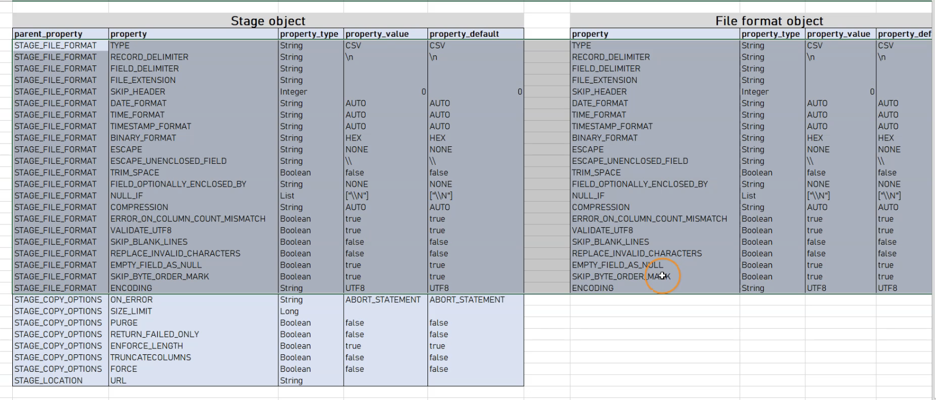

Instructor: So up until now we have always specified the file format in our copy command. That means for every copy command we have specifically defined the file format. That means the type, in this case it is a CSV, the field limiter, which is a comma in this case and also in this case whether we want to skip the header or not. So this is something we can do. This is totally fine, but there is another way of doing that and this is even a little bit better because it is more of a best practice because this file format can be actually also defined as an object. Same as a stage, we have defined the stage as an object and we can do the same thing for creating a file format object. And then we can always reuse this file format object in our copy commands. So let's see how we can do this. First we want to create a table so that we can work with the examples here. So we've created this table. And now again, so that we keep things organized we will create a schema in our managed database and the schema is called file formats. So this is where we will put all of our file formats. And again, this is not mandatory this is just a best practice to keep things organized. Now let's create our file format object. It is pretty simple, so as we know we can just use the create or replace command. Then we mention the keyword file format and after that we mention the fully-qualified name. In our case it is managedb.fileformats. This is the schema we've just created. And here we can specify the file format name as my file format. Let's go ahead and run this command. And we see this file format with the name. My file format has been successfully created. And you also see that here everything is in all caps. This is because this is the standard here in Snowflake and therefore it doesn't matter whether we write things in all caps or if we don't write them in all caps. So now that we've created this file format let's have a look at this object. We can see the properties of this five format object using the describe statement. So here we have run this statement using again the keyword and the name of this file format. And here we see all of the properties. So in here we see that we have a lot of properties. For example, we have the property type which is as a default set to CSV. So since we have not altered or changed anything for this value in here this is also the value that we have here for our file format object. And the same thing, we also have four field delimiter which is set to a comma. And these are the properties that we have available in here. So as we see in here, there are a lot more properties than just the type the field delimiter and whether we want to skip the header or not. So now that we have created this object we can also use it here in our copy command. Let's have a look at how we can do this. So if we want to use this format object in our copy command we can just do this here by specifying the file format name. So we say just format name, and then we just use the fully-qualified name of this file format in here. And the rest of the things we can just keep as they are. And therefore let's have a look and run this command to see what we get. So we see here there has been some errors, and this is because we, of course, also have to select a warehouse and currently there is no warehouse selected. So let's select a warehouse. We have here if we have a look at this file format again because here we have five errors and let's have a look at this object to see if we can find out why this has happened. So here we have the type, we have the skip header, which is set to false. So it is set to zero but luckily we have a couple of options. So for example, we could alter the file format. So for example, we could alter here we could use this alter statement and here alter the object type file format. And here is our file format name. So for example, we could set the field delimiter to a different value or we could also use the skip header and change this property to one. So if we are doing this, let's run this statement again and have a look again here at the result. So now we have here within this five format, the skip header said to true and now we should have less errors. Let's have a look at this in here. So now everything has worked. Of course we have again, these two errors but those are the errors that we expect that here this 1000 is not a numerical value. So this is how we can change or alter the properties in a given file format object. But we have another option because maybe if we are creating a file format object we don't want to use all of the default properties. Of course, this is usually the case that we want to change some types or some properties in here. And if we do this, if we define this object then we can set all of the properties as we would like to have them. For example, we can set the type here in this object to JSON and the time format to auto. So let's go ahead and run this statement here as well. We have successfully created this file format object and now let's have a look at the properties of this object. So now in here we see that the properties are now set to JSON for the type and the default of course is CSV but in this object the property value is JSON. And if we are looking at the result again, we will see that it will not work because the file format is JSON and we are working with a CSV file in here. So therefore, we first need to change the type of this file format object. So we want to change this to the type from JSON to CSV but we will see that this will not work in Snowflake because depending on the type, if we have CSV or JSON there are different file format options attached to this file format object. So for CSV type, we have different file format options. Then we have in the JSON file format objects and therefore it is not possible to alter or change this type to another type. So therefore we get here this message file format type cannot be changed. In this case, we really need to recreate this file format object. We will do this using the create or replace and as the default is CSV if we don't give any information here on the type it'll be automatically a CSV type. Let's have a look at the properties. And there we will see that in this case this is of the type CSV, but we can also just override certain properties of an existing file format object just for one single copy command. Like this, we won't use the file format option from this file format object, but we will just use what we have specified in the copy command. For example, our file format object is of the type CSV and it has at the skip header option the value zero. So if we have a look in here, we see skip header property is at zero because this is the default value. But if we in the copy command if we have here file format and then we use this file format and then we can just add here the additional file format options that we want to use in this single copy command in here. So if we set this to one, then for this copy command the skip header is set to true and therefore, for this copy command, the header will be skipped. So this is an option that we can use if we want to use a certain file format object with just an altered file format option. Now here is something a little bit surprising because we can also, if we have a look at the stage object define these properties in the stage object instead of the file format object. So here we see that if we describe here the properties of this stage object such as type and field delimiters, skip header and so on, are also defined in our stage object. In fact, if we have a look at the properties available in the stage object and compare it with the file format object, we see that almost all of the properties are the same and all of the file format properties are also available in the stage object. So we could just easily define all of the properties also in this stage object but it's just a best practice to use a separate file format to keep things a little bit separate and independent. And therefore we can use here this file format object to override the properties here of this stage object. So if we specify here in our case the file format in here then all of the file format properties will be overwritten. And then also in here we have on top of that here also the stage copy options. So these are also available here in our stage object. So this is what we should know about the file format object and using that within our copy command. So now that we've learned so much about the copy command, stage objects, transforming the data and the file format I think it's time to summarize what we've learned. And then again, of course also practice what we've learned.

// Specifying file_format in Copy command

COPY INTO OUR_FIRST_DB.PUBLIC.ORDERS_EX

FROM @MANAGE_DB.external_stages.aws_stage_errorex

file_format = (type = csv field_delimiter=',' skip_header=1)

files = ('OrderDetails_error.csv')

ON_ERROR = 'SKIP_FILE_3';

// Creating table

CREATE OR REPLACE TABLE OUR_FIRST_DB.PUBLIC.ORDERS_EX (

ORDER_ID VARCHAR(30),

AMOUNT INT,

PROFIT INT,

QUANTITY INT,

CATEGORY VARCHAR(30),

SUBCATEGORY VARCHAR(30));

// Creating schema to keep things organized

CREATE OR REPLACE SCHEMA MANAGE_DB.file_formats;

// Creating file format object

CREATE OR REPLACE file format MANAGE_DB.file_formats.my_file_format;

// See properties of file format object

DESC file format MANAGE_DB.file_formats.my_file_format;

// Using file format object in Copy command

COPY INTO OUR_FIRST_DB.PUBLIC.ORDERS_EX

FROM @MANAGE_DB.external_stages.aws_stage_errorex

file_format= (FORMAT_NAME=MANAGE_DB.file_formats.my_file_format)

files = ('OrderDetails_error.csv')

ON_ERROR = 'SKIP_FILE_3';

// Altering file format object

ALTER file format MANAGE_DB.file_formats.my_file_format

SET SKIP_HEADER = 1;

// Defining properties on creation of file format object

CREATE OR REPLACE file format MANAGE_DB.file_formats.my_file_format

TYPE=JSON,

TIME_FORMAT=AUTO;

// See properties of file format object

DESC file format MANAGE_DB.file_formats.my_file_format;

// Using file format object in Copy command

COPY INTO OUR_FIRST_DB.PUBLIC.ORDERS_EX

FROM @MANAGE_DB.external_stages.aws_stage_errorex

file_format= (FORMAT_NAME=MANAGE_DB.file_formats.my_file_format)

files = ('OrderDetails_error.csv')

ON_ERROR = 'SKIP_FILE_3';

// Altering the type of a file format is not possible

ALTER file format MANAGE_DB.file_formats.my_file_format

SET TYPE = CSV;

// Recreate file format (default = CSV)

CREATE OR REPLACE file format MANAGE_DB.file_formats.my_file_format;

// See properties of file format object

DESC file format MANAGE_DB.file_formats.my_file_format;

// Truncate table

TRUNCATE table OUR_FIRST_DB.PUBLIC.ORDERS_EX;

// Overwriting properties of file format object

COPY INTO OUR_FIRST_DB.PUBLIC.ORDERS_EX

FROM @MANAGE_DB.external_stages.aws_stage_errorex

file_format = (FORMAT_NAME= MANAGE_DB.file_formats.my_file_format field_delimiter = ',' skip_header=1 )

files = ('OrderDetails_error.csv')

ON_ERROR = 'SKIP_FILE_3';

DESC STAGE MANAGE_DB.external_stages.aws_stage_errorex;

Copy Options:

Instructor: So now let's talk about the first option we can add after our COPY command, and that is the VALIDATION_MODE. So like this, we can have a validation instead of loading our data. So maybe we only want to verify and validate how this COPY command would work and if we would encounter any errors. So if we add VALIDATION_MODE and then specify return errors, then no data would be loaded and it would be just validated if there are any errors and then also the list of errors would be returned. We have here another option that is called RETURN_n_ROWS. So like this, we can specify the number of rows that should be returned if there are no errors. So for example, we can add here the number 10. And then the first 10 rows would be returned if there are no errors. But still this would not be loaded into our table but it would be just returned. And if there are any errors in this first 10 rows, then this error would be returned. So these are the two main options we have here for this VALIDATION_MODE.

---- VALIDATION_MODE ----

// Prepare database & table

CREATE OR REPLACE DATABASE COPY_DB;

CREATE OR REPLACE TABLE COPY_DB.PUBLIC.ORDERS (

ORDER_ID VARCHAR(30),

AMOUNT VARCHAR(30),

PROFIT INT,

QUANTITY INT,

CATEGORY VARCHAR(30),

SUBCATEGORY VARCHAR(30));

// Prepare stage object

CREATE OR REPLACE STAGE COPY_DB.PUBLIC.aws_stage_copy

url='s3://snowflakebucket-copyoption/size/';

LIST @COPY_DB.PUBLIC.aws_stage_copy;

//Load data using copy command

COPY INTO COPY_DB.PUBLIC.ORDERS

FROM @aws_stage_copy

file_format= (type = csv field_delimiter=',' skip_header=1)

pattern='.*Order.*'

VALIDATION_MODE = RETURN_ERRORS;

SELECT * FROM ORDERS;

COPY INTO COPY_DB.PUBLIC.ORDERS

FROM @aws_stage_copy

file_format= (type = csv field_delimiter=',' skip_header=1)

pattern='.*Order.*'

VALIDATION_MODE = RETURN_5_ROWS ;

--- Use files with errors ---

create or replace stage copy_db.public.aws_stage_copy

url ='s3://snowflakebucket-copyoption/returnfailed/';

list @copy_db.public.aws_stage_copy;

-- show all errors --

copy into copy_db.public.orders

from @copy_db.public.aws_stage_copy

file_format = (type=csv field_delimiter=',' skip_header=1)

pattern='.*Order.*'

validation_mode=return_errors;

-- validate first n rows --

copy into copy_db.public.orders

from @copy_db.public.aws_stage_copy

file_format = (type=csv field_delimiter=',' skip_header=1)

pattern='.*error.*'

validation_mode=return_1_rows;

Rejected Records:

---- Use files with errors ----

CREATE OR REPLACE STAGE COPY_DB.PUBLIC.aws_stage_copy

url='s3://snowflakebucket-copyoption/returnfailed/';

LIST @COPY_DB.PUBLIC.aws_stage_copy;

COPY INTO COPY_DB.PUBLIC.ORDERS

FROM @aws_stage_copy

file_format= (type = csv field_delimiter=',' skip_header=1)

pattern='.*Order.*'

VALIDATION_MODE = RETURN_ERRORS;

COPY INTO COPY_DB.PUBLIC.ORDERS

FROM @aws_stage_copy

file_format= (type = csv field_delimiter=',' skip_header=1)

pattern='.*Order.*'

VALIDATION_MODE = RETURN_1_rows;

-------------- Working with error results -----------

---- 1) Saving rejected files after VALIDATION_MODE ----

CREATE OR REPLACE TABLE COPY_DB.PUBLIC.ORDERS (

ORDER_ID VARCHAR(30),

AMOUNT VARCHAR(30),

PROFIT INT,

QUANTITY INT,

CATEGORY VARCHAR(30),

SUBCATEGORY VARCHAR(30));

COPY INTO COPY_DB.PUBLIC.ORDERS

FROM @aws_stage_copy

file_format= (type = csv field_delimiter=',' skip_header=1)

pattern='.*Order.*'

VALIDATION_MODE = RETURN_ERRORS;

// Storing rejected /failed results in a table

CREATE OR REPLACE TABLE rejected AS

select rejected_record from table(result_scan(last_query_id()));

-- Adding additional records --

INSERT INTO rejected

select rejected_record from table(result_scan(last_query_id()));

SELECT * FROM rejected;

---- 2) Saving rejected files without VALIDATION_MODE ----

COPY INTO COPY_DB.PUBLIC.ORDERS

FROM @aws_stage_copy

file_format= (type = csv field_delimiter=',' skip_header=1)

pattern='.*Order.*'

ON_ERROR=CONTINUE;

select * from table(validate(orders, job_id => '_last'));

---- 3) Working with rejected records ----

SELECT REJECTED_RECORD FROM rejected;

CREATE OR REPLACE TABLE rejected_values as

SELECT

SPLIT_PART(rejected_record,',',1) as ORDER_ID,

SPLIT_PART(rejected_record,',',2) as AMOUNT,

SPLIT_PART(rejected_record,',',3) as PROFIT,

SPLIT_PART(rejected_record,',',4) as QUATNTITY,

SPLIT_PART(rejected_record,',',5) as CATEGORY,

SPLIT_PART(rejected_record,',',6) as SUBCATEGORY

FROM rejected;

SELECT * FROM rejected_values;

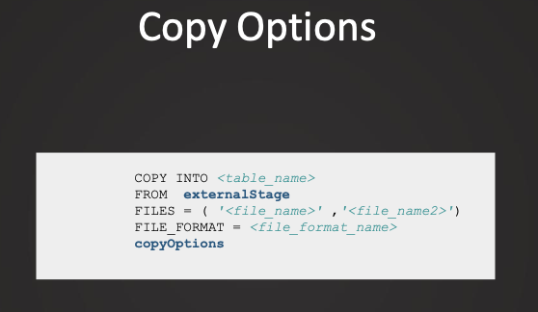

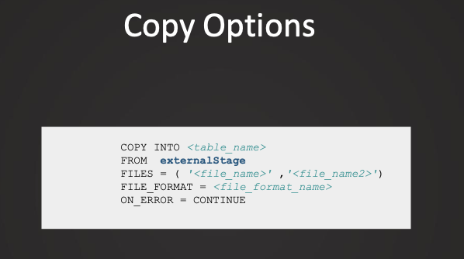

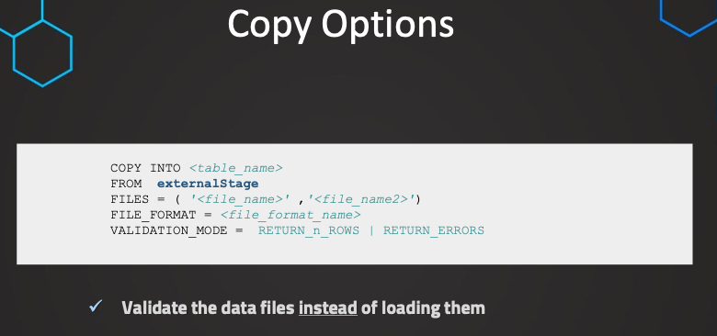

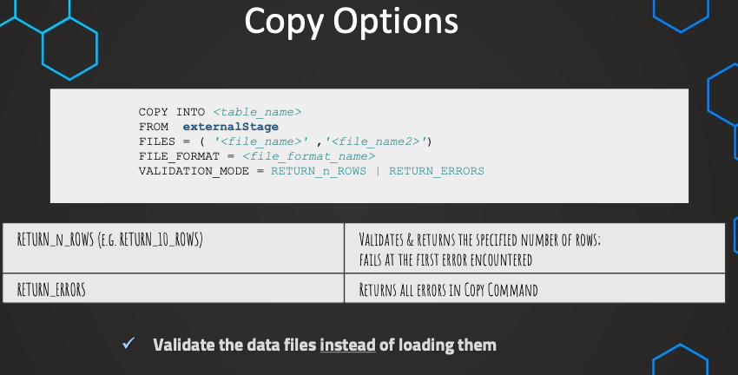

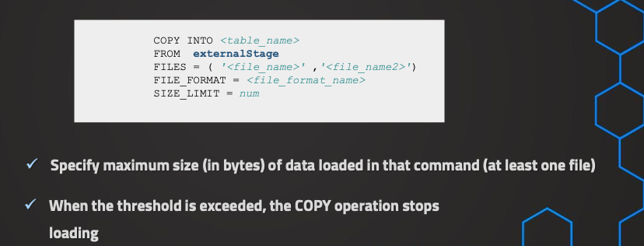

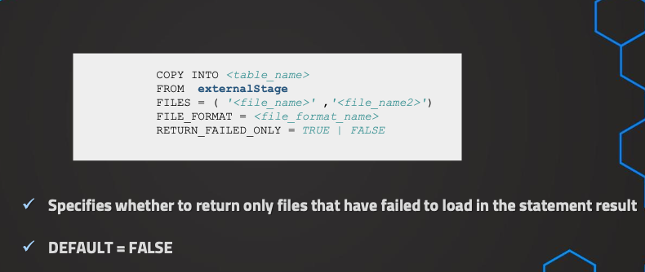

It works better

when used with ON_ERROR=continue

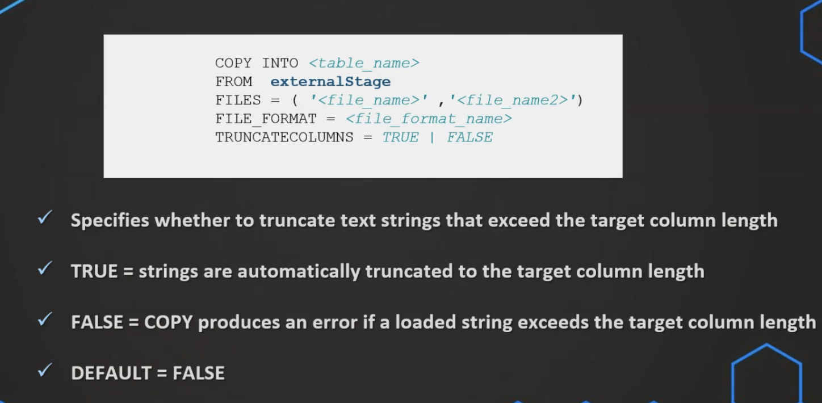

Like this we can specify whether a column or a value should be truncated or not. So if we have, for example, a table, and in this table we have a target column, with the type VARCHAR 10. That means only this column is allowing values up to 10 characters. But then if in the source, this character number is exceeded. So for example, we have a value of 12 characters, then this will be usually causing an error. But if we set this truncate columns option to true, then we can just truncate this text and then we just have these 10 characters and the rest will be just truncated.

But if we set this to true and we force that this will be loaded again, then anyways, this file, even though it has been loaded already

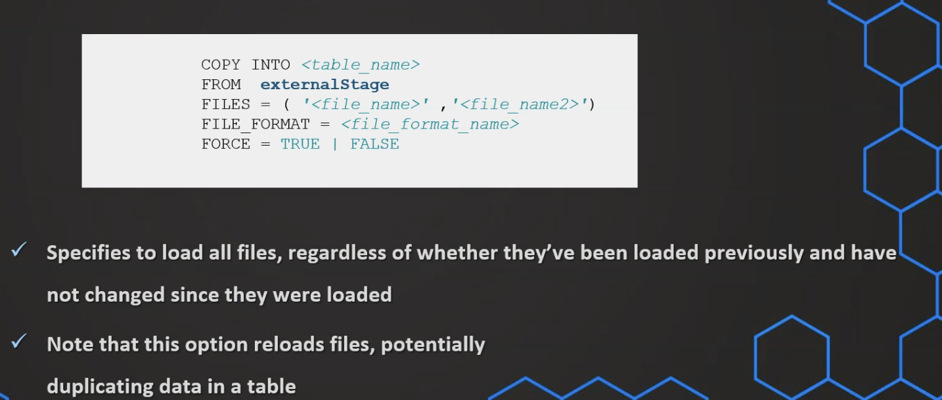

Load History:

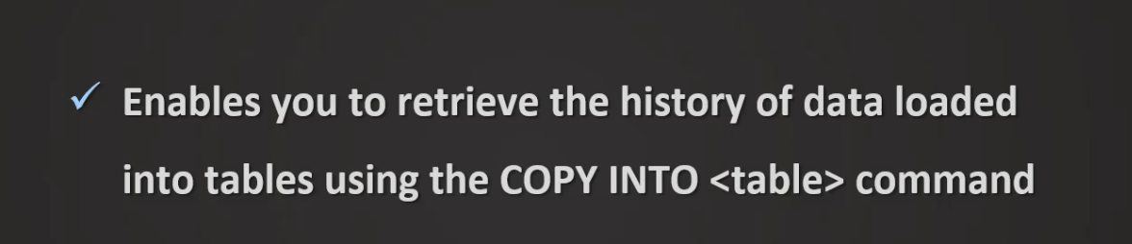

-- Query load history within a database --

USE COPY_DB;

SELECT * FROM information_schema.load_history

-- Query load history gloabally from SNOWFLAKE database --

SELECT * FROM snowflake.account_usage.load_history;

// Filter on specific table & schema

SELECT * FROM snowflake.account_usage.load_history

where schema_name='PUBLIC' and

table_name='ORDERS';

// Filter on specific table & schema

SELECT * FROM snowflake.account_usage.load_history

where schema_name='PUBLIC' and

table_name='ORDERS' and

error_count > 0;

// Filter on specific table & schema

SELECT * FROM snowflake.account_usage.load_history

WHERE DATE(LAST_LOAD_TIME) <= DATEADD(days,-1,CURRENT_DATE);

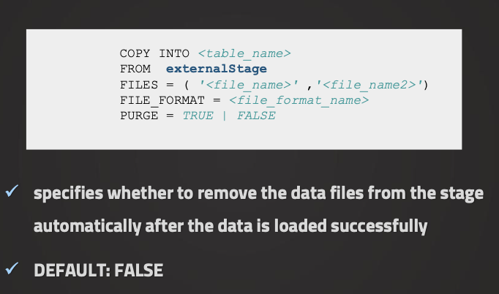

Loading Semi-Structured Data:

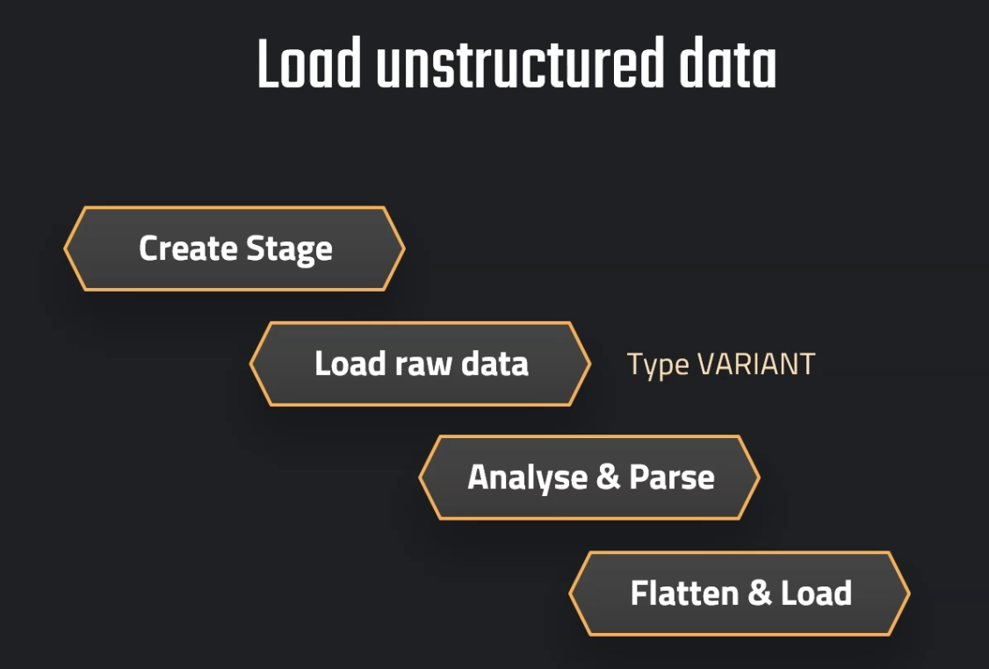

Instructor: If we are working with data, we are oftentimes confronted with unstructured or semi-structured data, as for example, JSON files or XML files. And luckily, Snowflake can handle this kind of data really well. So therefore, in this section, we will explore how we can work with unstructured and semi-structured data, as of course, this is something that's very important. So first of all, we want to have a look at the high-level steps that are involved for doing this or for loading this unstructured data, because there are multiple steps involved. And therefore, we want to have, first of all, a look at a high level of what are these steps before we are implementing all of those steps. So step number one is to create, of course, our stage object. This will establish the connection to our location where the file is located. So we have already seen this. The next step is to load the raw data into a separate table. So this will be a separate table. And this table actually has only one column. And this column is of a special data type, which is called the variant data type. So a very important data type that can handle all kinds of unstructured data. So this includes, of course, also JSON files. And the idea of this is that we don't need to be concerned with the structure of the data, as this is not so determined as if we would have a structured table or maybe a CSV file because then we know the structure, but it can be more flexible with the semi-structured data, as for example, JSON files. And therefore, in the beginning, we first use this variant data type which can deal with all of the structures more flexibly. And of course, afterwards, we need to then also pass the data. So once we have loaded this raw data into a table with this one column, we can now analyze it. And this means also that we can have functions to analyze and extract specific parts of this data. And it can be also hierarchical data. So therefore, we oftentimes also need to flatten the data. And we will also see how this works because here we also have some functions available in Snowflake that can help us with this here. And then, of course, after we have passed the data and flattened the data, we can now load it into our final table. And this is now a table with all of the columns, and it's in the way that we want to have it.

Load JSON File:

// First step: Load Raw JSON

CREATE OR REPLACE stage MANAGE_DB.EXTERNAL_STAGES.JSONSTAGE

url='s3://bucketsnowflake-jsondemo';

CREATE OR REPLACE file format MANAGE_DB.FILE_FORMATS.JSONFORMAT

TYPE = JSON;

CREATE OR REPLACE table OUR_FIRST_DB.PUBLIC.JSON_RAW (

raw_file variant);

COPY INTO OUR_FIRST_DB.PUBLIC.JSON_RAW

FROM @MANAGE_DB.EXTERNAL_STAGES.JSONSTAGE

file_format= MANAGE_DB.FILE_FORMATS.JSONFORMAT

files = ('HR_data.json');

SELECT * FROM OUR_FIRST_DB.PUBLIC.JSON_RAW;

Parse JSON:

// Second step: Parse & Analyse Raw JSON

// Selecting attribute/column

SELECT RAW_FILE:city FROM OUR_FIRST_DB.PUBLIC.JSON_RAW;

SELECT $1:first_name FROM OUR_FIRST_DB.PUBLIC.JSON_RAW;

// Selecting attribute/column - formattted

SELECT RAW_FILE:first_name::string as first_name FROM OUR_FIRST_DB.PUBLIC.JSON_RAW;

SELECT RAW_FILE:id::int as id FROM OUR_FIRST_DB.PUBLIC.JSON_RAW;

SELECT

RAW_FILE:id::int as id,

RAW_FILE:first_name::STRING as first_name,

RAW_FILE:last_name::STRING as last_name,

RAW_FILE:gender::STRING as gender

FROM OUR_FIRST_DB.PUBLIC.JSON_RAW;

// Handling nested data

SELECT RAW_FILE:job as job FROM OUR_FIRST_DB.PUBLIC.JSON_RAW;

Handle Nested Data:

SELECT

RAW_FILE:spoken_languages as spoken_languages

FROM OUR_FIRST_DB.PUBLIC.JSON_RAW;

SELECT * FROM OUR_FIRST_DB.PUBLIC.JSON_RAW;

SELECT

array_size(RAW_FILE:spoken_languages) as spoken_languages

FROM OUR_FIRST_DB.PUBLIC.JSON_RAW;

SELECT

RAW_FILE:first_name::STRING as first_name,

array_size(RAW_FILE:spoken_languages) as spoken_languages

FROM OUR_FIRST_DB.PUBLIC.JSON_RAW;

SELECT

RAW_FILE:spoken_languages[0] as First_language

FROM OUR_FIRST_DB.PUBLIC.JSON_RAW;

SELECT

RAW_FILE:first_name::STRING as first_name,

RAW_FILE:spoken_languages[0] as First_language

FROM OUR_FIRST_DB.PUBLIC.JSON_RAW;

SELECT

RAW_FILE:first_name::STRING as First_name,

RAW_FILE:spoken_languages[0].language::STRING as First_language,

RAW_FILE:spoken_languages[0].level::STRING as Level_spoken

FROM OUR_FIRST_DB.PUBLIC.JSON_RAW;

SELECT

RAW_FILE:id::int as id,

RAW_FILE:first_name::STRING as First_name,

RAW_FILE:spoken_languages[0].language::STRING as First_language,

RAW_FILE:spoken_languages[0].level::STRING as Level_spoken

FROM OUR_FIRST_DB.PUBLIC.JSON_RAW

UNION ALL

SELECT

RAW_FILE:id::int as id,

RAW_FILE:first_name::STRING as First_name,

RAW_FILE:spoken_languages[1].language::STRING as First_language,

RAW_FILE:spoken_languages[1].level::STRING as Level_spoken

FROM OUR_FIRST_DB.PUBLIC.JSON_RAW

UNION ALL

SELECT

RAW_FILE:id::int as id,

RAW_FILE:first_name::STRING as First_name,

RAW_FILE:spoken_languages[2].language::STRING as First_language,

RAW_FILE:spoken_languages[2].level::STRING as Level_spoken

FROM OUR_FIRST_DB.PUBLIC.JSON_RAW

ORDER BY ID;

select

RAW_FILE:first_name::STRING as First_name,

f.value:language::STRING as First_language,

f.value:level::STRING as Level_spoken

from OUR_FIRST_DB.PUBLIC.JSON_RAW, table(flatten(RAW_FILE:spoken_languages)) f;

// Option 1: CREATE TABLE AS

CREATE OR REPLACE TABLE Languages AS

select

RAW_FILE:first_name::STRING as First_name,

f.value:language::STRING as First_language,

f.value:level::STRING as Level_spoken

from OUR_FIRST_DB.PUBLIC.JSON_RAW, table(flatten(RAW_FILE:spoken_languages)) f;

SELECT * FROM Languages;

truncate table languages;

// Option 2: INSERT INTO

INSERT INTO Languages

select

RAW_FILE:first_name::STRING as First_name,

f.value:language::STRING as First_language,

f.value:level::STRING as Level_spoken

from OUR_FIRST_DB.PUBLIC.JSON_RAW, table(flatten(RAW_FILE:spoken_languages)) f;

SELECT * FROM Languages;

Read Parquet Data:

// Create file format and stage object

CREATE OR REPLACE FILE FORMAT MANAGE_DB.FILE_FORMATS.PARQUET_FORMAT

TYPE = 'parquet';

CREATE OR REPLACE STAGE MANAGE_DB.EXTERNAL_STAGES.PARQUETSTAGE

url = 's3://snowflakeparquetdemo'

FILE_FORMAT = MANAGE_DB.FILE_FORMATS.PARQUET_FORMAT;

// Preview the data

LIST @MANAGE_DB.EXTERNAL_STAGES.PARQUETSTAGE;

SELECT * FROM @MANAGE_DB.EXTERNAL_STAGES.PARQUETSTAGE;

// File format in Queries

CREATE OR REPLACE STAGE MANAGE_DB.EXTERNAL_STAGES.PARQUETSTAGE

url = 's3://snowflakeparquetdemo' ;

SELECT *

FROM @MANAGE_DB.EXTERNAL_STAGES.PARQUETSTAGE

(file_format => 'MANAGE_DB.FILE_FORMATS.PARQUET_FORMAT');

// Quotes can be omitted in case of the current namespace

USE MANAGE_DB.FILE_FORMATS;

SELECT *

FROM @MANAGE_DB.EXTERNAL_STAGES.PARQUETSTAGE

(file_format => MANAGE_DB.FILE_FORMATS.PARQUET_FORMAT);

CREATE OR REPLACE STAGE MANAGE_DB.EXTERNAL_STAGES.PARQUETSTAGE

url = 's3://snowflakeparquetdemo'

FILE_FORMAT = MANAGE_DB.FILE_FORMATS.PARQUET_FORMAT;

// Syntax for Querying unstructured data

SELECT

$1:__index_level_0__,

$1:cat_id,

$1:date,

$1:"__index_level_0__",

$1:"cat_id",

$1:"d",

$1:"date",

$1:"dept_id",

$1:"id",

$1:"item_id",

$1:"state_id",

$1:"store_id",

$1:"value"

FROM @MANAGE_DB.EXTERNAL_STAGES.PARQUETSTAGE;

// Date conversion

SELECT 1;

SELECT DATE(365*60*60*24);

// Querying with conversions and aliases

SELECT

$1:__index_level_0__::int as index_level,

$1:cat_id::VARCHAR(50) as category,

DATE($1:date::int ) as Date,

$1:"dept_id"::VARCHAR(50) as Dept_ID,

$1:"id"::VARCHAR(50) as ID,

$1:"item_id"::VARCHAR(50) as Item_ID,

$1:"state_id"::VARCHAR(50) as State_ID,

$1:"store_id"::VARCHAR(50) as Store_ID,

$1:"value"::int as value

FROM @MANAGE_DB.EXTERNAL_STAGES.PARQUETSTAGE;

// Adding metadata

SELECT

$1:__index_level_0__::int as index_level,

$1:cat_id::VARCHAR(50) as category,

DATE($1:date::int ) as Date,

$1:"dept_id"::VARCHAR(50) as Dept_ID,

$1:"id"::VARCHAR(50) as ID,

$1:"item_id"::VARCHAR(50) as Item_ID,

$1:"state_id"::VARCHAR(50) as State_ID,

$1:"store_id"::VARCHAR(50) as Store_ID,

$1:"value"::int as value,

METADATA$FILENAME as FILENAME,

METADATA$FILE_ROW_NUMBER as ROWNUMBER,

TO_TIMESTAMP_NTZ(current_timestamp) as LOAD_DATE

FROM @MANAGE_DB.EXTERNAL_STAGES.PARQUETSTAGE;

SELECT TO_TIMESTAMP_NTZ(current_timestamp);

// Create destination table

CREATE OR REPLACE TABLE OUR_FIRST_DB.PUBLIC.PARQUET_DATA (

ROW_NUMBER int,

index_level int,

cat_id VARCHAR(50),

date date,

dept_id VARCHAR(50),

id VARCHAR(50),

item_id VARCHAR(50),

state_id VARCHAR(50),

store_id VARCHAR(50),

value int,

Load_date timestamp default TO_TIMESTAMP_NTZ(current_timestamp));

// Load the parquet data

COPY INTO OUR_FIRST_DB.PUBLIC.PARQUET_DATA

FROM (SELECT

METADATA$FILE_ROW_NUMBER,

$1:__index_level_0__::int,

$1:cat_id::VARCHAR(50),

DATE($1:date::int ),

$1:"dept_id"::VARCHAR(50),

$1:"id"::VARCHAR(50),

$1:"item_id"::VARCHAR(50),

$1:"state_id"::VARCHAR(50),

$1:"store_id"::VARCHAR(50),

$1:"value"::int,

TO_TIMESTAMP_NTZ(current_timestamp)

FROM @MANAGE_DB.EXTERNAL_STAGES.PARQUETSTAGE);

SELECT * FROM OUR_FIRST_DB.PUBLIC.PARQUET_DATA;

Performance Optimization:

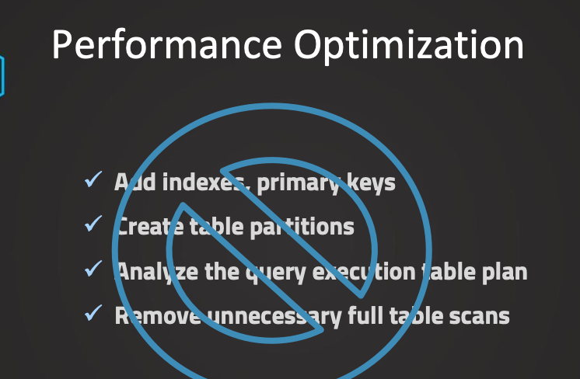

Performance Optimization is important because it helps our queries to run faster and in turn, it will therefore also help us to save cost because we are paying for the compute power that we use. We get not only faster queries, but with that we can also then directly save cost. So therefore, this is a very important topic for those two reasons. However, in Snowflake, things are a little bit different than in the classical way of what we will do when we want to optimize the performance in a data warehouse. So first of all, traditionally, this is what we would do in regards to improving the performance. So these are some of the things. We could add indexes and primary keys. We could include or introduce additional table partitions, and also we could remove unnecessary full table scans specifically with those larger tables. For example, by having those table partitions. And also we could analyze, of course, the query execution plan and try to optimize things in here. However, like I said, in Snowflake, many of these tasks are actually managed for us. So this is very good because, here, we don't need to do this. So Snowflake uses here automatically managed micro-partitions to ensure the performance is good when we are running our queries. So this means we don't have to manually handle many of those optimization techniques, but this is managed for us. So first of all, we can create a dedicated warehouse for specific user groups. For example, if we have one user group that has much different needs and different types of queries, different data, it can make sense to, of course, introduce a dedicated warehouse for each of those groups. Because if the workload is very different, then maybe one needs a much larger warehouse while the other one needs a much smaller one. So like this, we don't have oversized or undersized virtual warehouses, so we should separate the workloads like this with dedicated warehouses. This can make a lot of sense. Additionally, of course, we can scale our warehouses, so we can scale it up or down. For example, if we anticipate higher workloads at certain times, we can increase the size of the warehouse. So this is what we call scaling up. And this can be useful when we have more complex queries. For example, in this case, we can scale it up or just if we know the patterns of our workload, so maybe we have specific times where we expect maybe an ETL process or something to happen, then we can just scale it up. An alternative to this is to use a multi-cluster warehouse. So this is using scaling out. So instead of increasing the size, we can introduce those multi-cluster warehouses, which allow us to dynamically scale it based on the workload. So here, we can basically create additional warehouse clusters so we don't increase the size, but we create additional clusters in a given multi-cluster warehouse and they will all have the same size. So this is much more dynamic. So therefore, this is more helpful if we don't know the workload pattern. So this is maybe varying also stronger in different times. And this is also specifically useful for more concurrent users or more queries because, for example, when we have some peak hours, we have more users coming in, then it is efficient to scale out. This is more efficient actually than scaling up when we have more concurrent users or when the, yeah, just number of queries increases. While scaling up can be more efficient when the workload gets more, yeah, complex. So the workload itself is the queries, they get more complex, then scaling up can be more useful. Of course, Snowflake, as we have mentioned, has also automatic scaling. While this is managed by Snowflake, we can still try to maximize the benefits by our design and by our usage patterns. So therefore, it is also useful to understand the caching mechanism, how this works, and how we can maximize this. Additionally, we also have the cluster keys. So they are especially useful for larger tables because they help improve the query performance by optimizing how exactly the data is accessed so we can optimize the data access. And therefore we also want to talk a little bit and understand those cluster keys that are useful specifically for larger tables. All right? So these are the main aspects of the performance optimization. And in the following lectures, we will now go over each of those aspects in more detail. And of course, we will have a closer look at them and see also how we can implement them to optimize the performance in Snowflake.

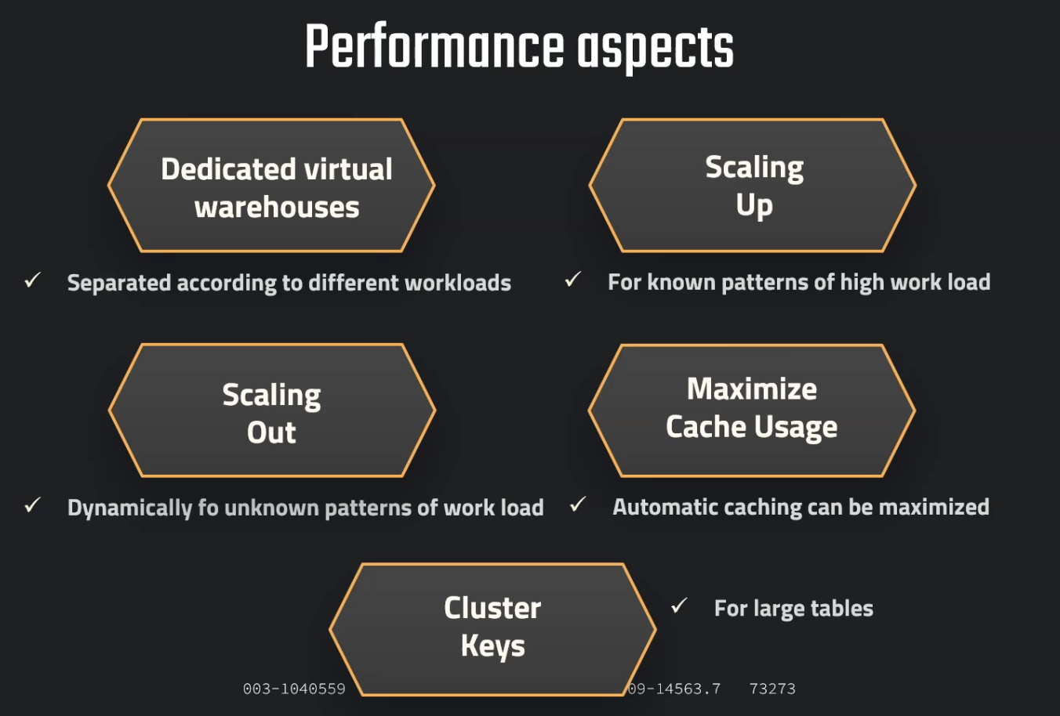

Dedicated Warehouse:

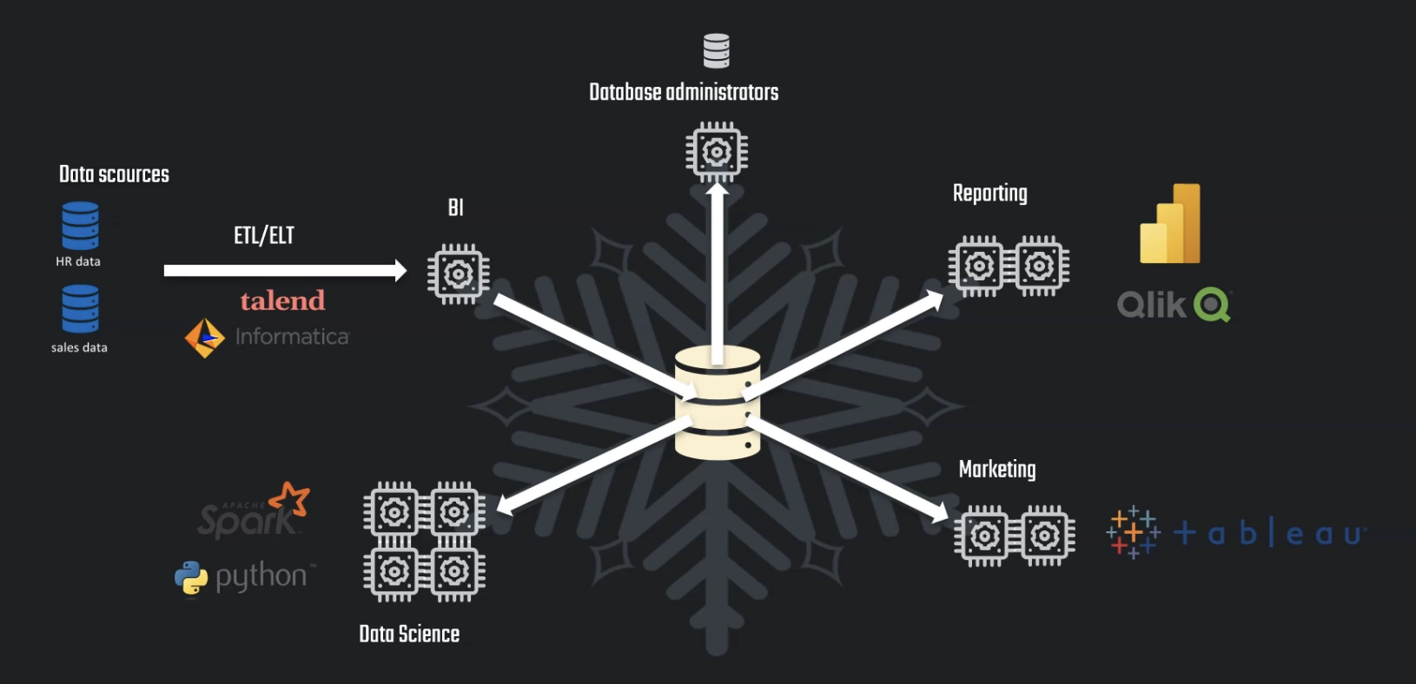

Here each team requires different amount of resources So therefore it can make sense, of course, to just have dedicated warehouses for different user groups. So this is then only accessible by their specific team or this specific application. And like this, it can be beneficial to have the right size and the right type of our warehouse. So this is what we want to focus on.

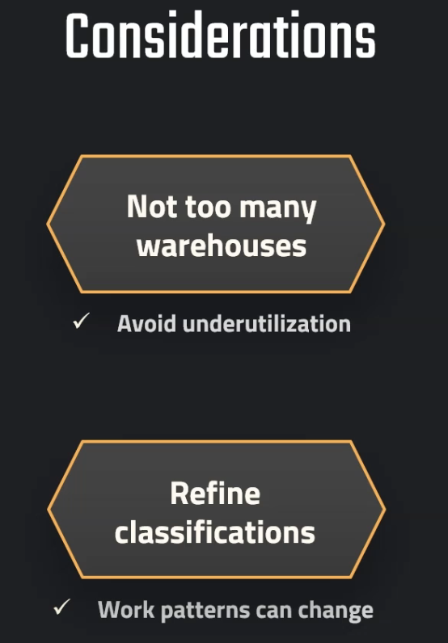

Scaling Up/Down:

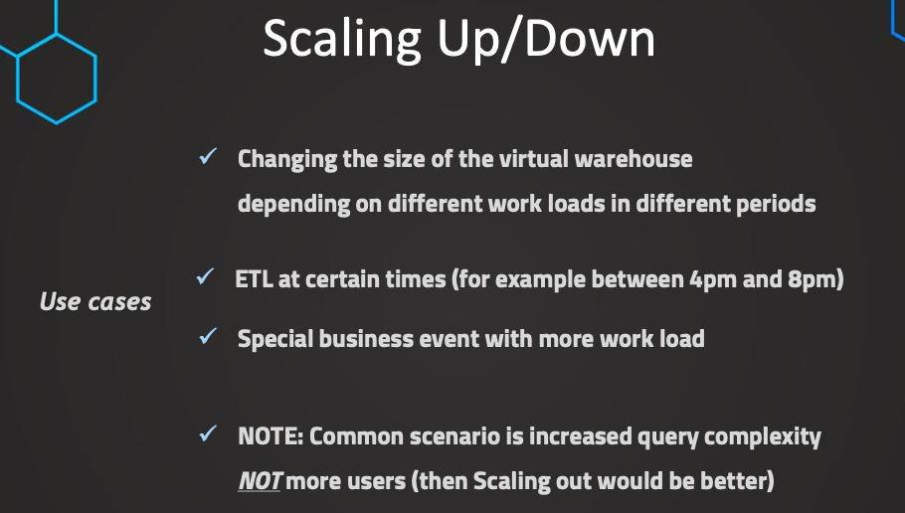

So this is what we refer to as scaling up or scaling down, depending on whether we increase or decrease the size of existing warehouse

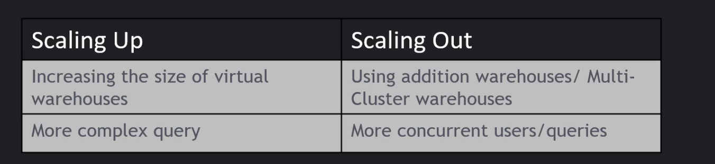

Scale Out:

however, scaling up might not help with more basic queries or in general, performance issues that are caused by a large number of concurrent users or concurrent queries. And in this case, it is scaling out that can be more beneficial.

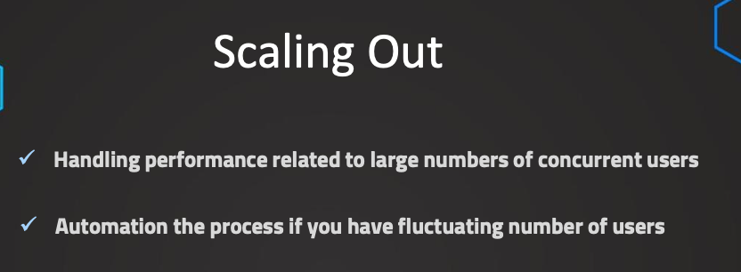

Caching:

So caching is an automatically enabled process that is designed to speed up the execution of query results by using the results from the cache. we don't need to reprocess the query again, but we will just use the results of the queries again that are stored in cache. First of all, this is an automated process and this works in the way that when a query is executed, the result the cached. Cached results are of course not stored indefinitely, but they are cached for 24 hours or until the underlying data changes. So of course, if the table some data is changing there, then the result can not be reused, but it will just execute the query again from fresh. So like this, we can make sure that we always get of course accurate results and that we don't get some wrong results from this process. So Snowflake here is very efficient actually in understanding the metadata, so like this ensured that the cached results are used only when they are actually valid. And also we have mentioned that caching is automatically managed by Snowflake. So this means that we don't have to bother with it and this is just simplified for us, but since this is automated, we might wonder what can we actually do in regards to optimize this. So caching in Snowflake is an automated process, but it can improve the performance and what we can do, is we can try to maximize this by ensuring that we run similar queries on the same warehouse.

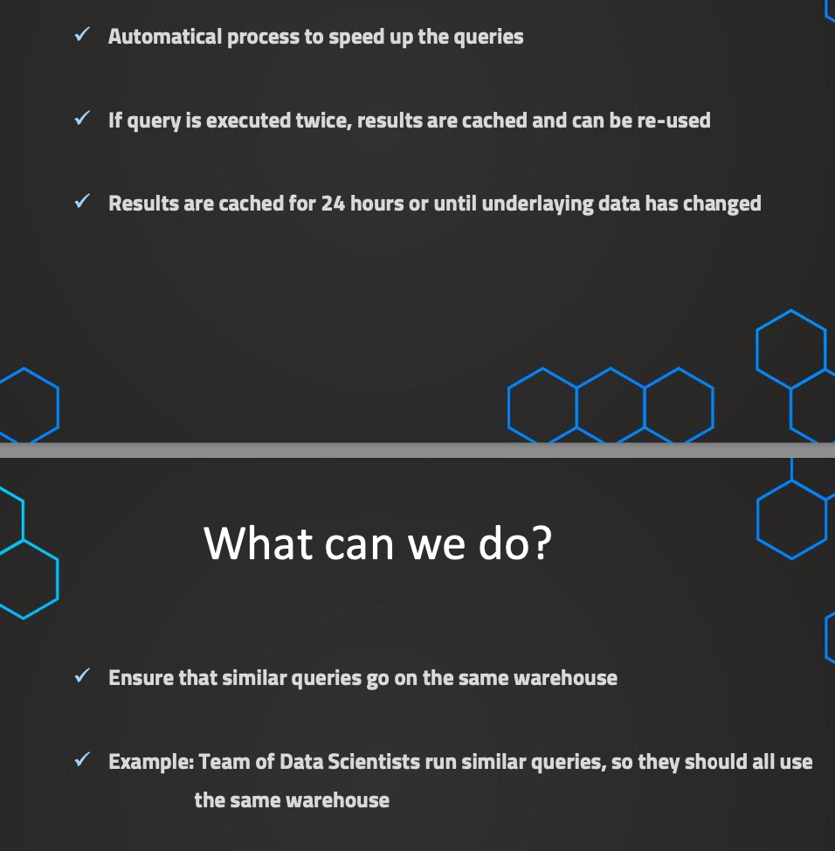

As long as we are in same warehouse it will be cached even with different users, only if we run query on different warehouse then it needs to be cached again

Clustering:

So, Snowflake creates those cluster keys on certain columns. But the idea is, based on this column, create subsets of rows. And they are then stored in, so-called, micro-partitions. So this helps to avoid full table scans because these full table scans is what usually is causing most of the time in the query.

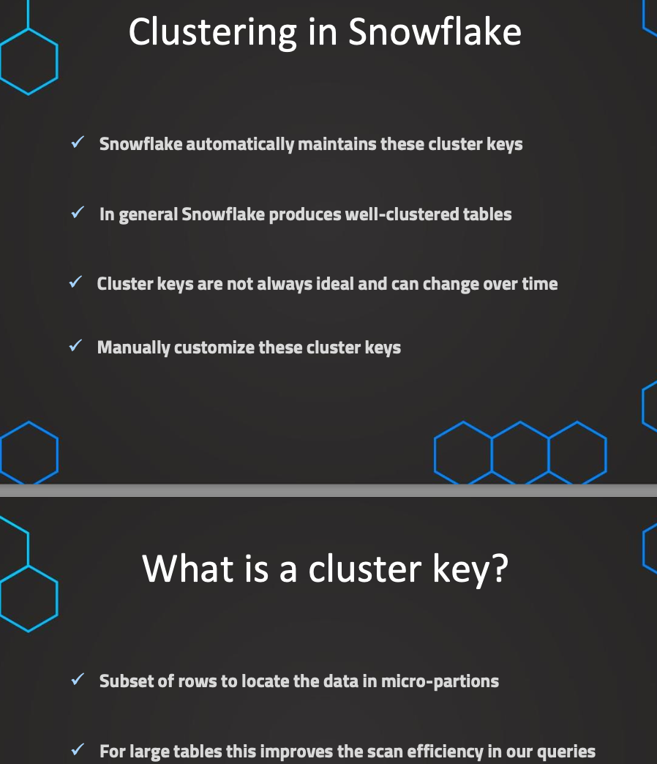

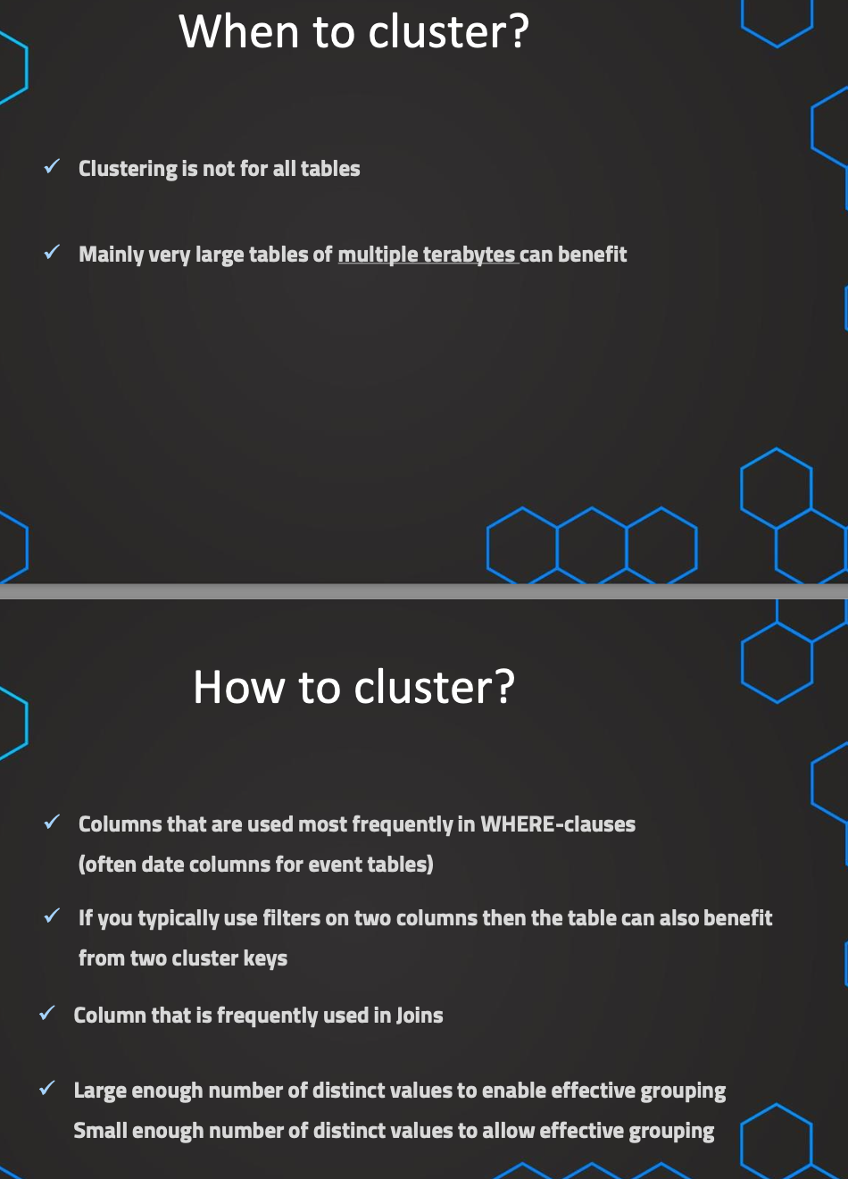

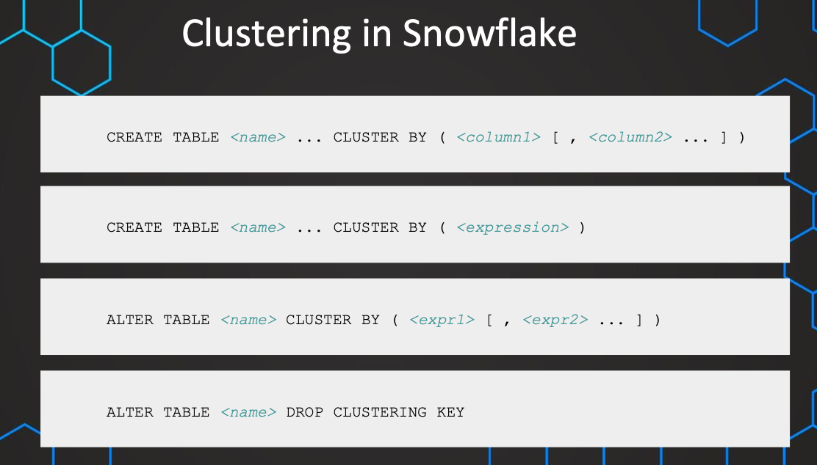

**What is Clustering in Snowflake?**

**Clustering in Snowflake** refers to the process of organizing and storing data in a way that improves query performance by physically sorting the data on disk according to a specified set of columns, known as **clustering keys**. While Snowflake automatically manages data storage in **micro-partitions** behind the scenes, clustering helps to enhance performance for large tables by reducing the amount of data scanned during query execution.

**Key Concepts:**

1. **Micro-partitions**:
   * Snowflake stores data in **micro-partitions**, which are immutable, compressed, and internal structures that store columnar data in storage.
   * Each micro-partition typically contains a **range of data** values for each column.
   * Clustering helps optimize the physical layout of the data within these micro-partitions by clustering the data based on the columns you specify.
2. **Clustering Keys**:
   * A **clustering key** is a set of one or more columns used to group the data in the underlying micro-partitions.
   * When you define a clustering key, Snowflake tries to organize data in such a way that similar values for the key are physically stored together in the same micro-partition or near each other.
   * This helps Snowflake skip irrelevant partitions when queries filter on the clustering columns, reducing query execution time.

**How Clustering Works:**

* **Automatic vs. Manual Clustering**:
  + **Automatic clustering**: By default, Snowflake handles clustering of data using micro-partitions automatically. This means Snowflake organizes the data in the most efficient way for querying, but it does not allow you to define the clustering key.
  + **Manual clustering**: If your queries often filter on specific columns (like date, region, or product_id), you can define one or more **clustering keys** for a table. Snowflake will then try to organize the data based on these columns to speed up query processing.

**Clustering and Query Performance:**

* **Performance Improvements**: When you query large tables, especially with range filters (e.g., WHERE date BETWEEN ...), Snowflake can skip unnecessary micro-partitions that don't meet the filter criteria. This is especially useful for large datasets where full table scans would be inefficient.
* **Minimized Data Scanning**: By clustering data on frequently filtered columns, Snowflake can minimize the number of micro-partitions it needs to scan, leading to significant query performance improvements.

// Publicly accessible staging area

CREATE OR REPLACE STAGE MANAGE_DB.external_stages.aws_stage

url='s3://bucketsnowflakes3';

// List files in stage

LIST @MANAGE_DB.external_stages.aws_stage;

//Load data using copy command

COPY INTO OUR_FIRST_DB.PUBLIC.ORDERS

FROM @MANAGE_DB.external_stages.aws_stage

file_format= (type = csv field_delimiter=',' skip_header=1)

pattern='.*OrderDetails.*';

// Create table

CREATE OR REPLACE TABLE ORDERS_CACHING (

ORDER_ID VARCHAR(30)

,AMOUNT NUMBER(38,0)

,PROFIT NUMBER(38,0)

,QUANTITY NUMBER(38,0)

,CATEGORY VARCHAR(30)

,SUBCATEGORY VARCHAR(30)

,DATE DATE) ;

INSERT INTO ORDERS_CACHING

SELECT

t1.ORDER_ID

,t1.AMOUNT

,t1.PROFIT

,t1.QUANTITY

,t1.CATEGORY

,t1.SUBCATEGORY

,DATE(UNIFORM(1500000000,1700000000,(RANDOM())))

FROM ORDERS t1

CROSS JOIN (SELECT * FROM ORDERS) t2

CROSS JOIN (SELECT TOP 100 * FROM ORDERS) t3;

// Query Performance before Cluster Key

SELECT * FROM ORDERS_CACHING WHERE DATE = '2020-06-09';

// Adding Cluster Key & Compare the result

ALTER TABLE ORDERS_CACHING CLUSTER BY ( DATE ) ;

SELECT * FROM ORDERS_CACHING WHERE DATE = '2020-01-05';

// Not ideal clustering & adding a different Cluster Key using function

SELECT * FROM ORDERS_CACHING WHERE MONTH(DATE)=11;

ALTER TABLE ORDERS_CACHING CLUSTER BY ( MONTH(DATE) );

AWS Integration with Snowflake:

// Create storage integration object

create or replace storage integration s3_int

TYPE = EXTERNAL_STAGE

STORAGE_PROVIDER = S3

ENABLED = TRUE

STORAGE_AWS_ROLE_ARN = ''

STORAGE_ALLOWED_LOCATIONS = ('s3://<your-bucket-name>/<your-path>/', 's3://<your-bucket-name>/<your-path>/')

COMMENT = 'This an optional comment' ;

// See storage integration properties to fetch external_id so we can update it in S3

DESC integration s3_int;

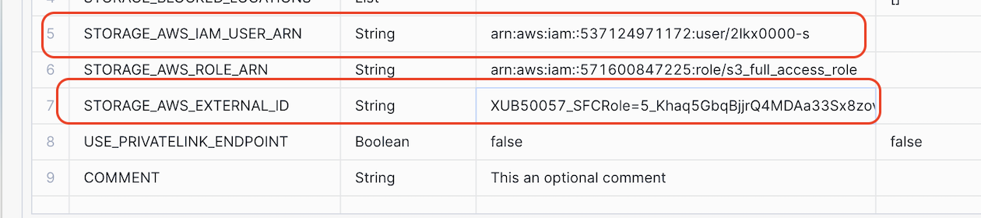

Copy these 2 values and paste it in trustpolicy

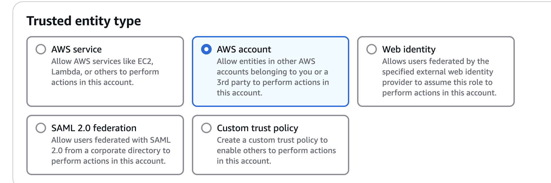

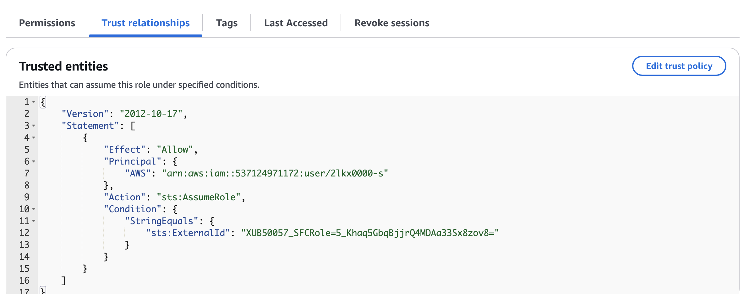

null_if = ('NULL','null') -> means if any column has this text it will be set to actual null

empty_field_as_null = TRUE -> if these is empty field it will be set to null

FIELD_OPTIONALLY_ENCLOSED_BY -> if column value looks like this “Atul, b, 23” then we should set FIELD_OPTIONALLY_ENCLOSED_BY = '"' so that it is considered as one field

// Create table first

CREATE OR REPLACE TABLE OUR_FIRST_DB.PUBLIC.movie_titles (

show_id STRING,

type STRING,

title STRING,

director STRING,

cast STRING,

country STRING,

date_added STRING,

release_year STRING,

rating STRING,

duration STRING,

listed_in STRING,

description STRING )

// Create file format object

CREATE OR REPLACE file format MANAGE_DB.file_formats.csv_fileformat

type = csv

field_delimiter = ','

skip_header = 1

null_if = ('NULL','null')

empty_field_as_null = TRUE;

// Create stage object with integration object & file format object

CREATE OR REPLACE stage MANAGE_DB.external_stages.csv_folder

URL = 's3://atullutasnow/csv/'

STORAGE_INTEGRATION = s3_int

FILE_FORMAT = MANAGE_DB.file_formats.csv_fileformat

// Use Copy command

COPY INTO OUR_FIRST_DB.PUBLIC.movie_titles

FROM @MANAGE_DB.external_stages.csv_folder

select * from OUR_FIRST_DB.PUBLIC.movie_titles;

// Create file format object

CREATE OR REPLACE file format MANAGE_DB.file_formats.csv_fileformat

type = csv

field_delimiter = ','

skip_header = 1

null_if = ('NULL','null')

empty_field_as_null = TRUE

FIELD_OPTIONALLY_ENCLOSED_BY = '"'

SELECT * FROM OUR_FIRST_DB.PUBLIC.movie_titles

JSON Ingestion:

// Taming the JSON file

// First query from S3 Bucket

SELECT * FROM @MANAGE_DB.external_stages.json_folder;

create or replace file format manage_db.file_formats.json_fileformat type=JSON;

CREATE OR REPLACE stage MANAGE_DB.external_stages.json_folder

URL = 's3://atullutasnow/json/'

STORAGE_INTEGRATION = s3_int

FILE_FORMAT = MANAGE_DB.file_formats.json_fileformat

// Introduce columns

SELECT

$1:asin,

$1:helpful,

$1:overall,

$1:reviewText,

$1:reviewTime,

$1:reviewerID,

$1:reviewTime,

$1:reviewerName,

$1:summary,

$1:unixReviewTime

FROM @MANAGE_DB.external_stages.json_folder;

// Format columns & use DATE function

SELECT

$1:asin::STRING as ASIN,

$1:helpful as helpful,

$1:overall as overall,

$1:reviewText::STRING as reviewtext,

$1:reviewTime::STRING,

$1:reviewerID::STRING,

$1:reviewTime::STRING,

$1:reviewerName::STRING,

$1:summary::STRING,

DATE($1:unixReviewTime::int) as Revewtime

FROM @MANAGE_DB.external_stages.json_folder;

// Format columns & handle custom date

SELECT

$1:asin::STRING as ASIN,

$1:helpful as helpful,

$1:overall as overall,

$1:reviewText::STRING as reviewtext,

DATE_FROM_PARTS( <year>, <month>, <day> )

$1:reviewTime::STRING,

$1:reviewerID::STRING,

$1:reviewTime::STRING,

$1:reviewerName::STRING,

$1:summary::STRING,

DATE($1:unixReviewTime::int) as Revewtime

FROM @MANAGE_DB.external_stages.json_folder;

// Use DATE_FROM_PARTS and see another difficulty

SELECT

$1:asin::STRING as ASIN,

$1:helpful as helpful,

$1:overall as overall,

$1:reviewText::STRING as reviewtext,

DATE_FROM_PARTS( RIGHT($1:reviewTime::STRING,4), LEFT($1:reviewTime::STRING,2), SUBSTRING($1:reviewTime::STRING,4,2) ),

$1:reviewerID::STRING,

$1:reviewTime::STRING,

$1:reviewerName::STRING,

$1:summary::STRING,

DATE($1:unixReviewTime::int) as unixRevewtime

FROM @MANAGE_DB.external_stages.json_folder;

// Use DATE_FROM_PARTS and handle the case difficulty

SELECT

$1:asin::STRING as ASIN,

$1:helpful as helpful,

$1:overall as overall,

$1:reviewText::STRING as reviewtext,

DATE_FROM_PARTS(

RIGHT($1:reviewTime::STRING,4),

LEFT($1:reviewTime::STRING,2),

CASE WHEN SUBSTRING($1:reviewTime::STRING,5,1)=','

THEN SUBSTRING($1:reviewTime::STRING,4,1) ELSE SUBSTRING($1:reviewTime::STRING,4,2) END),

$1:reviewerID::STRING,

$1:reviewTime::STRING,

$1:reviewerName::STRING,

$1:summary::STRING,

DATE($1:unixReviewTime::int) as UnixRevewtime

FROM @MANAGE_DB.external_stages.json_folder;

// Create destination table

CREATE OR REPLACE TABLE OUR_FIRST_DB.PUBLIC.reviews (

asin STRING,

helpful STRING,

overall STRING,

reviewtext STRING,

reviewtime DATE,

reviewerid STRING,

reviewername STRING,

summary STRING,

unixreviewtime DATE

);

// Copy transformed data into destination table

COPY INTO OUR_FIRST_DB.PUBLIC.reviews

FROM (SELECT

$1:asin::STRING as ASIN,

$1:helpful as helpful,

$1:overall as overall,

$1:reviewText::STRING as reviewtext,

DATE_FROM_PARTS(

RIGHT($1:reviewTime::STRING,4),

LEFT($1:reviewTime::STRING,2),

CASE WHEN SUBSTRING($1:reviewTime::STRING,5,1)=','

THEN SUBSTRING($1:reviewTime::STRING,4,1) ELSE SUBSTRING($1:reviewTime::STRING,4,2) END),

$1:reviewerID::STRING,

$1:reviewerName::STRING,

$1:summary::STRING,

DATE($1:unixReviewTime::int) Revewtime

FROM @MANAGE_DB.external_stages.json_folder);

// Validate results

SELECT * FROM OUR_FIRST_DB.PUBLIC.reviews ;

Ingest from Azure:

create DATABASE DEMO_DB;

USE DATABASE DEMO_DB;

-- create integration object that contains the access information

CREATE STORAGE INTEGRATION azure_integration

TYPE = EXTERNAL_STAGE

STORAGE_PROVIDER = AZURE

ENABLED = TRUE

AZURE_TENANT_ID = '8930685a-50b2-43ae-8df8-8edef3eb35fa'

STORAGE_ALLOWED_LOCATIONS = ('azure://atullutasa.blob.core.windows.net/csv', 'azure://atullutasa.blob.core.windows.net/json');

-- Describe integration object to provide access

DESC STORAGE integration azure_integration;

---- Create file format & stage objects ----

-- create file format

create or replace file format demo_db.public.fileformat_azure

TYPE = CSV

FIELD_DELIMITER = ','

SKIP_HEADER = 1;

-- create stage object

create or replace stage demo_db.public.stage_azure

STORAGE_INTEGRATION = azure_integration

URL = 'azure://storageaccountsnow.blob.core.windows.net/snowflakecsv'

FILE_FORMAT = fileformat_azure;

-- list files

LIST @demo_db.public.stage_azure;

Load CSV DATA:

---- Query files & Load data ----

--query files

SELECT

$1,

$2,

$3,

$4,

$5,

$6,

$7,

$8,

$9,

$10,

$11,

$12,

$13,

$14,

$15,

$16,

$17,

$18,

$19,

$20

FROM @demo_db.public.stage_azure;

create or replace table happiness (

country_name varchar,

regional_indicator varchar,

ladder_score number(4,3),

standard_error number(4,3),

upperwhisker number(4,3),

lowerwhisker number(4,3),

logged_gdp number(5,3),

social_support number(4,3),

healthy_life_expectancy number(5,3),

freedom_to_make_life_choices number(4,3),

generosity number(4,3),

perceptions_of_corruption number(4,3),

ladder_score_in_dystopia number(4,3),

explained_by_log_gpd_per_capita number(4,3),

explained_by_social_support number(4,3),

explained_by_healthy_life_expectancy number(4,3),

explained_by_freedom_to_make_life_choices number(4,3),

explained_by_generosity number(4,3),

explained_by_perceptions_of_corruption number(4,3),

dystopia_residual number (4,3));

COPY INTO HAPPINESS

FROM @demo_db.public.stage_azure;

SELECT * FROM HAPPINESS;

--- Load JSON ----

create or replace file format demo_db.public.fileformat_azure_json

TYPE = JSON;

create or replace stage demo_db.public.stage_azure

STORAGE_INTEGRATION = azure_integration

URL = 'azure://atullutasa.blob.core.windows.net/json'

FILE_FORMAT = fileformat_azure_json;

LIST @demo_db.public.stage_azure;

-- Query from stage

SELECT * FROM @demo_db.public.stage_azure;

-- Query one attribute/column

SELECT $1:"Car Model" FROM @demo_db.public.stage_azure;

-- Convert data type

SELECT $1:"Car Model"::STRING FROM @demo_db.public.stage_azure;

-- Query all attributes

SELECT

$1:"Car Model"::STRING,

$1:"Car Model Year"::INT,

$1:"car make"::STRING,

$1:"first_name"::STRING,

$1:"last_name"::STRING

FROM @demo_db.public.stage_azure;

-- Query all attributes and use aliases

SELECT

$1:"Car Model"::STRING as car_model,

$1:"Car Model Year"::INT as car_model_year,

$1:"car make"::STRING as "car make",

$1:"first_name"::STRING as first_name,

$1:"last_name"::STRING as last_name

FROM @demo_db.public.stage_azure;

Create or replace table car_owner (

car_model varchar,

car_model_year int,

car_make varchar,

first_name varchar,

last_name varchar);

COPY INTO car_owner

FROM

(SELECT

$1:"Car Model"::STRING as car_model,

$1:"Car Model Year"::INT as car_model_year,

$1:"car make"::STRING as "car make",

$1:"first_name"::STRING as first_name,

$1:"last_name"::STRING as last_name

FROM @demo_db.public.stage_azure);

SELECT * FROM CAR_OWNER;

-- Alternative: Using a raw file table step

truncate table car_owner;

select * from car_owner;

create or replace table car_owner_raw (

raw variant);

COPY INTO car_owner_raw

FROM @demo_db.public.stage_azure;

SELECT * FROM car_owner_raw;

INSERT INTO car_owner

(SELECT

$1:"Car Model"::STRING as car_model,

$1:"Car Model Year"::INT as car_model_year,

$1:"car make"::STRING as car_make,

$1:"first_name"::STRING as first_name,

$1:"last_name"::STRING as last_name

FROM car_owner_raw) ;

select * from car_owner;

For Azure when you describe storage integration you will see azure login url and u need to login with same account as portal login and then storage account IAM, need to add the role with that user

GCP Ingestion:

-- create integration object that contains the access information

CREATE STORAGE INTEGRATION gcp_integration

TYPE = EXTERNAL_STAGE

STORAGE_PROVIDER = GCS

ENABLED = TRUE

STORAGE_ALLOWED_LOCATIONS = ('gcs://atullutasf/csv', 'gcs://atullutasf/json');

-- Describe integration object to provide access

DESC STORAGE integration gcp_integration;

When you run describe integration, you will get service account and that account should be added permission in GCS

-- create file format

create or replace file format demo_db.public.fileformat_gcp

TYPE = CSV

FIELD_DELIMITER = ','

SKIP_HEADER = 1;

-- create stage object

create or replace stage demo_db.public.stage_gcp

STORAGE_INTEGRATION = gcp_integration

URL = 'gcs://atullutasf/csv'

FILE_FORMAT = fileformat_gcp;

LIST @demo_db.public.stage_gcp;

---- Query files & Load data ----

--query files

SELECT

$1,$2,$3,$4,$5,$6,$7,$8,$9,$10,$11,

$12,$13,$14,$15,$16,$17,$18,$19,$20

FROM @demo_db.public.stage_gcp;

create or replace table happiness (

country_name varchar,

regional_indicator varchar,

ladder_score number(4,3),

standard_error number(4,3),

upperwhisker number(4,3),

lowerwhisker number(4,3),

logged_gdp number(5,3),

social_support number(4,3),

healthy_life_expectancy number(5,3),

freedom_to_make_life_choices number(4,3),

generosity number(4,3),

perceptions_of_corruption number(4,3),

ladder_score_in_dystopia number(4,3),

explained_by_log_gpd_per_capita number(4,3),

explained_by_social_support number(4,3),

explained_by_healthy_life_expectancy number(4,3),

explained_by_freedom_to_make_life_choices number(4,3),

explained_by_generosity number(4,3),

explained_by_perceptions_of_corruption number(4,3),

dystopia_residual number (4,3));

COPY INTO HAPPINESS

FROM @demo_db.public.stage_gcp;

SELECT * FROM HAPPINESS;

------- Unload data -----

USE ROLE ACCOUNTADMIN;

USE DATABASE DEMO_DB;

-- create integration object that contains the access information

CREATE STORAGE INTEGRATION gcp_integration

TYPE = EXTERNAL_STAGE

STORAGE_PROVIDER = GCS

ENABLED = TRUE

STORAGE_ALLOWED_LOCATIONS = ('gcs://snowflakebucketgcp', 'gcs://snowflakebucketgcpjson');

-- create file format

create or replace file format demo_db.public.fileformat_gcp

TYPE = CSV

FIELD_DELIMITER = ','

SKIP_HEADER = 1;

-- create stage object

create or replace stage demo_db.public.stage_gcp

STORAGE_INTEGRATION = gcp_integration

URL = 'gcs://snowflakebucketgcp/csv_happiness'

FILE_FORMAT = fileformat_gcp;

ALTER STORAGE INTEGRATION gcp_integration

SET storage_allowed_locations=('gcs://snowflakebucketgcp', 'gcs://snowflakebucketgcpjson');

SELECT * FROM HAPPINESS;

COPY INTO @stage_gcp

FROM

HAPPINESS;

Snowpipe:

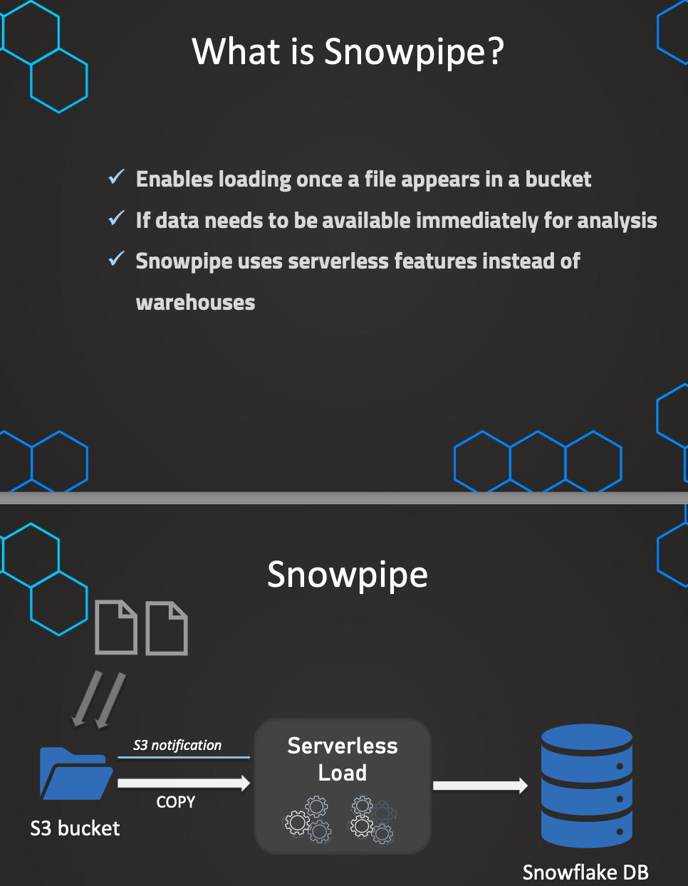

So, Snowpipe basically enables automatically loading data once a file appears in a given bucket. once a file appears in a given bucket. So automatically, when a new file is added to that bucket, we can automatically don't have to do anything but automatically, this file is loaded into the given table.

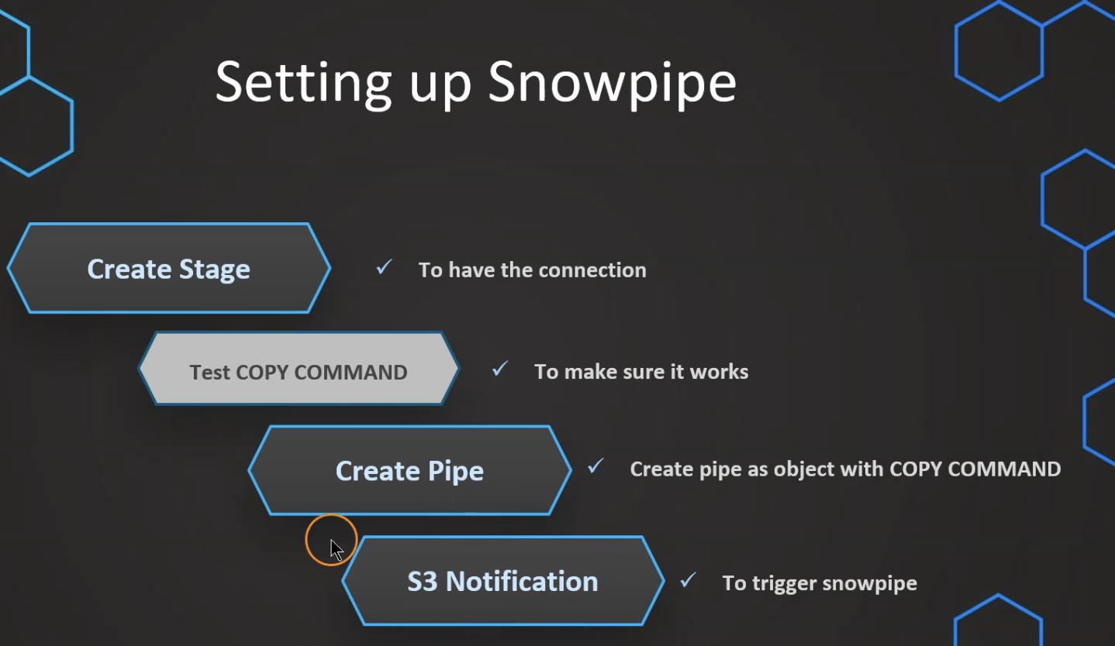

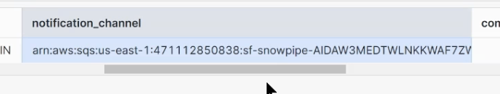

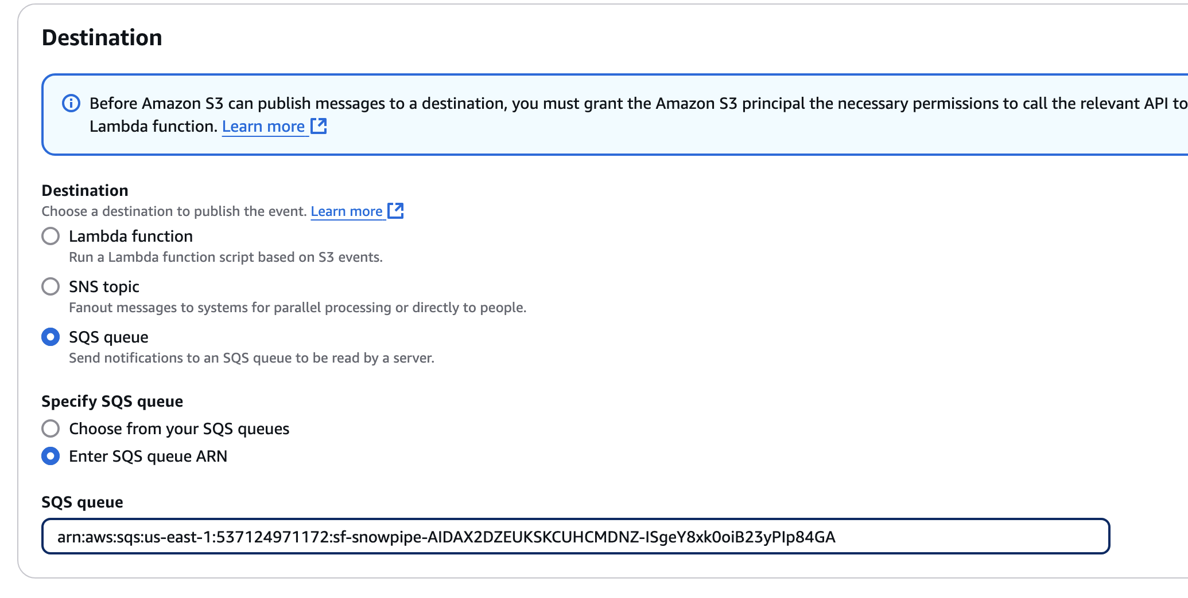

// Create table first

CREATE OR REPLACE TABLE OUR_FIRST_DB.PUBLIC.employees (

id INT,

first_name STRING,

last_name STRING,

email STRING,

location STRING,

department STRING

);

// Create file format object

CREATE OR REPLACE file format MANAGE_DB.file_formats.csv_fileformat

type = csv

field_delimiter = ','

skip_header = 1

null_if = ('NULL','null')

empty_field_as_null = TRUE;

// Create stage object with integration object & file format object

CREATE OR REPLACE stage MANAGE_DB.external_stages.csv_folder

URL = 's3://atullutasnow/csv/snowpipe/'

STORAGE_INTEGRATION = s3_int

FILE_FORMAT = MANAGE_DB.file_formats.csv_fileformat;

// Create stage object with integration object & file format object

LIST @MANAGE_DB.external_stages.csv_folder;

// Create schema to keep things organized

CREATE OR REPLACE SCHEMA MANAGE_DB.pipes;

// Define pipe

CREATE OR REPLACE pipe MANAGE_DB.pipes.employee_pipe

auto_ingest = TRUE

AS

COPY INTO OUR_FIRST_DB.PUBLIC.employees

FROM @MANAGE_DB.external_stages.csv_folder ;

// Describe pipe

DESC pipe employee_pipe;

SELECT * FROM OUR_FIRST_DB.PUBLIC.employees;

Error Handling:

// Handling errors

// Create file format object

CREATE OR REPLACE file format MANAGE_DB.file_formats.csv_fileformat

type = csv

field_delimiter = '|'

skip_header = 1

null_if = ('NULL','null')

empty_field_as_null = TRUE;

SELECT count(*) FROM OUR_FIRST_DB.PUBLIC.employees ;

ALTER PIPE employee_pipe refresh;

// Validate pipe is actually working

SELECT SYSTEM$PIPE_STATUS('employee_pipe');

// Snowpipe error message

SELECT * FROM TABLE(VALIDATE_PIPE_LOAD(

PIPE_NAME => 'MANAGE_DB.pipes.employee_pipe',

START_TIME => DATEADD(HOUR,-2,CURRENT_TIMESTAMP())));

// COPY command history from table to see error massage

SELECT * FROM TABLE (INFORMATION_SCHEMA.COPY_HISTORY(

table_name => 'OUR_FIRST_DB.PUBLIC.EMPLOYEES',

START_TIME =>DATEADD(HOUR,-2,CURRENT_TIMESTAMP())));

Manage Snow Pipes:

-- Manage pipes --

DESC pipe MANAGE_DB.pipes.employee_pipe;

SHOW PIPES;

SHOW PIPES like '%employee%';

SHOW PIPES in database MANAGE_DB;

SHOW PIPES in schema MANAGE_DB.pipes;

SHOW PIPES like '%employee%' in Database MANAGE_DB;

-- Changing pipe (alter stage or file format) --

// Preparation table first

CREATE OR REPLACE TABLE OUR_FIRST_DB.PUBLIC.employees2 (

id INT,

first_name STRING,

last_name STRING,

email STRING,

location STRING,

department STRING

);

// Pause pipe

ALTER PIPE MANAGE_DB.pipes.employee_pipe SET PIPE_EXECUTION_PAUSED = true;

// Verify pipe is paused and has pendingFileCount 0

SELECT SYSTEM$PIPE_STATUS('MANAGE_DB.pipes.employee_pipe') ;

// Recreate the pipe to change the COPY statement in the definition

CREATE OR REPLACE pipe MANAGE_DB.pipes.employee_pipe

auto_ingest = TRUE

AS

COPY INTO OUR_FIRST_DB.PUBLIC.employees2

FROM @MANAGE_DB.external_stages.csv_folder ;

ALTER PIPE MANAGE_DB.pipes.employee_pipe refresh;

// List files in stage

LIST @MANAGE_DB.external_stages.csv_folder ;

SELECT * FROM OUR_FIRST_DB.PUBLIC.employees2;

// Reload files manually that where aleady in the bucket

COPY INTO OUR_FIRST_DB.PUBLIC.employees2

FROM @MANAGE_DB.external_stages.csv_folder;

// Resume pipe

ALTER PIPE MANAGE_DB.pipes.employee_pipe SET PIPE_EXECUTION_PAUSED = false;

// Verify pipe is running again

SELECT SYSTEM$PIPE_STATUS('MANAGE_DB.pipes.employee_pipe') ;

In case of updating snowpipe using create or replace, Even if pipeline is recreated, metadata will not be lost

Snowpipe for Azure:

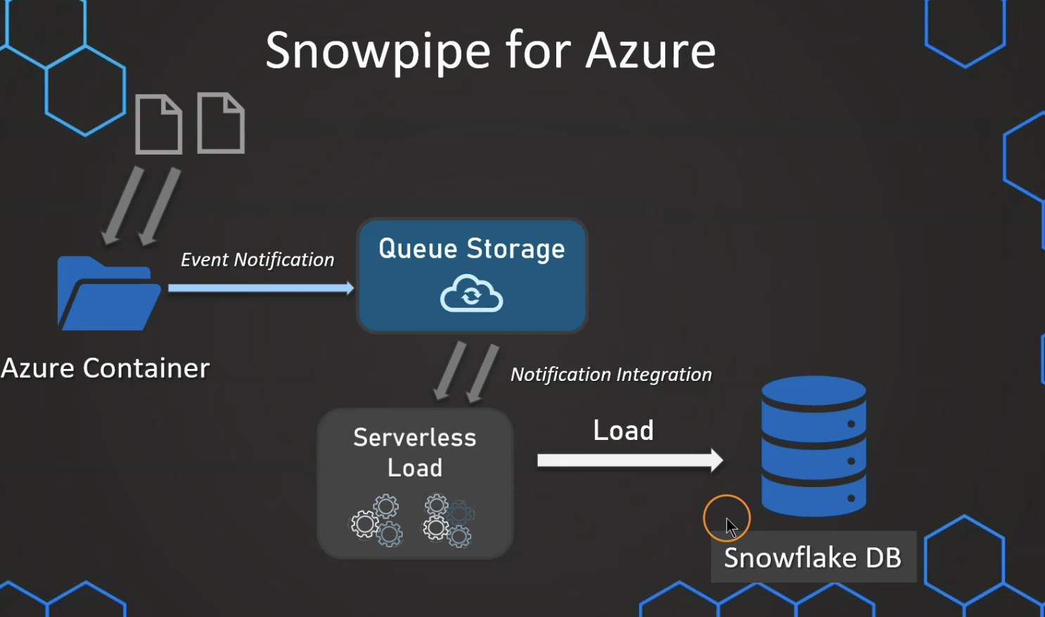

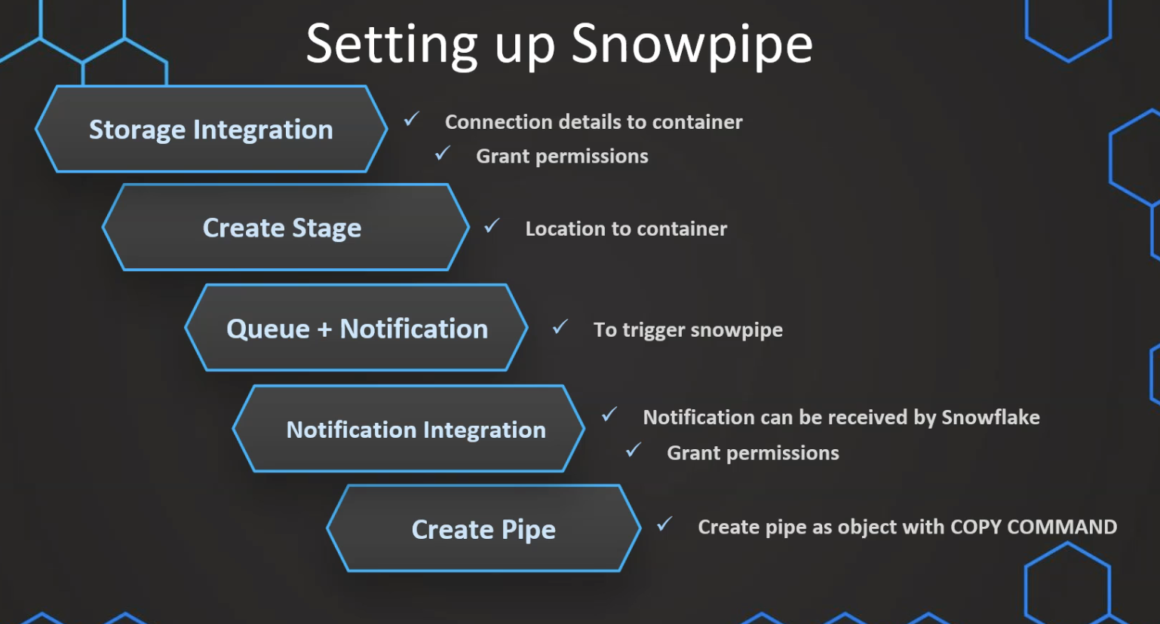

CREATE OR REPLACE DATABASE SNOWPIPE;

-- create integration object that contains the access information

CREATE OR REPLACE STORAGE INTEGRATION azure_snowpipe_integration

TYPE = EXTERNAL_STAGE

STORAGE_PROVIDER = AZURE

ENABLED = TRUE

AZURE_TENANT_ID = '<your-tenant-id>'

STORAGE_ALLOWED_LOCATIONS = ( 'https://<your-container-url>');

-- Describe integration object to provide access

DESC STORAGE integration azure_snowpipe_integration;

---- Create file format & stage objects ----

-- create file format

create or replace file format snowpipe.public.fileformat_azure

TYPE = CSV

FIELD_DELIMITER = ','

SKIP_HEADER = 1;

-- create stage object

create or replace stage snowpipe.public.stage_azure

STORAGE_INTEGRATION = azure_snowpipe_integration

URL = 'https://<your-container-url>'

FILE_FORMAT = fileformat_azure;

-- list files

LIST @snowpipe.public.stage_azure;

CREATE OR REPLACE NOTIFICATION INTEGRATION snowpipe_event

ENABLED = true

TYPE = QUEUE

NOTIFICATION_PROVIDER = AZURE_STORAGE_QUEUE

AZURE_STORAGE_QUEUE_PRIMARY_URI = 'https://<your-container-url>'

AZURE_TENANT_ID = '<your-tenant-id>';

-- Register Integration

DESC notification integration snowpipe_event;

We can create queue in storage account:

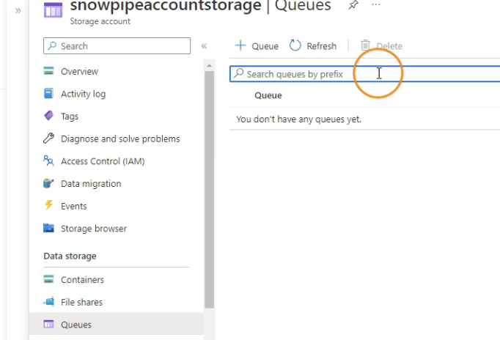

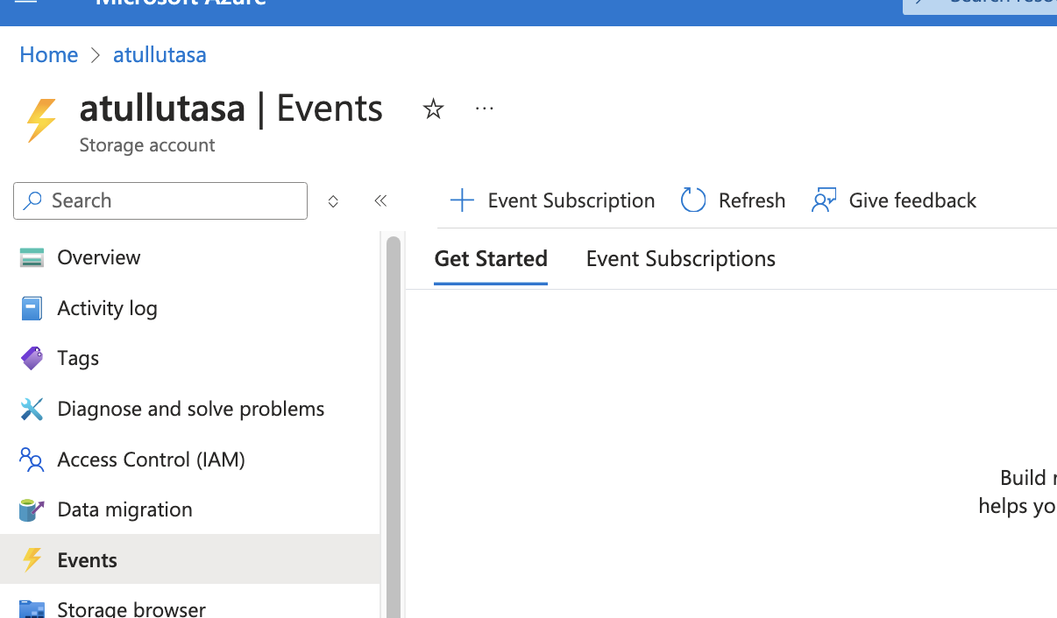

CREATE OR REPLACE NOTIFICATION INTEGRATION snowpipe_event

ENABLED = true

TYPE = QUEUE

NOTIFICATION_PROVIDER = AZURE_STORAGE_QUEUE

AZURE_STORAGE_QUEUE_PRIMARY_URI = 'https://<your-container-url>'

AZURE_TENANT_ID = '<your-tenant-id>';

-- Register Integration

DESC notification integration snowpipe_event;

--query file

SELECT

$1,

$2,

$3,

$4,

$5,

$6,

$7,

$8,

$9,

$10,

$11,

$12,

$13,

$14,

$15,

$16,

$17,

$18,

$19,

$20

FROM @snowpipe.public.stage_azure;

-- create destination table

create or replace table snowpipe.public.happiness (

country_name varchar,

regional_indicator varchar,

ladder_score number(4,3),

standard_error number(4,3),

upperwhisker number(4,3),

lowerwhisker number(4,3),

logged_gdp number(5,3),

social_support number(4,3),

healthy_life_expectancy number(5,3),

freedom_to_make_life_choices number(4,3),

generosity number(4,3),

perceptions_of_corruption number(4,3),

ladder_score_in_dystopia number(4,3),

explained_by_log_gpd_per_capita number(4,3),

explained_by_social_support number(4,3),

explained_by_healthy_life_expectancy number(4,3),

explained_by_freedom_to_make_life_choices number(4,3),

explained_by_generosity number(4,3),

explained_by_perceptions_of_corruption number(4,3),

dystopia_residual number (4,3));

COPY INTO HAPPINESS

FROM @snowpipe.public.stage_azure;

SELECT * FROM snowpipe.public.happiness;

TRUNCATE TABLE snowpipe.public.happiness;

-- create pipe

create pipe azure_pipe

auto_ingest = true

integration = 'SNOWPIPE_EVENT'

as

copy into snowpipe.public.happiness

from @snowpipe.public.stage_azure;

SELECT SYSTEM$PIPE_STATUS( 'AZURE_PIPE' );

Time Travel:

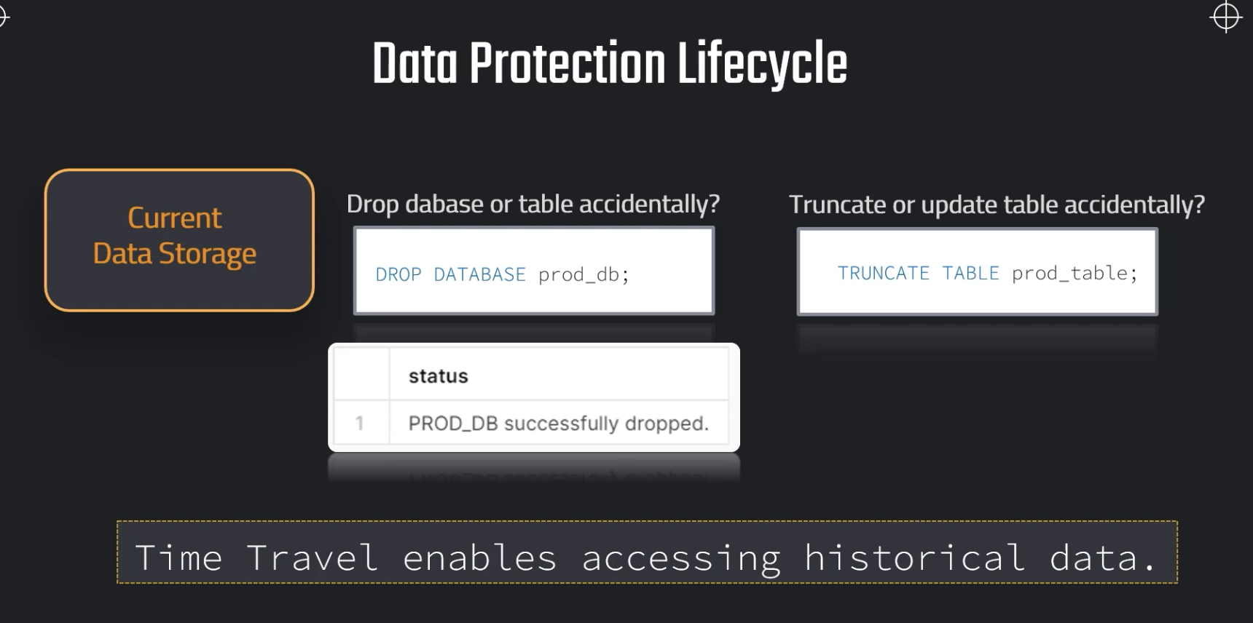

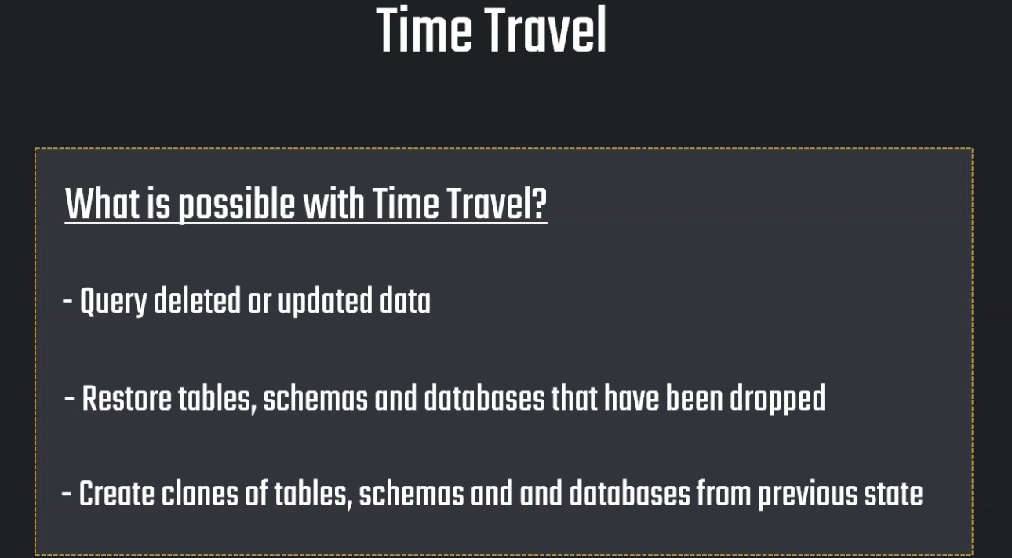

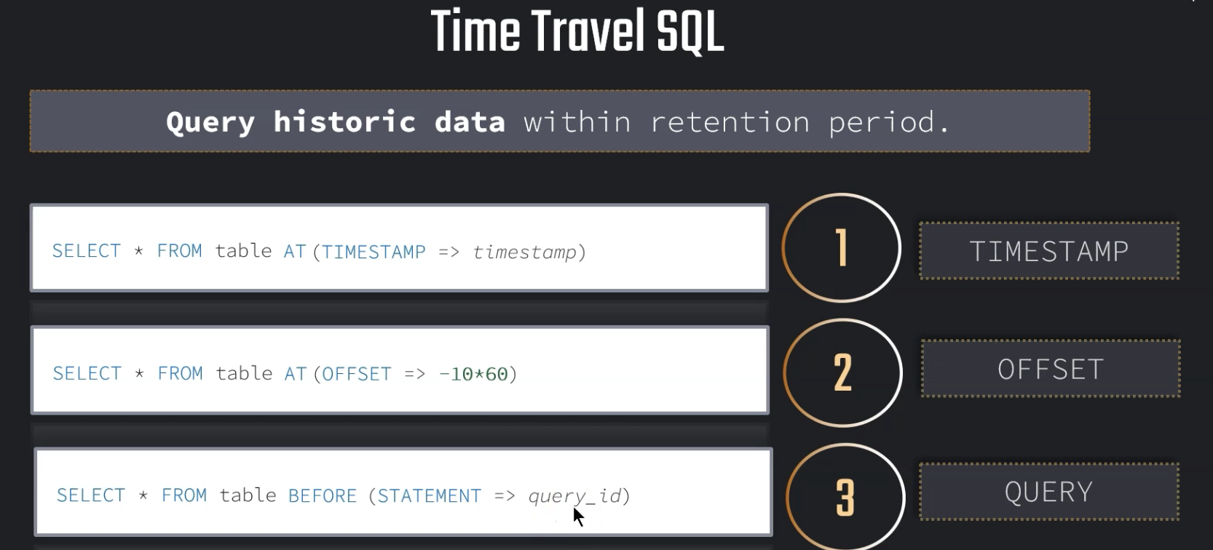

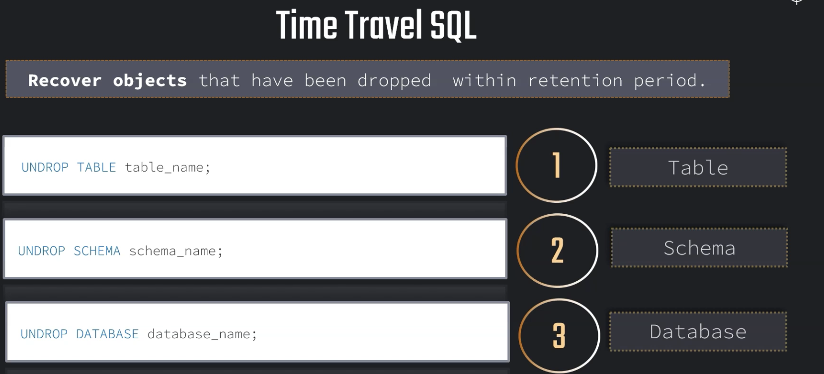

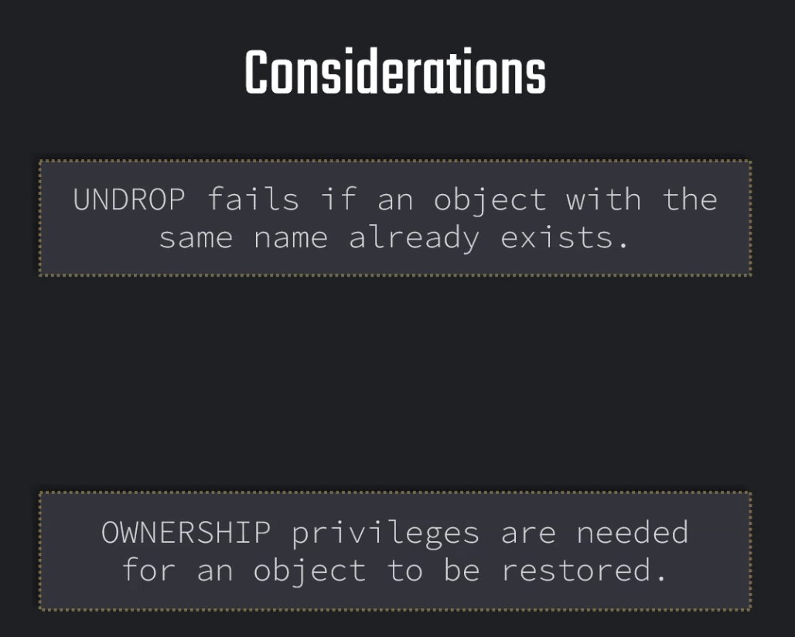

// Setting up table

CREATE OR REPLACE TABLE OUR_FIRST_DB.public.test (

id int,

first_name string,

last_name string,

email string,

gender string,

Job string,

Phone string);

CREATE OR REPLACE FILE FORMAT MANAGE_DB.file_formats.csv_file

type = csv

field_delimiter = ','

skip_header = 1;

CREATE OR REPLACE STAGE MANAGE_DB.external_stages.time_travel_stage

URL = 's3://data-snowflake-fundamentals/time-travel/'

file_format = MANAGE_DB.file_formats.csv_file;

LIST @MANAGE_DB.external_stages.time_travel_stage;

COPY INTO OUR_FIRST_DB.public.test

from @MANAGE_DB.external_stages.time_travel_stage

files = ('customers.csv');

SELECT * FROM OUR_FIRST_DB.public.test;

// Use-case: Update data (by mistake)

UPDATE OUR_FIRST_DB.public.test

SET FIRST_NAME = 'Joyen' ;

// // // Using time travel: Method 1 - 2 minutes back

SELECT * FROM OUR_FIRST_DB.public.test at (OFFSET => -60*1);

// // // Using time travel: Method 2 - before timestamp

SELECT * FROM OUR_FIRST_DB.public.test before (timestamp => '2025-03-15 17:47:50.581'::timestamp);

-- Setting up table

CREATE OR REPLACE TABLE OUR_FIRST_DB.public.test (

id int,

first_name string,

last_name string,

email string,

gender string,

Job string,

Phone string);

COPY INTO OUR_FIRST_DB.public.test

from @MANAGE_DB.external_stages.time_travel_stage

files = ('customers.csv');

SELECT * FROM OUR_FIRST_DB.public.test;

2021-04-17 08:16:24.259

-- Setting up UTC time for convenience

ALTER SESSION SET TIMEZONE ='UTC'

SELECT DATEADD(DAY, 1, CURRENT_TIMESTAMP);

UPDATE OUR_FIRST_DB.public.test

SET Job = 'Data Scientist';

SELECT * FROM OUR_FIRST_DB.public.test;

SELECT * FROM OUR_FIRST_DB.public.test before (timestamp => '2025-03-15 04:13:59.145'::timestamp);

// // // Using time travel: Method 3 - before Query ID

// Preparing table

CREATE OR REPLACE TABLE OUR_FIRST_DB.public.test (

id int,

first_name string,

last_name string,

email string,

gender string,

Phone string,

Job string);

COPY INTO OUR_FIRST_DB.public.test

from @MANAGE_DB.external_stages.time_travel_stage

files = ('customers.csv');

SELECT * FROM OUR_FIRST_DB.public.test;

// Altering table (by mistake)

UPDATE OUR_FIRST_DB.public.test

SET EMAIL = null;

SELECT * FROM OUR_FIRST_DB.public.test;

SELECT * FROM OUR_FIRST_DB.public.test before (statement => '01bb043e-020c-ae9f-000c-64670003f17e');

Restore Data using Time Travel:

// Setting up table

CREATE OR REPLACE TABLE OUR_FIRST_DB.public.test (

id int,

first_name string,

last_name string,

email string,

gender string,

Job string,

Phone string);

COPY INTO OUR_FIRST_DB.public.test

from @MANAGE_DB.external_stages.time_travel_stage

files = ('customers.csv');

SELECT * FROM OUR_FIRST_DB.public.test;

// Use-case: Update data (by mistake)

UPDATE OUR_FIRST_DB.public.test

SET LAST_NAME = 'Tyson';

UPDATE OUR_FIRST_DB.public.test

SET JOB = 'Data Analyst';

SELECT * FROM OUR_FIRST_DB.public.test before (statement => '019b9eea-0500-845a-0043-4d830007402a');

// // // Bad method

CREATE OR REPLACE TABLE OUR_FIRST_DB.public.test as

SELECT * FROM OUR_FIRST_DB.public.test before (statement => '019b9eea-0500-845a-0043-4d830007402a');

SELECT * FROM OUR_FIRST_DB.public.test;

CREATE OR REPLACE TABLE OUR_FIRST_DB.public.test as

SELECT * FROM OUR_FIRST_DB.public.test before (statement => '019b9eea-0500-8473-0043-4d830007307a');

// // // Good method

CREATE OR REPLACE TABLE OUR_FIRST_DB.public.test_backup as

SELECT * FROM OUR_FIRST_DB.public.test before (statement => '019b9ef0-0500-8473-0043-4d830007309a');

TRUNCATE OUR_FIRST_DB.public.test;

INSERT INTO OUR_FIRST_DB.public.test

SELECT * FROM OUR_FIRST_DB.public.test_backup;

SELECT * FROM OUR_FIRST_DB.public.test ;

If we recreate table with same name using time travel then previous time travel will be lost, it’s better to create a backup and then truncate current table and insert data from backup table to truncate table

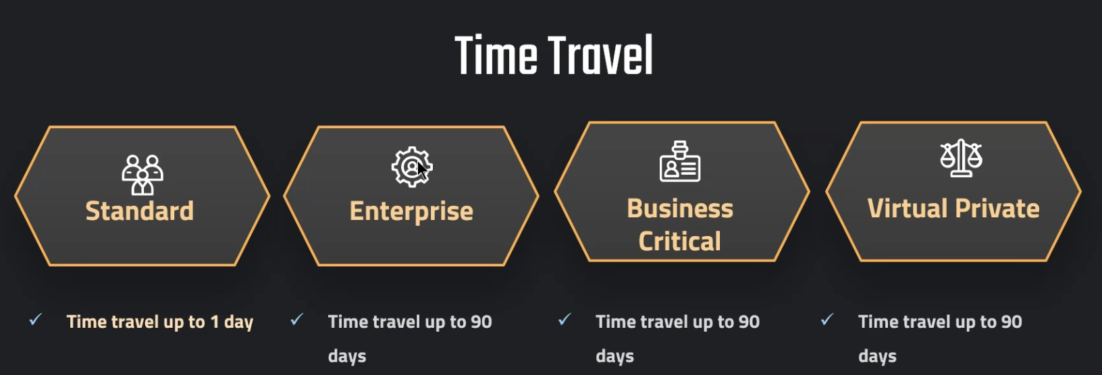

SHOW TABLES like '%CUSTOMERS%';

ALTER TABLE OUR_FIRST_DB.PUBLIC.CUSTOMERS

SET DATA_RETENTION_TIME_IN_DAYS = 1;

CREATE OR REPLACE TABLE OUR_FIRST_DB.public.ret_example (

id int,

first_name string,

last_name string,

email string,

gender string,

Job string,

Phone string)

DATA_RETENTION_TIME_IN_DAYS = 3;

SHOW TABLES like '%EX%';

DROP TABLE OUR_FIRST_DB.public.ret_example;

UNDROP TABLE OUR_FIRST_DB.public.ret_example;

ALTER TABLE OUR_FIRST_DB.public.ret_example

SET DATA_RETENTION_TIME_IN_DAYS = 0;

Time Travel cost:

SELECT * FROM SNOWFLAKE.ACCOUNT_USAGE.STORAGE_USAGE ORDER BY USAGE_DATE DESC;

SELECT * FROM SNOWFLAKE.ACCOUNT_USAGE.TABLE_STORAGE_METRICS;

// Query time travel storage

SELECT ID,

TABLE_NAME,

TABLE_SCHEMA,

TABLE_CATALOG,

ACTIVE_BYTES / (1024*1024*1024) AS STORAGE_USED_GB,

TIME_TRAVEL_BYTES / (1024*1024*1024) AS TIME_TRAVEL_STORAGE_USED_GB

FROM SNOWFLAKE.ACCOUNT_USAGE.TABLE_STORAGE_METRICS

ORDER BY STORAGE_USED_GB DESC,TIME_TRAVEL_STORAGE_USED_GB DESC;

So the question is, why would this be the case and why wouldn't we always set this to 90 days? And the very simple answer is just cost. So we might not need it for all of the tables. And the more we have this set to 90 days, so the longer the period is, the more storage would be needed for time travel. And to understand the cost of time travel, we only need to understand that all of the costs arising from time travel is purely storage cost.

Fail Safe:

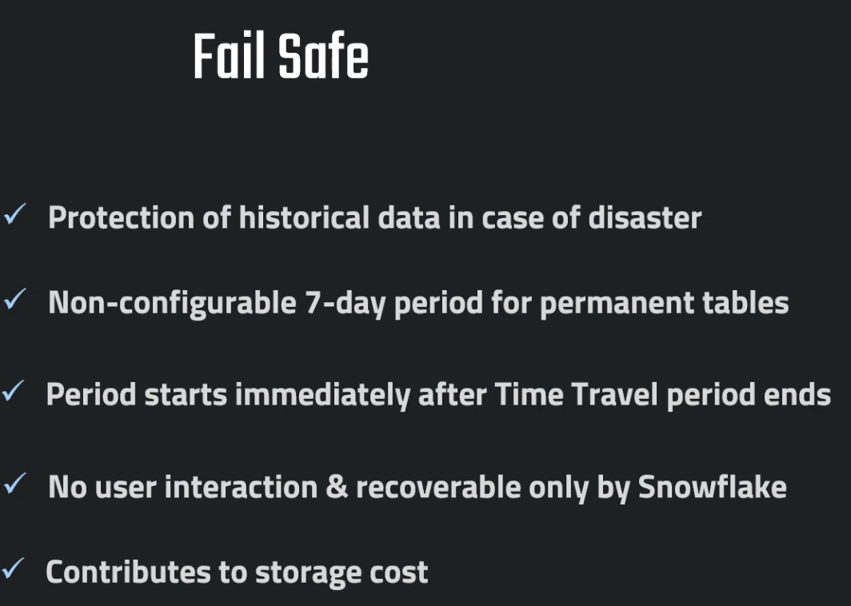

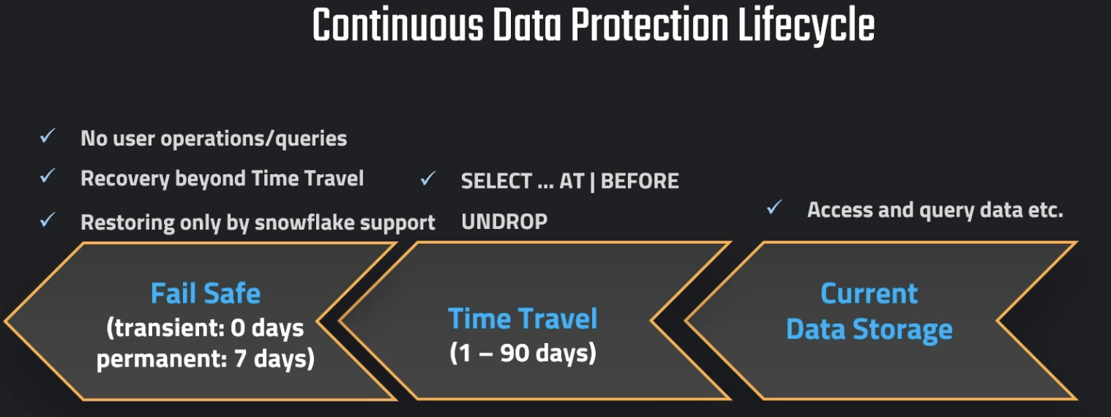

So Fail Safe serves as a data protection mechanism for our data in case of a disaster. This means if we lose the data or if it gets corrupted due to some kind of a disaster event, Fail Safe allows us to recover this data. The important thing here is that the data will be, yeah, in this Fail Safe area, but we cannot configure this. So this is a non configurable seven day period for the so-called, "Permanent tables." So this period of seven days just starts after the Time Travel period has ended. So once the Time Travel period ends, the data from Time Travel just moves into the Fail Safe area from where we can restore it. To be more precise, it is not us that is restoring this because this is the next important point. We are not able, as users, to interact with the Fail Safe. This is nothing that we can restore here from, but we have to reach out to the Snowflake support that we need to recover this data. So this is something that is different from Time Travel. So this is why it is also just a disaster recovery. So if we have no other way, and this is hugely important data, then we should reach out to Snowflake and it will be recovered.

// Storage usage on account level

SELECT * FROM SNOWFLAKE.ACCOUNT_USAGE.STORAGE_USAGE ORDER BY USAGE_DATE DESC;

// Storage usage on account level formatted

SELECT USAGE_DATE,

STORAGE_BYTES / (1024*1024*1024) AS STORAGE_GB,

STAGE_BYTES / (1024*1024*1024) AS STAGE_GB,

FAILSAFE_BYTES / (1024*1024*1024) AS FAILSAFE_GB

FROM SNOWFLAKE.ACCOUNT_USAGE.STORAGE_USAGE ORDER BY USAGE_DATE DESC;

// Storage usage on table level

SELECT * FROM SNOWFLAKE.ACCOUNT_USAGE.TABLE_STORAGE_METRICS;

// Storage usage on table level formatted

SELECT ID,

TABLE_NAME,

TABLE_SCHEMA,

ACTIVE_BYTES / (1024*1024*1024) AS STORAGE_USED_GB,

TIME_TRAVEL_BYTES / (1024*1024*1024) AS TIME_TRAVEL_STORAGE_USED_GB,

FAILSAFE_BYTES / (1024*1024*1024) AS FAILSAFE_STORAGE_USED_GB

FROM SNOWFLAKE.ACCOUNT_USAGE.TABLE_STORAGE_METRICS

ORDER BY FAILSAFE_STORAGE_USED_GB DESC;

Different Tables Types:

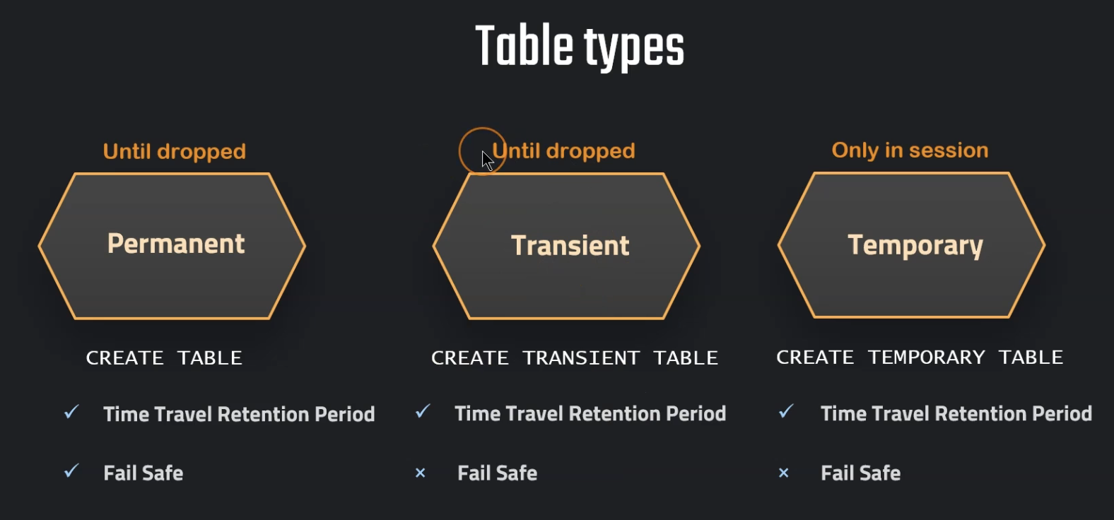

So again, let's start with the permanent table. This is the default table and we have so far only actually worked with those permanent tables. So again, this is the table that is created just using the Create Table command, And here we have all of these standard capabilities, which includes Time Travel retention period and also Fail Safe. But unfortunately sometimes this can cause more cost than we actually want to have because we need to pay now for this additional storage cost that is associated with Time Travel and Fail Safe. And not all of our tables, not all of our data may require those very strict and very strong data protection measures. So we might use unnecessary data storage, which we can control by using a different table type. So in this case we could also use a so-called transient table. We create this type of table by using Create Transient Table. So it's exactly the same thing apart from this additional transient keyword. Additionally, we also have the temporary tables. They are created using the Create Temporary Table command. And here we also have the Time Travel retention period. But again, we don't have any Fail Safe. So this is something that looks very similar to the transient table, but the question is how they are different. So they are different in that these temporary tables, they only exist in the current session. This means that once our session ends, they will be completely deleted. So when the session is closed, it is not recoverable anymore, so they will be gone basically because here we don't have any Fail Safe and we cannot access them anymore. Well, the transient table of course is good for very large data sets that don't need so much data protection. So it can be also useful for development or temporary data that doesn't need to have this high level of protection. And of course, permanent table, this is our choice for productive environments. So data that needs to be protected here, we basically should use the permanent tables. And then again, we have also the temporary tables. This is suitable for non-permanent data.

These are applicable to schema as well, if we have permanent and temporary table in same session, then temporary table will be given more preference

CREATE OR REPLACE DATABASE PDB;

CREATE OR REPLACE TABLE PDB.public.customers (

id int,

first_name string,

last_name string,

email string,

gender string,

Job string,

Phone string);

CREATE OR REPLACE TABLE PDB.public.helper (

id int,

first_name string,

last_name string,

email string,

gender string,

Job string,

Phone string);

// Stage and file format

CREATE OR REPLACE FILE FORMAT MANAGE_DB.file_formats.csv_file

type = csv

field_delimiter = ','

skip_header = 1

CREATE OR REPLACE STAGE MANAGE_DB.external_stages.time_travel_stage

URL = 's3://data-snowflake-fundamentals/time-travel/'

file_format = MANAGE_DB.file_formats.csv_file;

LIST @MANAGE_DB.external_stages.time_travel_stage;

// Copy data and insert in table

COPY INTO PDB.public.helper

FROM @MANAGE_DB.external_stages.time_travel_stage

files = ('customers.csv');

SELECT * FROM PDB.public.helper;

INSERT INTO PDB.public.customers

SELECT

t1.ID

,t1.FIRST_NAME

,t1.LAST_NAME

,t1.EMAIL

,t1.GENDER

,t1.JOB

,t1.PHONE

FROM PDB.public.helper t1

CROSS JOIN (SELECT * FROM PDB.public.helper) t2

CROSS JOIN (SELECT TOP 100 * FROM PDB.public.helper) t3;

// Show table and validate

SHOW TABLES;

// Permanent tables

USE OUR_FIRST_DB

CREATE OR REPLACE TABLE customers (

id int,

first_name string,

last_name string,

email string,

gender string,

Job string,

Phone string);

CREATE OR REPLACE DATABASE PDB;

SHOW DATABASES;

SHOW TABLES;

// View table metrics (takes a bit to appear)

SELECT * FROM SNOWFLAKE.ACCOUNT_USAGE.TABLE_STORAGE_METRICS

SELECT ID,

TABLE_NAME,

TABLE_SCHEMA,

TABLE_CATALOG,

ACTIVE_BYTES / (1024*1024*1024) AS ACTIVE_STORAGE_USED_GB,

TIME_TRAVEL_BYTES / (1024*1024*1024) AS TIME_TRAVEL_STORAGE_USED_GB,

FAILSAFE_BYTES / (1024*1024*1024) AS FAILSAFE_STORAGE_USED_GB,

IS_TRANSIENT,

DELETED,

TABLE_CREATED,

TABLE_DROPPED,

TABLE_ENTERED_FAILSAFE

FROM SNOWFLAKE.ACCOUNT_USAGE.TABLE_STORAGE_METRICS

--WHERE TABLE_CATALOG ='PDB'

WHERE TABLE_DROPPED is not null

ORDER BY FAILSAFE_BYTES DESC;

What we need to be aware is that those transient tables, we remember, they can have a retention period of either zero or one.

CREATE OR REPLACE DATABASE TDB;

CREATE OR REPLACE TRANSIENT TABLE TDB.public.customers_transient (

id int,

first_name string,

last_name string,

email string,

gender string,

Job string,

Phone string);

INSERT INTO TDB.public.customers_transient

SELECT t1.* FROM OUR_FIRST_DB.public.customers t1

CROSS JOIN (SELECT * FROM OUR_FIRST_DB.public.customers) t2

SHOW TABLES;

// Query storage

SELECT * FROM SNOWFLAKE.ACCOUNT_USAGE.TABLE_STORAGE_METRICS

SELECT ID,

TABLE_NAME,

TABLE_SCHEMA,

TABLE_CATALOG,

ACTIVE_BYTES,

TIME_TRAVEL_BYTES / (1024*1024*1024) AS TIME_TRAVEL_STORAGE_USED_GB,

FAILSAFE_BYTES / (1024*1024*1024) AS FAILSAFE_STORAGE_USED_GB,

IS_TRANSIENT,

DELETED,

TABLE_CREATED,

TABLE_DROPPED,

TABLE_ENTERED_FAILSAFE

FROM SNOWFLAKE.ACCOUNT_USAGE.TABLE_STORAGE_METRICS

WHERE TABLE_CATALOG ='TDB'

ORDER BY TABLE_CREATED DESC;

// Set retention time to 0

ALTER TABLE TDB.public.customers_transient

SET DATA_RETENTION_TIME_IN_DAYS = 0

DROP TABLE TDB.public.customers_transient;

UNDROP TABLE TDB.public.customers_transient;

SHOW TABLES;

// Creating transient schema and then table

CREATE OR REPLACE TRANSIENT SCHEMA TRANSIENT_SCHEMA;

SHOW SCHEMAS;

CREATE OR REPLACE TABLE TDB.TRANSIENT_SCHEMA.new_table (

id int,

first_name string,

last_name string,

email string,

gender string,

Job string,

Phone string);

ALTER TABLE TDB.TRANSIENT_SCHEMA.new_table

SET DATA_RETENTION_TIME_IN_DAYS = 2

SHOW TABLES;

Table created under transient schema will be transient by default even though we don’t use the keyword

create or replace DATABASE PDB;

USE DATABASE PDB;

// Create permanent table

CREATE OR REPLACE TABLE PDB.public.customers (

id int,

first_name string,

last_name string,

email string,

gender string,

Job string,

Phone string);

INSERT INTO PDB.public.customers

SELECT t1.* FROM OUR_FIRST_DB.public.customers t1

SELECT * FROM PDB.public.customers

// Create temporary table (with the same name)

CREATE OR REPLACE TEMPORARY TABLE PDB.public.customers (

id int,

first_name string,

last_name string,

email string,

gender string,

Job string,

Phone string);

// Validate temporary table is the active table

SELECT * FROM PDB.public.customers;

// Create second temporary table (with a new name)

CREATE OR REPLACE TEMPORARY TABLE PDB.public.temp_table (

id int,

first_name string,

last_name string,

email string,

gender string,

Job string,

Phone string);

// Insert data in the new table

INSERT INTO PDB.public.temp_table

SELECT * FROM PDB.public.customers

SELECT * FROM PDB.public.temp_table

SHOW TABLES;

We can’t create temporary database

Zero Copy Cloning  
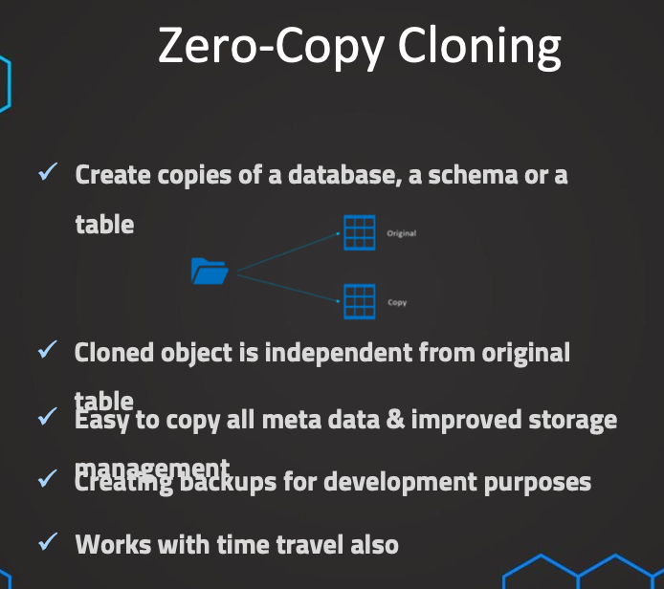

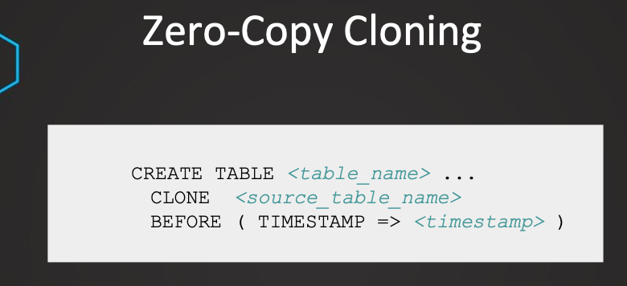

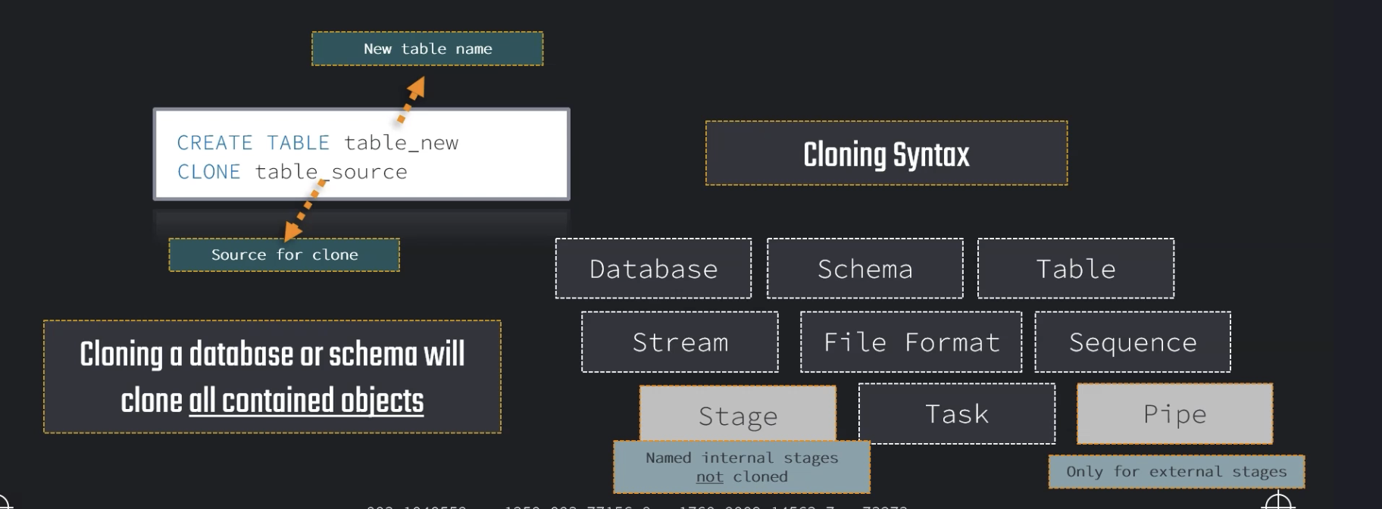

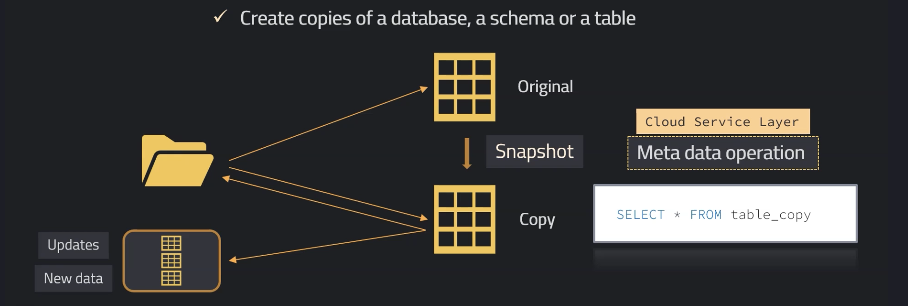

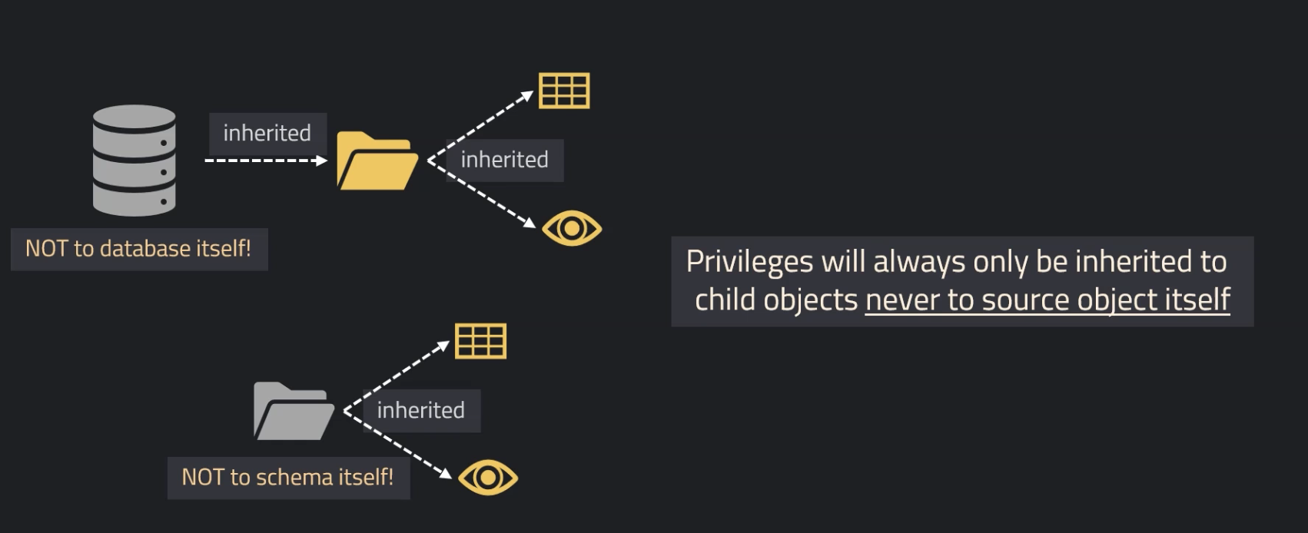

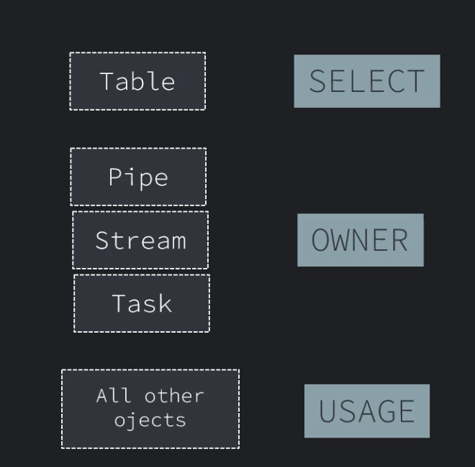

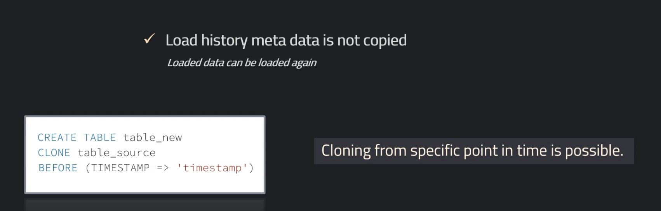

Traditionally, when we want to copy objects in a database, this can be a super complicated process. We need to copy all of the structure, of course, all of the data, maybe there are some keys on a table, all of this has to be done manually. In Snowflake, this can be done very easily with just one simple command. For example, if we want to clone a table, we can just use the create table command and the name of the table, and then we can just add clone, and then the table source that we want to clone from. This is a very simple process, and it can be also done for other database objects. So we need to remember, this can be done for databases, schemas, and tables, streams, file format, sequences, stages, tasks, and pipes, with some limitations for pipes and stages. So a pipe can only be cloned if it is referencing an external stage and named internal stages cannot be cloned. It is also important to remember that when we clone an entire database or a schema, all of the child objects will also be cloned, with of course, the exception of named internal stages as they cannot be cloned. And the same goes also for pipes that are not referencing external stages. So let's learn why this is called zero-copy cloning and how this works. Typically, the most common example is a table. So here we can also learn why it's called zero-copy cloning. So let's assume we clone a table, we have the original one, and then the clone. It is important to know this is only a metadata operation. This means it will be of course, therefore executed by the cloud service layer, and this means that no data will actually be copied. So this clone will just still reference the same micro partitions. We remember that the data is stored in micro partitions in so-called blocks in the cloud provider. And then when we now create a clone, this will just take a snapshot at the moment when this clone is created, and this new table will still reference the exact same micro partition. So there will be no additional storage cost when this clone has been created. But then of course, this table is a completely independent table. This means we can now query from this table, we can make modifications, and this will only affect the table itself and not the original one. And of course, vice versa also. When we modify the original one, it will have no effect on the clone. So the question is now if we make some modifications, and this is still the same micro partitions, how does it work if we add some data or make some modifications? So this is the only time when there will be some additional micro partitions added when we are adding new data or when we make some modifications to our data. So this means that it will be super efficient in terms of storage, since we only need to pay for the additional amount of data that is used for these updates and this additional data. And for all of the rest, we will just reference the original data in these micro partitions. So this is very important to understand. This is an independent table, independent from the original one. And since this is a metadata operation only, we have this improved storage and this will be also super easy and super fast. Just one command and everything is done. This can be used, for example, if we want to create some backups, we want to test some things on some tables, and therefore we just quickly want to create some kind of a backup in case we are messing things up. Typically, this is combined also with time travel, and therefore afterwards we also have a quick look on how we combine this with time travel. But now an important question, how does it work with the privileges? For example, we copy an entire database and then of course we remember all of the child objects will also be cloned. And now it's important to remember that the database itself will not inherit the privileges but all of the child objects do. So those privileges of the child objects will be inherited, but not for the database itself. And this is also true for schemas. When we clone a schema, all of the child object privileges will be inherited, but the privileges for the schema itself needs to be done afterwards by the administrator. So this needs to be done again because those privileges for the object itself will not be inherited, only for the child objects they will be inherited. And now, what privileges are needed to be able to clone a table or other objects? We need to remember just three things. For the table, we just need to have select privileges. For pipes, streams and tasks, we need to have ownership privileges and for all other objects, we need to have usage privileges. So this is what we need to know. And then there are just two additional considerations. The first one is that when we clone a table, then we have to remember that the load history metadata is not copied. This means that when we have already loaded some data into the original table, of course, if we will try to load the same data again into this original table, the data won't be loaded because it's stored already in the metadata of this table that this has been already loaded. And this is not true for the clone. So this data can be loaded again without any problems because the load history metadata is not copied, so this can be done again. And now, regarding the cloning from time travel, this is also possible. Just after the clone, we add before, for example, or add, and then the method that we want to use in our time travel. So this is all that we need to know about zero-copy cloning.

So we cannot create a permanent table out of a temporary table.

// Cloning

SELECT * FROM OUR_FIRST_DB.PUBLIC.CUSTOMERS;

CREATE TABLE OUR_FIRST_DB.PUBLIC.CUSTOMERS_CLONE

CLONE OUR_FIRST_DB.PUBLIC.CUSTOMERS;

// Validate the data

SELECT * FROM OUR_FIRST_DB.PUBLIC.CUSTOMERS_CLONE;

// Update cloned table

UPDATE OUR_FIRST_DB.public.CUSTOMERS_CLONE

SET LAST_NAME = NULL;

SELECT * FROM OUR_FIRST_DB.PUBLIC.CUSTOMERS ;

SELECT * FROM OUR_FIRST_DB.PUBLIC.CUSTOMERS_CLONE;

// Cloning a temporary table is not possible

CREATE OR REPLACE TEMPORARY TABLE OUR_FIRST_DB.PUBLIC.TEMP_TABLE(

id int);

CREATE TRANSIENT TABLE OUR_FIRST_DB.PUBLIC.TABLE_COPY

CLONE OUR_FIRST_DB.PUBLIC.TEMP_TABLE;

SELECT * FROM OUR_FIRST_DB.PUBLIC.TABLE_COPY;

Cloning Schema:

// Cloning Schema

CREATE TRANSIENT SCHEMA OUR_FIRST_DB.COPIED_SCHEMA

CLONE OUR_FIRST_DB.PUBLIC;

SELECT * FROM COPIED_SCHEMA.CUSTOMERS;

CREATE TRANSIENT SCHEMA OUR_FIRST_DB.EXTERNAL_STAGES_COPIED

CLONE MANAGE_DB.EXTERNAL_STAGES;

// Cloning Database

CREATE TRANSIENT DATABASE OUR_FIRST_DB_COPY

CLONE OUR_FIRST_DB;

DROP DATABASE OUR_FIRST_DB_COPY;

DROP SCHEMA OUR_FIRST_DB.EXTERNAL_STAGES_COPIED;

DROP SCHEMA OUR_FIRST_DB.COPIED_SCHEMA;

// Cloning using time travel

// Setting up table

CREATE OR REPLACE TABLE OUR_FIRST_DB.public.time_travel (

id int,

first_name string,

last_name string,

email string,

gender string,

Job string,

Phone string);

CREATE OR REPLACE FILE FORMAT MANAGE_DB.file_formats.csv_file

type = csv

field_delimiter = ','

skip_header = 1;

CREATE OR REPLACE STAGE MANAGE_DB.external_stages.time_travel_stage

URL = 's3://data-snowflake-fundamentals/time-travel/'

file_format = MANAGE_DB.file_formats.csv_file;

LIST @MANAGE_DB.external_stages.time_travel_stage;

COPY INTO OUR_FIRST_DB.public.time_travel

from @MANAGE_DB.external_stages.time_travel_stage

files = ('customers.csv');

SELECT * FROM OUR_FIRST_DB.public.time_travel;

// Update data

UPDATE OUR_FIRST_DB.public.time_travel

SET FIRST_NAME = 'Frank' ;

// Using time travel

SELECT * FROM OUR_FIRST_DB.public.time_travel at (OFFSET => -60*1);

// Using time travel

CREATE OR REPLACE TABLE OUR_FIRST_DB.PUBLIC.time_travel_clone

CLONE OUR_FIRST_DB.public.time_travel at (OFFSET => -60*1.5);

SELECT * FROM OUR_FIRST_DB.PUBLIC.time_travel_clone;

// Update data again

UPDATE OUR_FIRST_DB.public.time_travel_clone

SET JOB = 'Snowflake Analyst' ;

// Using time travel: Method 2 - before Query

SELECT * FROM OUR_FIRST_DB.public.time_travel_clone before (statement => '<your-query-id>);

CREATE OR REPLACE TABLE OUR_FIRST_DB.PUBLIC.time_travel_clone_of_clone

CLONE OUR_FIRST_DB.public.time_travel_clone before (statement => '<your-query-id>');

SELECT * FROM OUR_FIRST_DB.public.time_travel_clone_of_clone ;

Swapping:

Instructor: Let's now have a look at a very similar feature to cloning, which is swapping tables. This can be especially useful if we, for example, want to take a development table into production or a development database into production. So, of course, there would be multiple ways of achieving this as well. So for example, we could create a clone or a copy of our development table and then just rename this clone into the production table afterwards. However, Snowflake offers a much simpler method, which would be to just swap those two tables with just one single command. So like cloning, this process involves only swapping actually the metadata. So this is, again, just a metadata operation. And like this, we can achieve this very easily with just one single command. So let's have a closer look at how this works. We want to understand that when a table is stored in Snowflake, it is, of course, not actually stored in Snowflake itself, but the data, the underlying data of the table is, of course, stored in an external cloud provider and we just have the metadata that is associated with this table so that we can work on this table, do our queries and so on. And this swapping is also just a metadata operation. So when we swap those two tables, all we are actually doing is just swapping the metadata and then the storage, the underlying storage of those tables, it's just pointing to the metadata of the production table. So then this will be our production table with all of the associated metadata and, of course, vice versa. So we basically swap those two tables. Also, this just requires one simple command. So it is, of course, technically very, yeah, just one command. And also for us users, it is also just one single command to swap those two tables. So this can be very useful, especially when we want to have this use case of bringing a development table into production. To be able to do this, we can just use this simple command. We alter the table, and then we use the keyword swap with. So like this, we are just swapping the table, the original table with a given target table. And just like this, those two tables will be swapped. And we can do the same thing also for schemas. So here, we can also just alter the schema and then swap it with another one. So this is also very simple in the same way. So therefore, let's just also quickly have a look at this in practice in Snowflake.

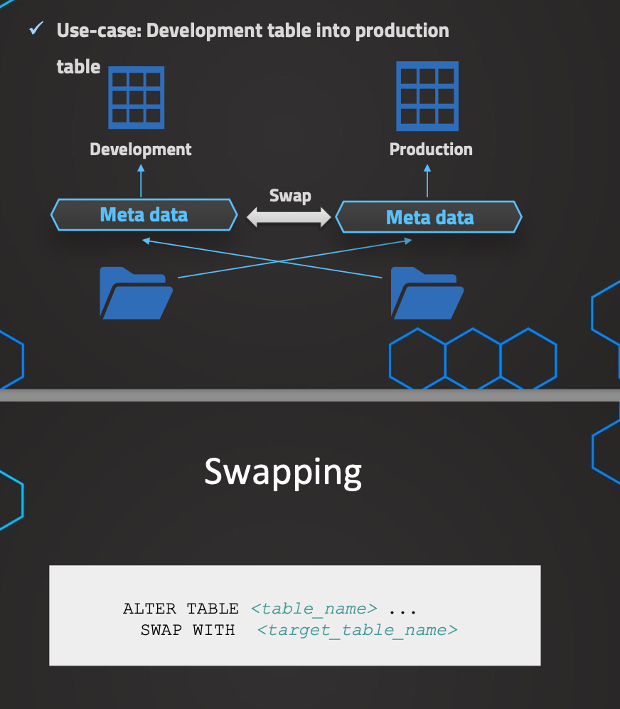

//// Swapping tables

// Setting up dev table

CREATE TRANSIENT SCHEMA OUR_FIRST_DB.COPIED_SCHEMA

CLONE OUR_FIRST_DB.PUBLIC;

SELECT * FROM OUR_FIRST_DB.COPIED_SCHEMA.CUSTOMERS

SELECT * FROM OUR_FIRST_DB.PUBLIC.CUSTOMERS

// Modifying "Dev Table"

DELETE FROM OUR_FIRST_DB.COPIED_SCHEMA.CUSTOMERS WHERE ID < 500

SELECT * FROM OUR_FIRST_DB.COPIED_SCHEMA.CUSTOMERS

// Swapping Tables

ALTER TABLE OUR_FIRST_DB.COPIED_SCHEMA.CUSTOMERS

SWAP WITH OUR_FIRST_DB.PUBLIC.CUSTOMERS

// Verifying results

SELECT * FROM OUR_FIRST_DB.COPIED_SCHEMA.CUSTOMERS

SELECT * FROM OUR_FIRST_DB.PUBLIC.CUSTOMERS

Data Sharing:

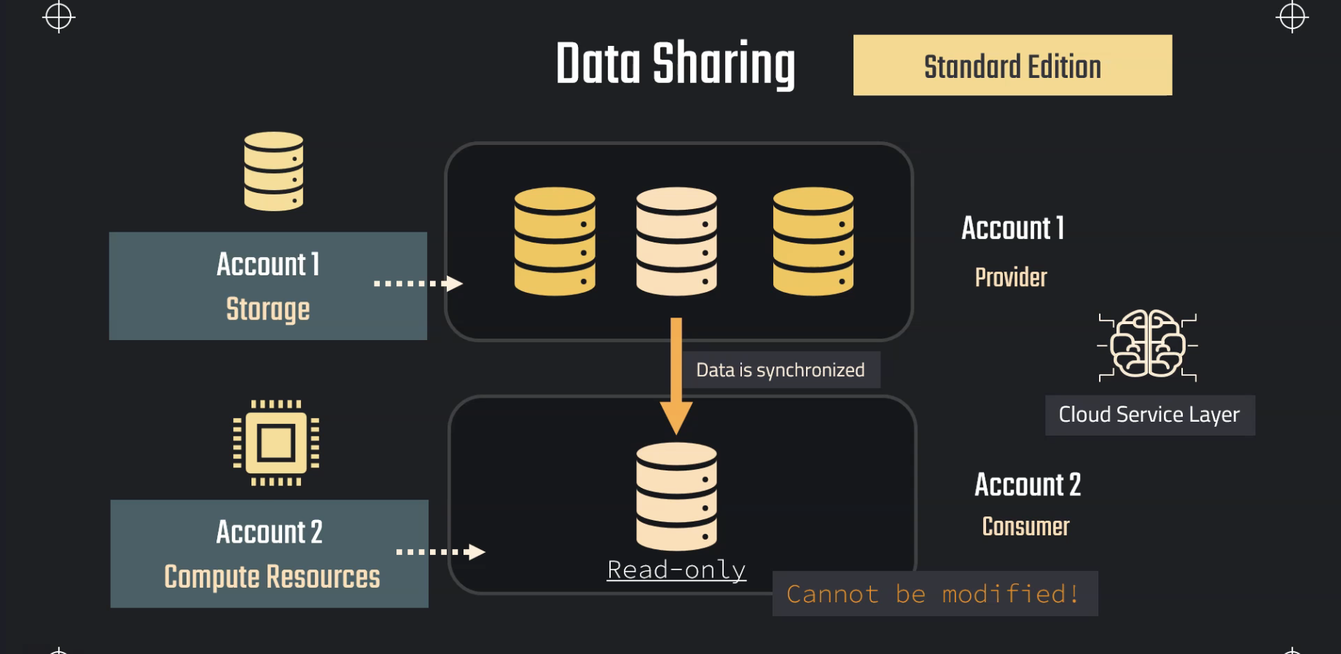

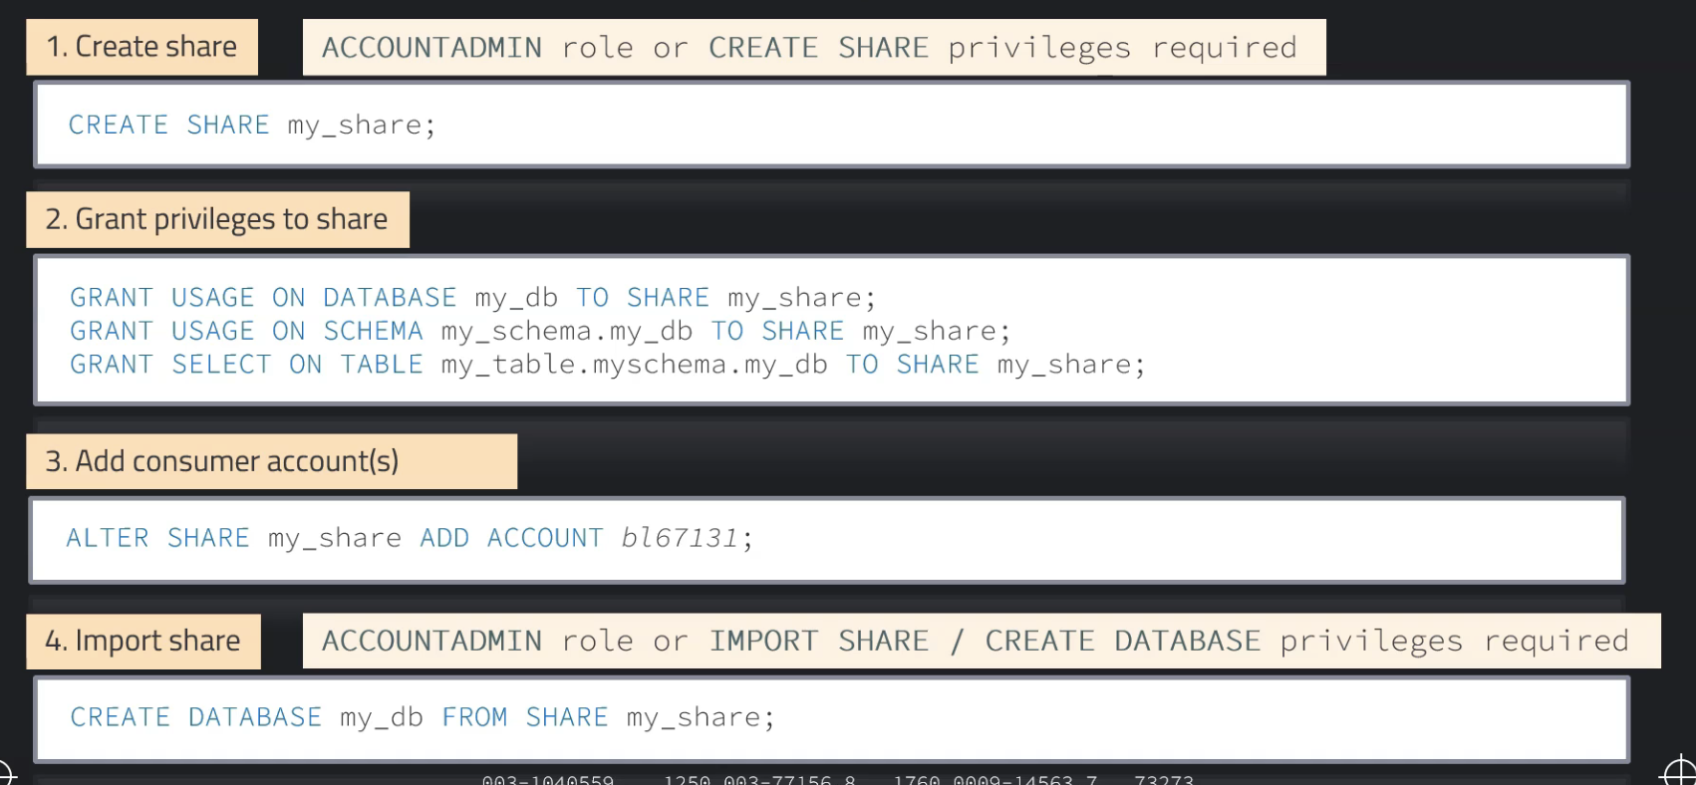

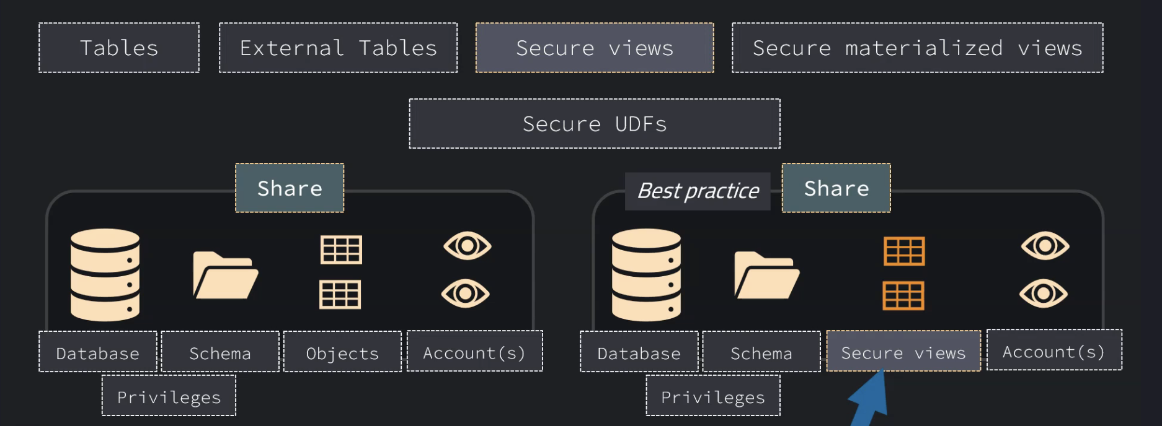

Instructor: Let's talk about data sharing, which is also a very unique feature in Snowflake because traditionally data sharing could be quite a complicated process 'cause once we have shared the data, for example, with some customer, we, again, once the data has been changed and updated, we need to again extract and load the data to the customer. So traditionally this was very complicated, but thanks to the unique architecture in Snowflake, we know storage is decoupled from compute, this is actually very simple. So we can share the data without actually making a copy of the data. We just grant access to the storage layer, to this specific data, and then we can let the consumer use their own compute resources. So like this, the data in this share, will always be up to date because it's actually the same data and we don't need to pay for the compute as the provider, but the customer, the so-called consumer, will use their own compute resources. So let's have a closer look at how this works. First of all, this is available for all of these Snowflake editions. So every account can make use of sharing. We have, for example, one account that wants to share some data. This is called the Provider account. And then we have another account that wants to consume our data. So they want to have a look at the data, and therefore this is called the Consumer account. So we can just create a share and we'll see just in a second how this works exactly, and then the consumer will have read only access to this data. So there will be then a database that the consumer can create. And we'll see in just a second how this works exactly. But it is important that this is a read-only database. So the consumer can only read the data but cannot make any modifications like adding objects or adding data, changing data. This is read only, and as mentioned, this is not actually copying any data. So this is again, just a metadata operation, and therefore we again use the cloud service layer to leverage this operation. And then like this, we have still the storage, which is just paid by the provider. There's no need to duplicate the data. And then when the consumer wants to query from this database, they use their own compute resources. So this is important for the billing because then the consumer is paying for the compute, and we as provider just provide the storage, and of course also then pay for the storage. And it is also possible to be a provider and a consumer in the same time. So we can both consume data and also provide data. Actually, it's even possible to provide and consume in the same account, so with the same data share. But this is usually not very relevant. But in general, it's important to know that it's possible to be both a provider and a consumer. So let's have a closer look now at how this works exactly. The first step to set this up would be to create a share in our provider account. This means we would have to have the account admin role or the create share privileges. Usually this is the account admin, because this is an account operation. So this would be usually the role that executes this command. So this will be just a create share command, which is basically just acting as an empty shell, so just the container in which we can grant the privileges, we put the database and then all of the privileges and of course the accounts that we want to share this to. So the first step, just creating this empty shell. Then the second step would be to grant now the privileges to the database, the schema, and then all of the objects in this database. So for example, a select on some tables, this is done as the second step. And afterwards we can add also the consumer accounts. We can of course create this share with these accounts already, or we can have also a share that in the beginning when we created has zero consumers, so we can just add them later on by just altering the share. And we can then like this, just add the consumer accounts, so one or multiple accounts. And as mentioned, even it's possible to have zero consumer accounts to a share. This is theoretically not a problem at all. And then the last step would be to now in the consumer account, import this share. So now once we have shared this to the account, this is visible, and the account admin or someone with import share privileges and create database privileges can create now a database from this share. So again, usually this is just for simplicity, the account admin, but in theory also import share and create database privileges would be enough. So this could be delegated and then also be done by someone else. So like this, we have now a database created from the share. And of course now if we want, we can grant additional privileges because the privileges will not be shared. So we are responsible now in the consumer account to grant the relevant privileges. And now finally, let's also quickly demonstrate what is possible to be shared. So we have tables, external tables, secure views, secure materialized views, and secure user defined functions. So as mentioned, the share itself is just the container. And in the share we have one database. Then we can grant again, usage on the schema, and then also all of the objects that we want to grant privileges to. And then the last component is the accounts. So we can have zero, one or multiple accounts. And of course, the privileges to these objects are also part of a share. As a best practice, when we want to share data, it is recommended to use secure views because if we would just use views, we could make some information available that we maybe don't want to reveal. And also, for example, when we have data coming from multiple databases, typically we create one view in a separate database, and this will be then the database that we share. So this is a best practice, especially when data is coming from multiple databases.

CREATE OR REPLACE DATABASE DATA_S;

CREATE OR REPLACE STAGE aws_stage

url='s3://bucketsnowflakes3';

// List files in stage

LIST @aws_stage;

// Create table

CREATE OR REPLACE TABLE ORDERS (

ORDER_ID VARCHAR(30)

,AMOUNT NUMBER(38,0)

,PROFIT NUMBER(38,0)

,QUANTITY NUMBER(38,0)

,CATEGORY VARCHAR(30)

,SUBCATEGORY VARCHAR(30));

// Load data using copy command

COPY INTO ORDERS

FROM @MANAGE_DB.external_stages.aws_stage

file_format= (type = csv field_delimiter=',' skip_header=1)

pattern='.*OrderDetails.*';

SELECT * FROM ORDERS;

// Create a share object

CREATE OR REPLACE SHARE ORDERS_SHARE;

---- Setup Grants ----

// Grant usage on database

GRANT USAGE ON DATABASE DATA_S TO SHARE ORDERS_SHARE;

// Grant usage on schema

GRANT USAGE ON SCHEMA DATA_S.PUBLIC TO SHARE ORDERS_SHARE;

// Grant SELECT on table

GRANT SELECT ON TABLE DATA_S.PUBLIC.ORDERS TO SHARE ORDERS_SHARE;

// Validate Grants

SHOW GRANTS TO SHARE ORDERS_SHARE;

---- Add Consumer Account ----

ALTER SHARE ORDERS_SHARE ADD ACCOUNT=XOB90370;



Then login to another account

show shares;

desc share EASXGMN.XOB90370.orders_share;

create database data_s from share EASXGMN.XOB90370.orders_share;

select * from orders;

Sharing to Non-Snowflake account:

Instructor: Let's now have a closer look at how we can also share data with a customer, for example, that doesn't have an own Snowflake account. This is also possible, we just need to use in our provider account the role ACCOUNTADMIN. And then we can create a so-called Reader Account. This will be just some access for the customer, but this account just basically belongs to our provider account. So this is not really an account like a customer of Snowflake, but it's just part of our provider account. It will be just a URL, so something that the users or the customer can log into. But this is for the sole purpose of consuming our share. So this will be completely created and managed by our provider account. And then we can just make this share available to the customer. And of course, now we remember, we, of course, are responsible for the storage. This is normal. But now with this reader account, since this customer is not really a customer of Snowflake, they are not paying for the compute, but we are now responsible to provide compute resources and of course, this is also relevant for the billing, because now, since this reader account is part of our account, we are responsible also for these compute costs. So we are responsible here for all of the costs and the reader account so this customer will have no cost. So we have to be a bit careful with these costs because we are responsible for this.

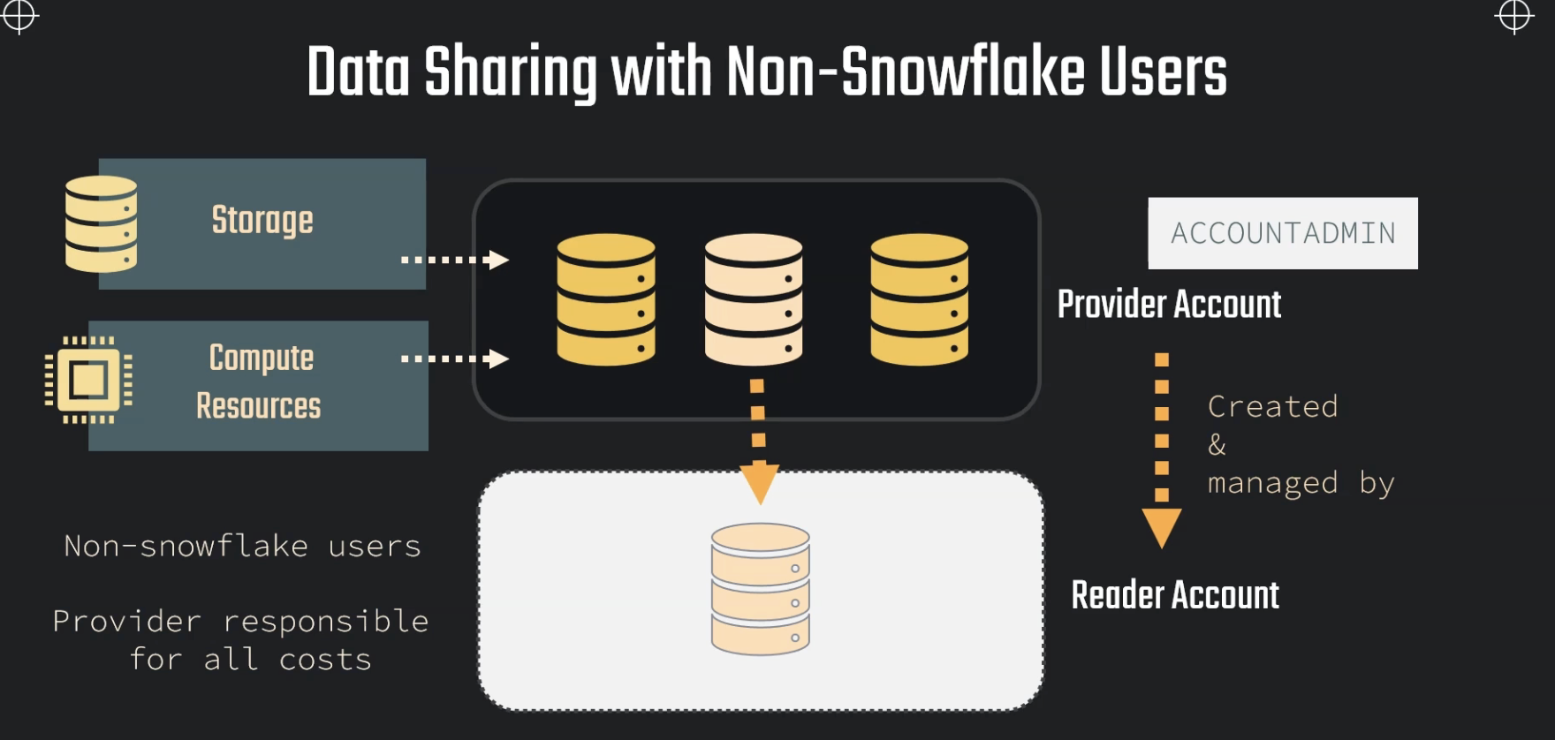

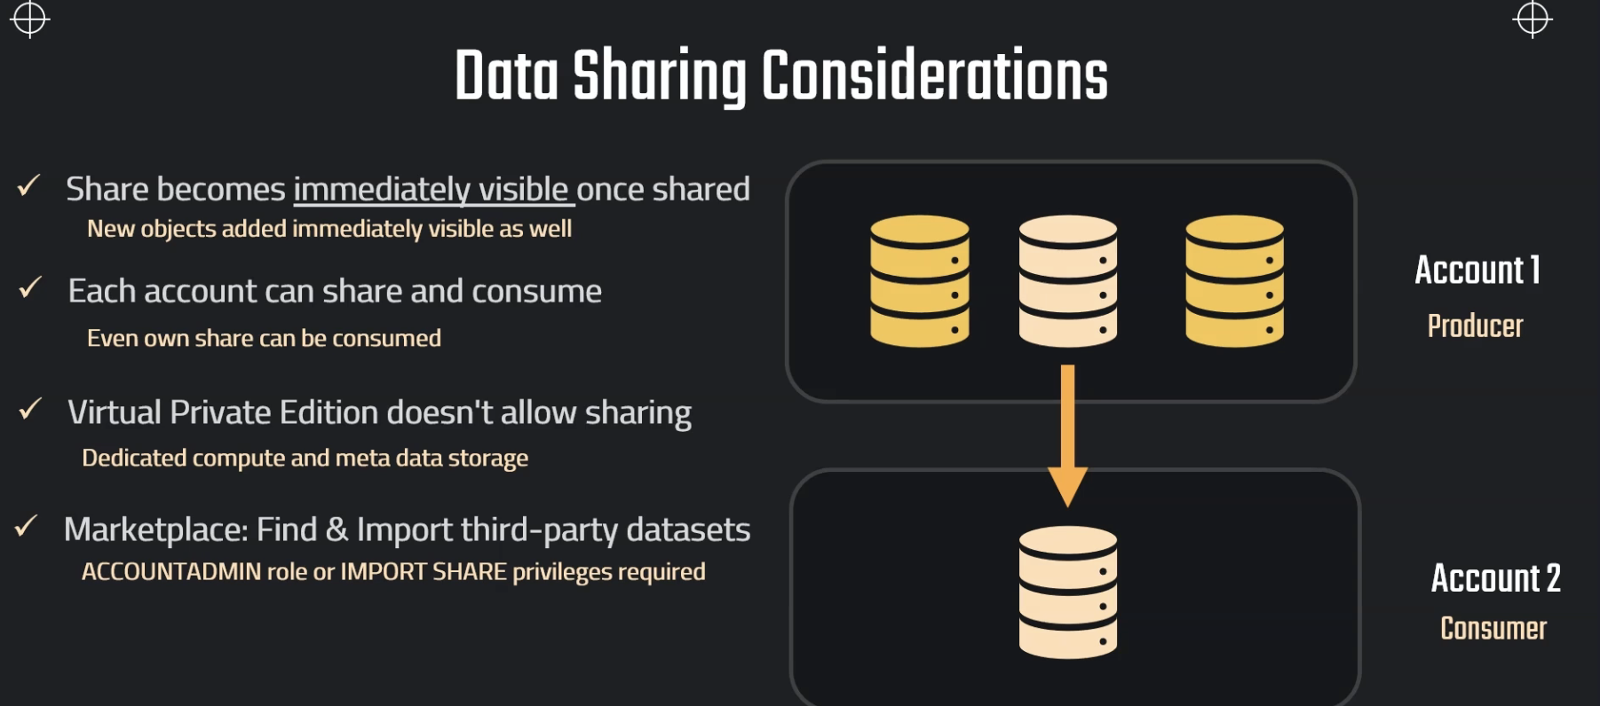

-- Create Reader Account --

CREATE MANAGED ACCOUNT tech_joy_account

ADMIN_NAME = tech_joy_admin,

ADMIN_PASSWORD = 'Bharadwaj12345',

TYPE = READER;

// Make sure to have selected the role of accountadmin

// Show accounts

SHOW MANAGED ACCOUNTS;

-- Share the data --

ALTER SHARE ORDERS_SHARE

ADD ACCOUNT = XYB26013;

ALTER SHARE ORDERS_SHARE

ADD ACCOUNT = XYB26013

SHARE_RESTRICTIONS=false;

-- Create database from share --

// Show all shares (consumer & producers)

SHOW SHARES;

// See details on share

DESC SHARE QNA46172.ORDERS_SHARE;

// Create a database in consumer account using the share

CREATE DATABASE DATA_SHARE_DB FROM SHARE <account_name_producer>.ORDERS_SHARE;

// Validate table access

SELECT * FROM DATA_SHARE_DB.PUBLIC.ORDERS;

// Setup virtual warehouse

CREATE WAREHOUSE READ_WH WITH

WAREHOUSE_SIZE='X-SMALL'

AUTO_SUSPEND = 180

AUTO_RESUME = TRUE

INITIALLY_SUSPENDED = TRUE;

Now newly created user can create further users

-- Create and set up users --

// Create user

CREATE USER MYRIAM PASSWORD = 'difficult_passw@ord=123';

// Grant usage on warehouse

GRANT USAGE ON WAREHOUSE READ_WH TO ROLE PUBLIC;

// Grating privileges on a Shared Database for other users

GRANT IMPORTED PRIVILEGES ON DATABASE DATA_SHARE_DB TO REOLE PUBLIC;

SHOW SHARES;

// Create share object

CREATE OR REPLACE SHARE COMEPLETE_SCHEMA_SHARE;

// Grant usage on dabase & schema

GRANT USAGE ON DATABASE OUR_FIRST_DB TO SHARE COMEPLETE_SCHEMA_SHARE;

GRANT USAGE ON SCHEMA OUR_FIRST_DB.PUBLIC TO SHARE COMEPLETE_SCHEMA_SHARE;

// Grant select on all tables

GRANT SELECT ON ALL TABLES IN SCHEMA OUR_FIRST_DB.PUBLIC TO SHARE COMEPLETE_SCHEMA_SHARE;

GRANT SELECT ON ALL TABLES IN DATABASE OUR_FIRST_DB TO SHARE COMEPLETE_SCHEMA_SHARE;

// Add account to share

ALTER SHARE COMEPLETE_SCHEMA_SHARE

ADD ACCOUNT=KAA74702;

// Updating data

UPDATE OUR_FIRST_DB.PUBLIC.ORDERS

SET PROFIT=0 WHERE PROFIT < 0;

// Add new table

CREATE TABLE OUR_FIRST_DB.PUBLIC.NEW_TABLE (ID int);

Sharing Views:

-- Create database & table --

CREATE OR REPLACE DATABASE CUSTOMER_DB;

CREATE OR REPLACE TABLE CUSTOMER_DB.public.customers (

id int,

first_name string,

last_name string,

email string,

gender string,

Job string,

Phone string);

// Stage and file format

CREATE OR REPLACE FILE FORMAT MANAGE_DB.file_formats.csv_file

type = csv

field_delimiter = ','

skip_header = 1;

CREATE OR REPLACE STAGE MANAGE_DB.external_stages.time_travel_stage

URL = 's3://data-snowflake-fundamentals/time-travel/'

file_format = MANAGE_DB.file_formats.csv_file;

LIST @MANAGE_DB.external_stages.time_travel_stage;

// Copy data and insert in table

COPY INTO CUSTOMER_DB.public.customers

FROM @MANAGE_DB.external_stages.time_travel_stage

files = ('customers.csv');

SELECT * FROM CUSTOMER_DB.PUBLIC.CUSTOMERS;

-- Create VIEW --

CREATE OR REPLACE VIEW CUSTOMER_DB.PUBLIC.CUSTOMER_VIEW AS

SELECT

FIRST_NAME,

LAST_NAME,

EMAIL

FROM CUSTOMER_DB.PUBLIC.CUSTOMERS

WHERE JOB != 'DATA SCIENTIST';

-- Grant usage & SELECT --

GRANT USAGE ON DATABASE CUSTOMER_DB TO ROLE PUBLIC;

GRANT USAGE ON SCHEMA CUSTOMER_DB.PUBLIC TO ROLE PUBLIC;

GRANT SELECT ON TABLE CUSTOMER_DB.PUBLIC.CUSTOMERS TO ROLE PUBLIC;

GRANT SELECT ON VIEW CUSTOMER_DB.PUBLIC.CUSTOMER_VIEW TO ROLE PUBLIC;

SHOW VIEWS LIKE '%CUSTOMER%';

-- Create SECURE VIEW --

CREATE OR REPLACE SECURE VIEW CUSTOMER_DB.PUBLIC.CUSTOMER_VIEW_SECURE AS

SELECT

FIRST_NAME,

LAST_NAME,

EMAIL

FROM CUSTOMER_DB.PUBLIC.CUSTOMERS

WHERE JOB != 'DATA SCIENTIST' ;

GRANT SELECT ON VIEW CUSTOMER_DB.PUBLIC.CUSTOMER_VIEW_SECURE TO ROLE PUBLIC;

SHOW VIEWS LIKE '%CUSTOMER%';

CREATE OR REPLACE SECURE VIEW CUSTOMER_DB.PUBLIC.CUSTOMER_VIEW_1 AS

SELECT

FIRST_NAME,

LAST_NAME,

EMAIL

FROM CUSTOMER_DB.PUBLIC.CUSTOMERS

WHERE JOB != 'DATA SCIENTIST';

Sharing Secure Views:

SHOW SHARES;

// Create share object

CREATE OR REPLACE SHARE VIEW_SHARE;

// Grant usage on dabase & schema

GRANT USAGE ON DATABASE CUSTOMER_DB TO SHARE VIEW_SHARE;

GRANT USAGE ON SCHEMA CUSTOMER_DB.PUBLIC TO SHARE VIEW_SHARE;

// Grant select on view

GRANT SELECT ON VIEW CUSTOMER_DB.PUBLIC.CUSTOMER_VIEW TO SHARE VIEW_SHARE;

GRANT SELECT ON VIEW CUSTOMER_DB.PUBLIC.CUSTOMER_VIEW_SECURE TO SHARE VIEW_SHARE;

// Add account to share

ALTER SHARE VIEW_SHARE

ADD ACCOUNT=KAA74702;

Sharing Multiple DB:”

CREATE SECURE VIEW SECURE_VIEW_M AS

SELECT

T1.ID,

T1.FIRST_NAME,

T2.JOB

FROM CUSTOMER_DB.PUBLIC.CUSTOMERS T1

INNER JOIN OUR_FIRST_DB.PUBLIC.CUSTOMERS T2

ON T1.ID = T2.ID;

SELECT * FROM SECURE_VIEW_M;

SHOW SHARES;

// Create share object

CREATE OR REPLACE SHARE VIEW_SHARE;

// Grant usage on dabase & schema

GRANT USAGE ON DATABASE CUSTOMER_DB TO SHARE VIEW_SHARE;

GRANT USAGE ON SCHEMA CUSTOMER_DB.PUBLIC TO SHARE VIEW_SHARE;

GRANT REFERENCE_USAGE ON DATABASE OUR_FIRST_DB TO SHARE VIEW_SHARE;

// Grant select on view

GRANT SELECT ON VIEW CUSTOMER_DB.PUBLIC.SECURE_VIEW_M TO SHARE VIEW_SHARE;

GRANT SELECT ON VIEW CUSTOMER_DB.PUBLIC.CUSTOMER_VIEW_SECURE TO SHARE VIEW_SHARE;

alter share VIEW_SHARE

set secure_objects_only = false;

// Add account to share

ALTER SHARE VIEW_SHARE

ADD ACCOUNT=OW45605;

Data Sampling:

And therefore the idea is instead of querying on this complete database, we would just take a, for example, random sample out of this database, out of the original database, and then we use this sample to develop. And like this, we can test if this view is now working on our data or not. So this is something that we can also use, for example, for data analysis to get some understanding. So here, of course we have the use cases for query development.

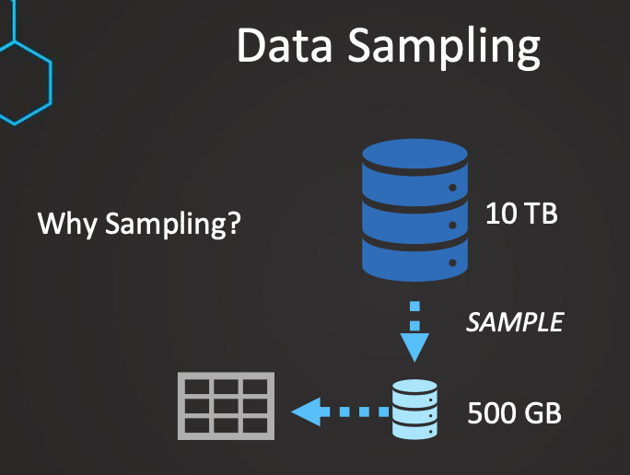

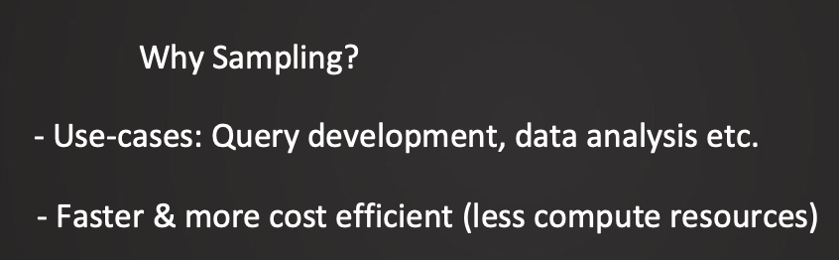

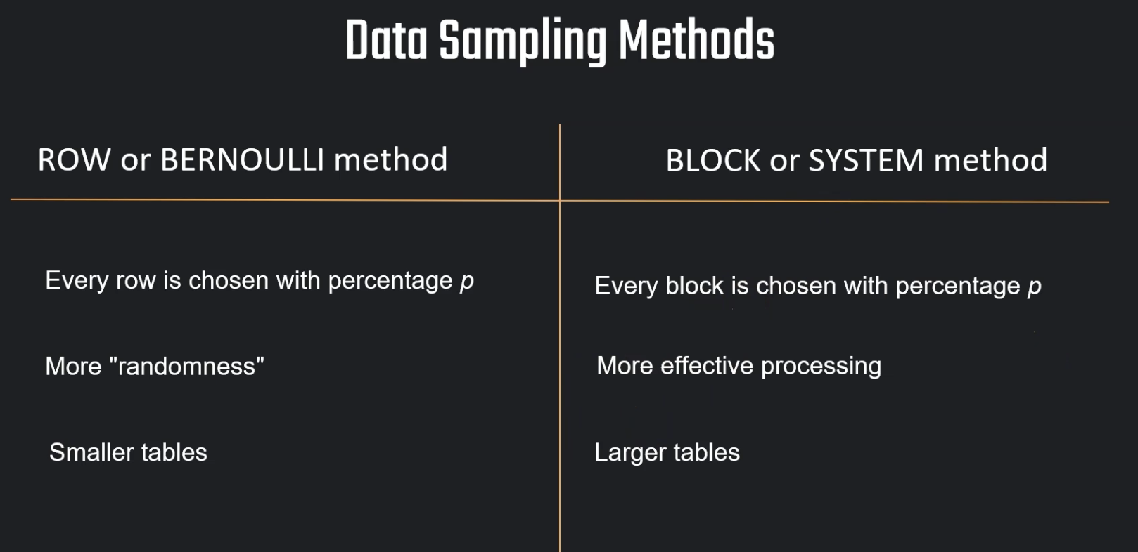

Percentage is nothing but probabi;lity of row getting picked

ROW (1) SEED(27)

1 is the percentage and seed(27) means everytime we run we get same results

CREATE OR REPLACE TRANSIENT DATABASE SAMPLING_DB;

CREATE OR REPLACE VIEW ADDRESS_SAMPLE

AS

SELECT * FROM SNOWFLAKE_SAMPLE_DATA.TPCDS_SF10TCL.CUSTOMER_ADDRESS

SAMPLE ROW (1) SEED(27);

SELECT * FROM ADDRESS_SAMPLE;

SELECT CA_LOCATION_TYPE, COUNT(*)/3254250*100

FROM ADDRESS_SAMPLE

GROUP BY CA_LOCATION_TYPE;

SELECT * FROM SNOWFLAKE_SAMPLE_DATA.TPCDS_SF10TCL.CUSTOMER_ADDRESS

SAMPLE SYSTEM (1) SEED(23);

SELECT * FROM SNOWFLAKE_SAMPLE_DATA.TPCDS_SF10TCL.CUSTOMER_ADDRESS

SAMPLE SYSTEM (10) SEED(23);

Tasks:

Educator: Now it is time to learn about tasks in Snowflake. We can use task. A task basically is just an object that stores, for example, a certain SQL statement. So they, these tasks, they can be used to execute basically some kind of a function. And this can be in the form of, for example, just a simple SQL statement. And this will be then executed, the SQL statement, for example, to insert a value or anything else. This will be then just executed at a specific time or maybe also in a specific interval. So this is something that we can create as a standalone task, or we can also create it with dependency. So that one task will be executed

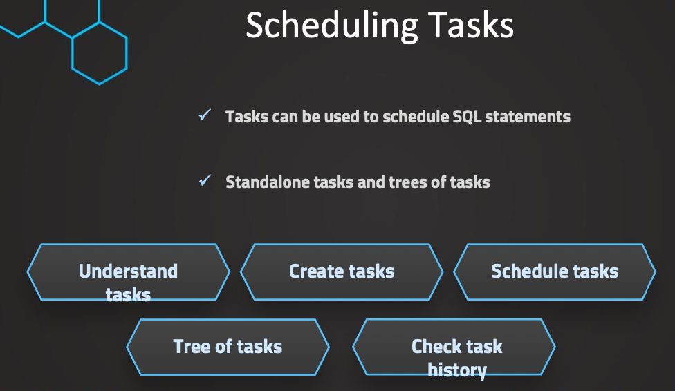

CREATE OR REPLACE TRANSIENT DATABASE TASK_DB;

// Prepare table

CREATE OR REPLACE TABLE CUSTOMERS (

CUSTOMER_ID INT AUTOINCREMENT START = 1 INCREMENT =1,

FIRST_NAME VARCHAR(40) DEFAULT 'JENNIFER' ,

CREATE_DATE DATE);

// Create task

CREATE OR REPLACE TASK CUSTOMER_INSERT

WAREHOUSE = COMPUTE_WH

SCHEDULE = '1 MINUTE'

AS

INSERT INTO CUSTOMERS(CREATE_DATE) VALUES(CURRENT_TIMESTAMP);

SHOW TASKS;

// Task starting and suspending

ALTER TASK CUSTOMER_INSERT RESUME;

ALTER TASK CUSTOMER_INSERT SUSPEND;

SELECT * FROM CUSTOMERS;

Using CRON:

CREATE OR REPLACE TASK CUSTOMER_INSERT

WAREHOUSE = COMPUTE_WH

SCHEDULE = '60 MINUTE'

AS

INSERT INTO CUSTOMERS(CREATE_DATE) VALUES(CURRENT_TIMESTAMP);

CREATE OR REPLACE TASK CUSTOMER_INSERT

WAREHOUSE = COMPUTE_WH

SCHEDULE = 'USING CRON 0 7,10 * * 5L UTC'

AS

INSERT INTO CUSTOMERS(CREATE_DATE) VALUES(CURRENT_TIMESTAMP);

# __________ minute (0-59)

# | ________ hour (0-23)

# | | ______ day of month (1-31, or L)

# | | | ____ month (1-12, JAN-DEC)

# | | | | __ day of week (0-6, SUN-SAT, or L)

# | | | | |

# | | | | |

# * * * * *

// Every minute

SCHEDULE = 'USING CRON * * * * * UTC';

// Every day at 6am UTC timezone

SCHEDULE = 'USING CRON 0 6 * * * UTC';

// Every hour starting at 9 AM and ending at 5 PM on Sundays

SCHEDULE = 'USING CRON 0 9-17 * * SUN America/Los_Angeles';

CREATE OR REPLACE TASK CUSTOMER_INSERT

WAREHOUSE = COMPUTE_WH

SCHEDULE = 'USING CRON 0 9,17 * * * UTC'

AS

INSERT INTO CUSTOMERS(CREATE_DATE) VALUES(CURRENT_TIMESTAMP);

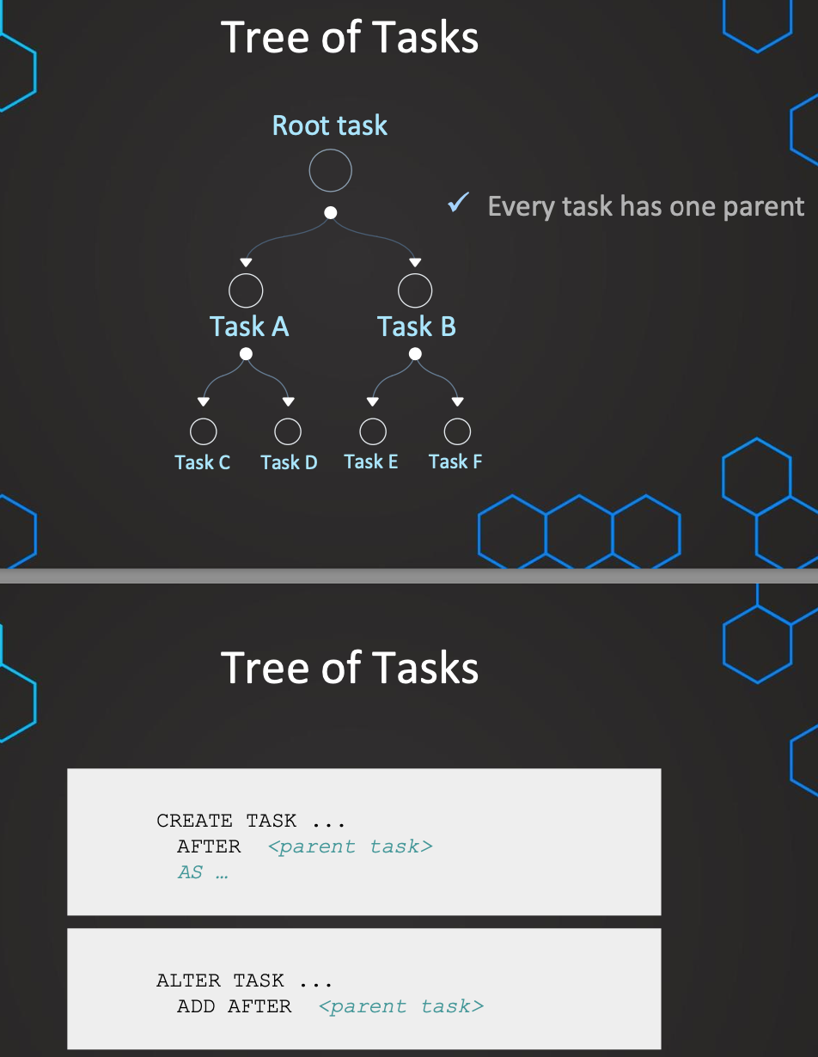

USE TASK_DB;

SHOW TASKS;

SELECT * FROM CUSTOMERS;

// Prepare a second table

CREATE OR REPLACE TABLE CUSTOMERS2 (

CUSTOMER_ID INT,

FIRST_NAME VARCHAR(40),

CREATE_DATE DATE);

// Suspend parent task

// **NOTE: Before modifying anything in the tree of tasks the root task needs to be suspended**

ALTER TASK CUSTOMER_INSERT SUSPEND;

// Create a child task

CREATE OR REPLACE TASK CUSTOMER_INSERT2

WAREHOUSE = MY_WH

AFTER CUSTOMER_INSERT

AS

INSERT INTO CUSTOMERS2 SELECT * FROM CUSTOMERS;

// Prepare a third table

CREATE OR REPLACE TABLE CUSTOMERS3 (

CUSTOMER_ID INT,

FIRST_NAME VARCHAR(40),

CREATE_DATE DATE,

INSERT_DATE DATE DEFAULT DATE(CURRENT_TIMESTAMP));

// Create a child task

CREATE OR REPLACE TASK CUSTOMER_INSERT3

WAREHOUSE = MY_WH

AFTER CUSTOMER_INSERT2

AS

INSERT INTO CUSTOMERS3 (CUSTOMER_ID,FIRST_NAME,CREATE_DATE) SELECT * FROM CUSTOMERS2;

SHOW TASKS;

ALTER TASK CUSTOMER_INSERT

SET SCHEDULE = '1 MINUTE';

// Resume tasks (first resume child tasks)

ALTER TASK CUSTOMER_INSERT3 RESUME;

ALTER TASK CUSTOMER_INSERT2 RESUME;

// Resume tasks (then resume root task)

ALTER TASK CUSTOMER_INSERT RESUME;

// Recursively resumes a specified task and all its dependent tasks

SELECT SYSTEM$TASK_DEPENDENTS_ENABLE( '<task_name>' )

SELECT * FROM CUSTOMERS2;

SELECT * FROM CUSTOMERS3;

// Suspend tasks again

ALTER TASK CUSTOMER_INSERT SUSPEND;

ALTER TASK CUSTOMER_INSERT2 SUSPEND;

ALTER TASK CUSTOMER_INSERT3 SUSPEND;

While starting task first child tasks should be started and then parent and while suspending parent task should be suspended first and then child task

// Create a stored procedure

USE TASK_DB;

SELECT * FROM CUSTOMERS;

CREATE OR REPLACE PROCEDURE CUSTOMERS_INSERT_PROCEDURE (CREATE_DATE varchar)

RETURNS STRING NOT NULL

LANGUAGE JAVASCRIPT

AS

$$

var sql_command = 'INSERT INTO CUSTOMERS(CREATE_DATE) VALUES(:1);'

snowflake.execute(

{

sqlText: sql_command,

binds: [CREATE_DATE]

});

return "Successfully executed.";

$$;

CREATE OR REPLACE TASK CUSTOMER_TAKS_PROCEDURE

WAREHOUSE = COMPUTE_WH

SCHEDULE = '1 MINUTE'

AS CALL CUSTOMERS_INSERT_PROCEDURE (CURRENT_TIMESTAMP);

SHOW TASKS;

ALTER TASK CUSTOMER_TAKS_PROCEDURE RESUME;

SELECT * FROM CUSTOMERS;

Monitor Tasks:

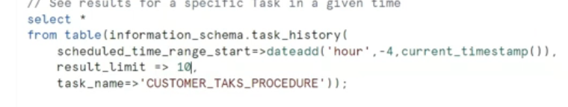

Tasks with COndition

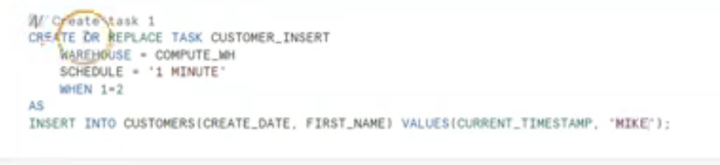

Streams:

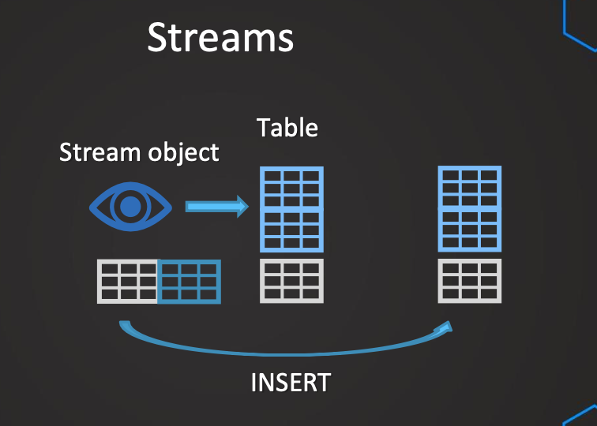

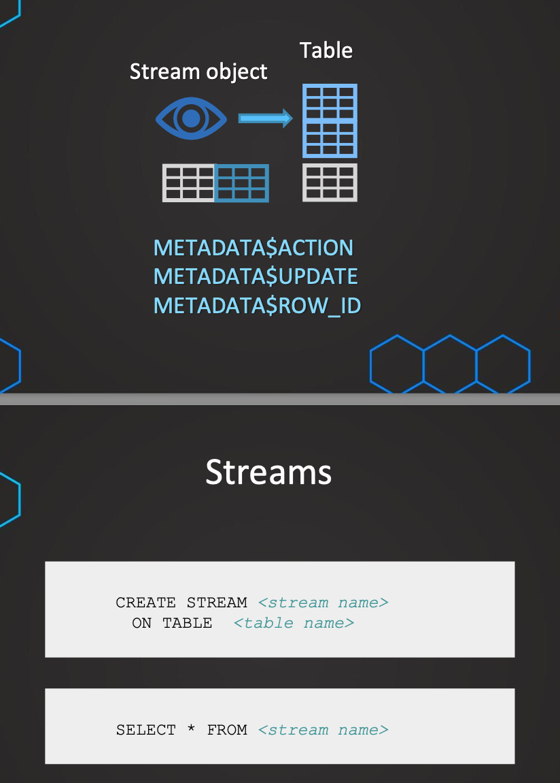

In DW we do bulk upload only for first time and then we do delta inserts, which can involve insert, update or delete. Streams is an object which captures only these DML changes and we can even query the same, once streams are added to destination table it will be removed

Streams Inserts

-------------------- Stream example: INSERT ------------------------

CREATE OR REPLACE TRANSIENT DATABASE STREAMS_DB;

-- Create example table

create or replace table sales_raw_staging(

id varchar,

product varchar,

price varchar,

amount varchar,

store_id varchar);

-- insert values

insert into sales_raw_staging

values

(1,'Banana',1.99,1,1),

(2,'Lemon',0.99,1,1),

(3,'Apple',1.79,1,2),

(4,'Orange Juice',1.89,1,2),

(5,'Cereals',5.98,2,1);

create or replace table store_table(

store_id number,

location varchar,

employees number);

INSERT INTO STORE_TABLE VALUES(1,'Chicago',33);

INSERT INTO STORE_TABLE VALUES(2,'London',12);

create or replace table sales_final_table(

id int,

product varchar,

price number,

amount int,

store_id int,

location varchar,

employees int);

-- Insert into final table

INSERT INTO sales_final_table

SELECT

SA.id,

SA.product,

SA.price,

SA.amount,

ST.STORE_ID,

ST.LOCATION,

ST.EMPLOYEES

FROM SALES_RAW_STAGING SA

JOIN STORE_TABLE ST ON ST.STORE_ID=SA.STORE_ID ;

-- Create a stream object

create or replace stream sales_stream on table sales_raw_staging;

SHOW STREAMS;

DESC STREAM sales_stream;

-- Get changes on data using stream (INSERTS)

select * from sales_stream;

select * from sales_raw_staging;

-- insert values

insert into sales_raw_staging

values

(6,'Mango',1.99,1,2),

(7,'Garlic',0.99,1,1);

-- Get changes on data using stream (INSERTS)

select * from sales_stream;

select * from sales_raw_staging;

select * from sales_final_table;

-- Consume stream object

INSERT INTO sales_final_table

SELECT

SA.id,

SA.product,

SA.price,

SA.amount,

ST.STORE_ID,

ST.LOCATION,

ST.EMPLOYEES

FROM SALES_STREAM SA

JOIN STORE_TABLE ST ON ST.STORE_ID=SA.STORE_ID ;

-- Get changes on data using stream (INSERTS)

select * from sales_stream;

-- insert values

insert into sales_raw_staging

values

(8,'Paprika',4.99,1,2),

(9,'Tomato',3.99,1,2);

-- Consume stream object

INSERT INTO sales_final_table

SELECT

SA.id,

SA.product,

SA.price,

SA.amount,

ST.STORE_ID,

ST.LOCATION,

ST.EMPLOYEES

FROM SALES_STREAM SA

JOIN STORE_TABLE ST ON ST.STORE_ID=SA.STORE_ID ;

SELECT * FROM SALES_FINAL_TABLE;

SELECT * FROM SALES_RAW_STAGING;

SELECT * FROM SALES_STREAM;

Streams Update:

-- ******* UPDATE 1 ********

SELECT * FROM SALES_RAW_STAGING;

SELECT * FROM SALES_STREAM;

UPDATE SALES_RAW_STAGING

SET PRODUCT ='Potato' WHERE PRODUCT = 'Banana';

merge into SALES_FINAL_TABLE F -- Target table to merge changes from source table

using SALES_STREAM S -- Stream that has captured the changes

on f.id = s.id

when matched

and S.METADATA$ACTION ='INSERT'

and S.METADATA$ISUPDATE ='TRUE' -- Indicates the record has been updated

then update

set f.product = s.product,

f.price = s.price,

f.amount= s.amount,

f.store_id=s.store_id;

SELECT * FROM SALES_FINAL_TABLE;

SELECT * FROM SALES_RAW_STAGING;

SELECT * FROM SALES_STREAM;

-- ******* UPDATE 2 ********

UPDATE SALES_RAW_STAGING

SET PRODUCT ='Green apple' WHERE PRODUCT = 'Apple';

merge into SALES_FINAL_TABLE F -- Target table to merge changes from source table

using SALES_STREAM S -- Stream that has captured the changes

on f.id = s.id

when matched

and S.METADATA$ACTION ='INSERT'

and S.METADATA$ISUPDATE ='TRUE' -- Indicates the record has been updated

then update

set f.product = s.product,

f.price = s.price,

f.amount= s.amount,

f.store_id=s.store_id;

SELECT * FROM SALES_FINAL_TABLE;

SELECT * FROM SALES_RAW_STAGING;

SELECT * FROM SALES_STREAM;

Streams uses offsets:

In Snowflake, **streams** are a change data capture (CDC) feature that tracks changes to a table (inserts, updates, and deletes) and allows you to query those changes. Snowflake streams are helpful for maintaining data consistency between tables or between Snowflake and external systems.

Regarding **offsets in streams**, Snowflake's streams do not directly support the traditional concept of "offsets" as found in systems like Kafka, but there are mechanisms to track and process changes in an ordered manner.

Instructor: In the last lecture we have learned about the offset and we have learned that the offset is essentially remembering the state of the table and then from this moment on, it'll track the changes.

When stream is created it will have an expiry and once it cross expiry we call it stale

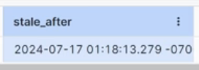

An additional thing is that the stream, even though the time is set to one day for the parameter data retention time in days, this is usually extended up to 14 days. And this is regardless of the version that we are using. So even if the addition that we are using in Snowflake is just the standard edition, this will anyways be extended up to 14 days. So this is exactly this parameter MAX_DATA_RETENTION_TIME_IN_DAYS.

-------------------- Stream example: STALENESS ------------------------

SHOW STREAMS;

DESC STREAM sales_stream;

-- View Retention time

SHOW PARAMETERS IN TABLE sales_raw_staging;

-- Change retention time

ALTER TABLE sales_raw_staging

SET MAX_DATA_EXTENSION_TIME_IN_DAYS = 34;

Minimal-set-of-changes:

Suppose If I update same value with multiple new values, it will only consider the latest value not the intermediate value

-- ******* How Changes are captured ********

USE STREAMS_DB_OFFSET.PUBLIC;

SELECT * FROM SALES_RAW_STAGING;

SELECT * FROM SALES_STREAM;

UPDATE SALES_RAW_STAGING

SET PRODUCT ='Potato' WHERE PRODUCT = 'Banana';

SET PRODUCT ='Potato-NEW' WHERE PRODUCT = 'Potato';

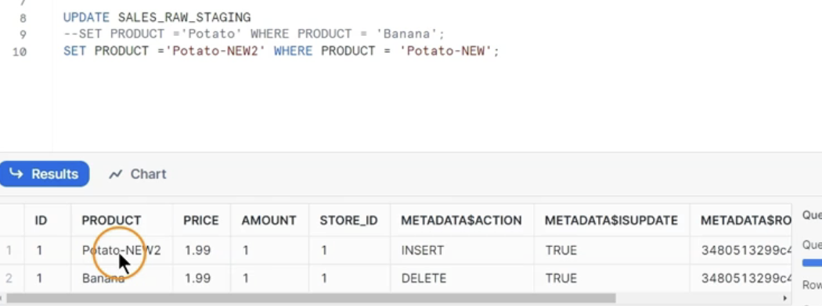

Delete from stream:

-- ******* DELETE ********

SELECT * FROM SALES_FINAL_TABLE;

SELECT * FROM SALES_RAW_STAGING;

SELECT * FROM SALES_STREAM;

DELETE FROM SALES_RAW_STAGING

WHERE PRODUCT = 'Lemon';

-- ******* Process stream ********

merge into SALES_FINAL_TABLE F -- Target table to merge changes from source table

using SALES_STREAM S -- Stream that has captured the changes

on f.id = s.id

when matched

and S.METADATA$ACTION ='DELETE'

and S.METADATA$ISUPDATE = 'FALSE'

then delete ;

All Operations:

merge into SALES_FINAL_TABLE F -- Target table to merge changes from source table

USING ( SELECT STRE.*,ST.location,ST.employees

FROM SALES_STREAM STRE

JOIN STORE_TABLE ST

ON STRE.store_id = ST.store_id

) S

ON F.id=S.id

when matched -- DELETE condition

and S.METADATA$ACTION ='DELETE'

and S.METADATA$ISUPDATE = 'FALSE'

then delete

when matched -- UPDATE condition

and S.METADATA$ACTION ='INSERT'

and S.METADATA$ISUPDATE = 'TRUE'

then update

set f.product = s.product,

f.price = s.price,

f.amount= s.amount,

f.store_id=s.store_id

when not matched

and S.METADATA$ACTION ='INSERT'

then insert

(id,product,price,store_id,amount,employees,location)

values

(s.id, s.product,s.price,s.store_id,s.amount,s.employees,s.location);

Streams & Tasks:

------- Automatate the updates using tasks --

CREATE OR REPLACE TASK all_data_changes

WAREHOUSE = COMPUTE_WH

SCHEDULE = '1 MINUTE'

WHEN SYSTEM$STREAM_HAS_DATA('SALES_STREAM')

AS

merge into SALES_FINAL_TABLE F -- Target table to merge changes from source table

USING ( SELECT STRE.*,ST.location,ST.employees

FROM SALES_STREAM STRE

JOIN STORE_TABLE ST

ON STRE.store_id = ST.store_id

) S

ON F.id=S.id

when matched -- DELETE condition

and S.METADATA$ACTION ='DELETE'

and S.METADATA$ISUPDATE = 'FALSE'

then delete

when matched -- UPDATE condition

and S.METADATA$ACTION ='INSERT'

and S.METADATA$ISUPDATE = 'TRUE'

then update

set f.product = s.product,

f.price = s.price,

f.amount= s.amount,

f.store_id=s.store_id

when not matched

and S.METADATA$ACTION ='INSERT'

then insert

(id,product,price,store_id,amount,employees,location)

values

(s.id, s.product,s.price,s.store_id,s.amount,s.employees,s.location);

ALTER TASK all_data_changes RESUME;

SHOW TASKS;

// Change data

INSERT INTO SALES_RAW_STAGING VALUES (11,'Milk',1.99,1,2);

INSERT INTO SALES_RAW_STAGING VALUES (12,'Chocolate',4.49,1,2);

INSERT INTO SALES_RAW_STAGING VALUES (13,'Cheese',3.89,1,1);

UPDATE SALES_RAW_STAGING

SET PRODUCT = 'Chocolate bar'

WHERE PRODUCT ='Chocolate';

DELETE FROM SALES_RAW_STAGING

WHERE PRODUCT = 'Mango';

// Verify results

SELECT * FROM SALES_RAW_STAGING;

SELECT * FROM SALES_STREAM;

SELECT * FROM SALES_FINAL_TABLE;

// Verify the history

select *

from table(information_schema.task_history())

order by name asc,scheduled_time desc;

Append Only Streams:

So the issue with our default streams can be sometimes that we have maybe, let's say we have a huge table and then we just want to truncate this table. Well this can make our stream explode in some way. So it is not very good for the performance. If our ETL for example, relies only on inserts. So we don't want to track any deletes or any updates because maybe this occurs frequently in our table

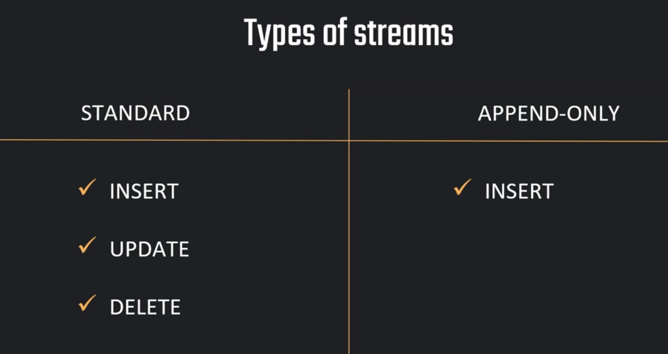

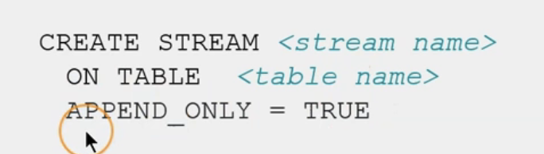

We can’t alter it, we can only recreate it

Append Stream:

------- Append-only type ------

USE STREAMS_DB;

SHOW STREAMS;

SELECT * FROM SALES_RAW_STAGING;

-- Create stream with default

CREATE OR REPLACE STREAM SALES_STREAM_DEFAULT

ON TABLE SALES_RAW_STAGING;

-- Create stream with append-only

CREATE OR REPLACE STREAM SALES_STREAM_APPEND

ON TABLE SALES_RAW_STAGING

APPEND_ONLY = TRUE;

-- View streams

SHOW STREAMS;

-- Insert values

INSERT INTO SALES_RAW_STAGING VALUES (14,'Honey',4.99,1,1);

INSERT INTO SALES_RAW_STAGING VALUES (15,'Coffee',4.89,1,2);

INSERT INTO SALES_RAW_STAGING VALUES (15,'Coffee',4.89,1,2);

SELECT * FROM SALES_STREAM_APPEND;

SELECT * FROM SALES_STREAM_DEFAULT;

-- Delete values

SELECT * FROM SALES_RAW_STAGING;

DELETE FROM SALES_RAW_STAGING WHERE ID=7;

SELECT * FROM SALES_STREAM_APPEND;

SELECT * FROM SALES_STREAM_DEFAULT;

-- Consume stream via "CREATE TABLE ... AS"

CREATE OR REPLACE TEMPORARY TABLE PRODUCT_TABLE

AS SELECT * FROM SALES_STREAM_DEFAULT;

CREATE OR REPLACE TEMPORARY TABLE PRODUCT_TABLE

AS SELECT * FROM SALES_STREAM_APPEND;

-- Update

UPDATE SALES_RAW_STAGING

SET PRODUCT = 'Coffee 200g'

WHERE PRODUCT ='Coffee';

SELECT * FROM SALES_STREAM_APPEND;

SELECT * FROM SALES_STREAM;

Change Clause:

It is similar to stream but bit more manual, where we have more control in setting offset

----- Change clause ------

--- Create example db & table ---

CREATE OR REPLACE DATABASE SALES_DB;

create or replace table sales_raw(

id varchar,

product varchar,

price varchar,

amount varchar,

store_id varchar);

-- insert values

insert into sales_raw

values

(1, 'Eggs', 1.39, 1, 1),

(2, 'Baking powder', 0.99, 1, 1),

(3, 'Eggplants', 1.79, 1, 2),

(4, 'Ice cream', 1.89, 1, 2),

(5, 'Oats', 1.98, 2, 1);

ALTER TABLE sales_raw

SET CHANGE_TRACKING = TRUE;

SELECT * FROM SALES_RAW

CHANGES(information => default)

AT (offset => -0.5*60);

SELECT CURRENT_TIMESTAMP;

-- Insert values

INSERT INTO SALES_RAW VALUES (6, 'Bread', 2.99, 1, 2);

INSERT INTO SALES_RAW VALUES (7, 'Onions', 2.89, 1, 2);

SELECT * FROM SALES_RAW

CHANGES(information => default)

AT (timestamp => '2025-03-17 00:56:57.636 -0700'::timestamp_tz);

UPDATE SALES_RAW

SET PRODUCT = 'Toast2' WHERE ID=6;

// information value

SELECT * FROM SALES_RAW

CHANGES(information => default)

AT (timestamp => 'your-timestamp'::timestamp_tz);

SELECT * FROM SALES_RAW

CHANGES(information => append_only)

AT (timestamp => 'your-timestamp'::timestamp_tz);

CREATE OR REPLACE TABLE PRODUCTS

AS

SELECT * FROM SALES_RAW

CHANGES(information => append_only)

AT (timestamp => 'your-timestamp'::timestamp_tz);

SELECT * FROM PRODUCTS;

Materialized Views:

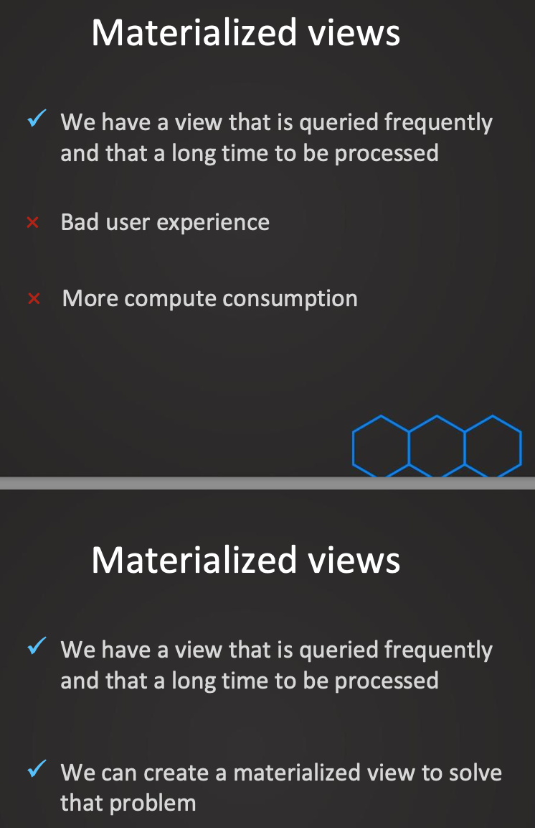

-- Remove caching just to have a fair test -- Part 1

ALTER SESSION SET USE_CACHED_RESULT=FALSE; -- disable global caching

ALTER warehouse my_wh suspend;

ALTER warehouse my_wh resume;

-- Prepare table

CREATE OR REPLACE TRANSIENT DATABASE ORDERS;

CREATE OR REPLACE SCHEMA TPCH_SF100;

CREATE OR REPLACE TABLE TPCH_SF100.ORDERS AS

SELECT * FROM SNOWFLAKE_SAMPLE_DATA.TPCH_SF100.ORDERS;

SELECT * FROM ORDERS LIMIT 100;

-- Example statement view --

SELECT

YEAR(O_ORDERDATE) AS YEAR,

MAX(O_COMMENT) AS MAX_COMMENT,

MIN(O_COMMENT) AS MIN_COMMENT,

MAX(O_CLERK) AS MAX_CLERK,

MIN(O_CLERK) AS MIN_CLERK

FROM ORDERS.TPCH_SF100.ORDERS

GROUP BY YEAR(O_ORDERDATE)

ORDER BY YEAR(O_ORDERDATE);

-- Create materialized view

CREATE OR REPLACE MATERIALIZED VIEW ORDERS_MV

AS

SELECT

YEAR(O_ORDERDATE) AS YEAR,

MAX(O_COMMENT) AS MAX_COMMENT,

MIN(O_COMMENT) AS MIN_COMMENT,

MAX(O_CLERK) AS MAX_CLERK,

MIN(O_CLERK) AS MIN_CLERK

FROM ORDERS.TPCH_SF100.ORDERS

GROUP BY YEAR(O_ORDERDATE);

SHOW MATERIALIZED VIEWS;

-- Query view

SELECT * FROM ORDERS_MV

ORDER BY YEAR;

-- UPDATE or DELETE values

UPDATE ORDERS

SET O_CLERK='Clerk#99900000'

WHERE O_ORDERDATE='1992-01-01';

-- Test updated data --

-- Example statement view --

SELECT

YEAR(O_ORDERDATE) AS YEAR,

MAX(O_COMMENT) AS MAX_COMMENT,

MIN(O_COMMENT) AS MIN_COMMENT,

MAX(O_CLERK) AS MAX_CLERK,

MIN(O_CLERK) AS MIN_CLERK

FROM ORDERS_MV

GROUP BY YEAR(O_ORDERDATE)

ORDER BY YEAR(O_ORDERDATE);

-- Query view

SELECT * FROM ORDERS_MV

ORDER BY YEAR;

SHOW MATERIALIZED VIEWS;

In materialized when update is done, refresh is done automatically but If I update many records and run select immediately then based on refresh time, it will go to underlying data to get latest records

So like this we can see that the refresh is going on and it will be managed by snowflake. But if we are behind then we can be still sure that the data is always up to date. So this is very beneficial because then we can always see the most up to date data anyways. And also therefore we now in the next lecture quickly want to also talk about this maintenance and how the cost involved is affecting this and how we should decide because yeah, maybe this performance boost is not enough to make up for the maintenance cost.

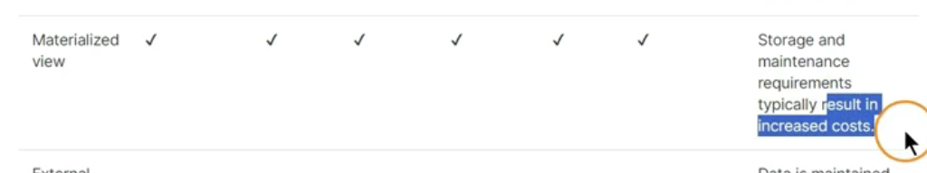

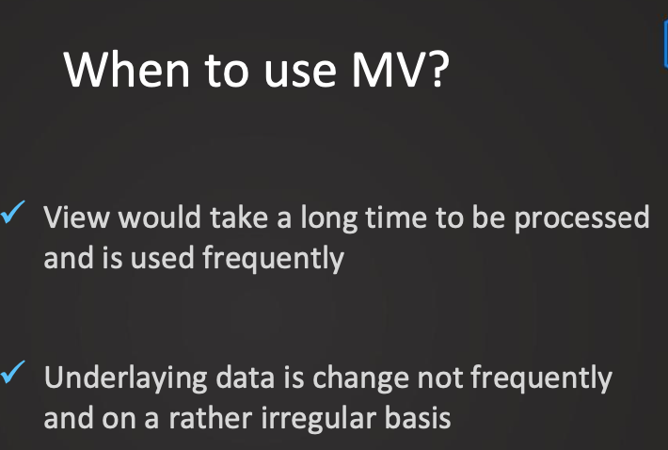

When Not to use MV

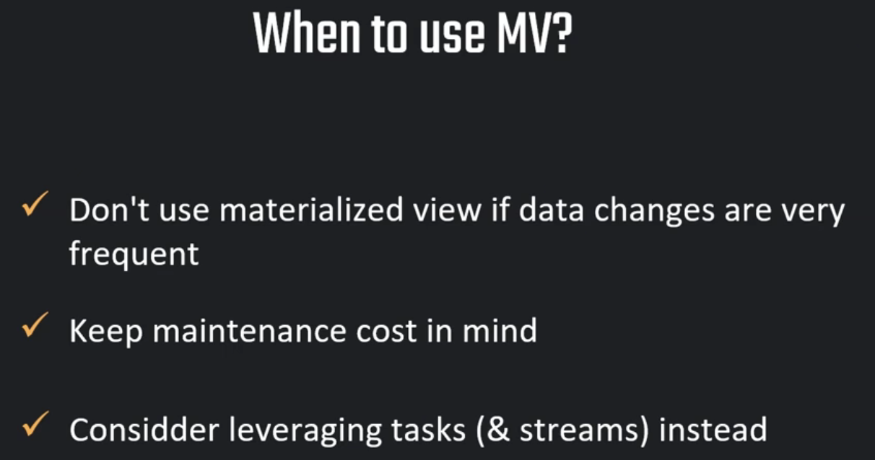

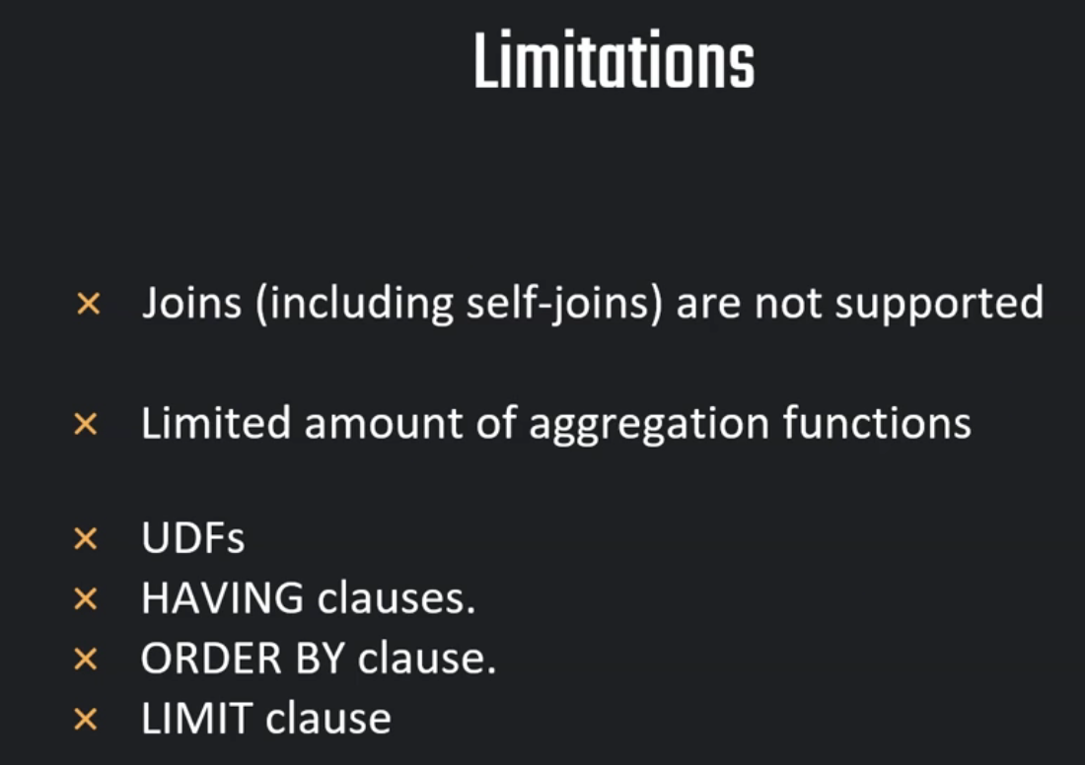

Dynamic Data Masking:

So what is dynamic data masking. The purpose of this is if we have a table with, for example, some kind of personal information. And this we would like to protect. In this case we can use dynamic data masking. So this ensures that before the query is executed actually only masked results are returned. And this way the sensitive data is not visible. And we have full control over which role sees what kind of data and other roles.

USE DEMO_DB;

USE ROLE ACCOUNTADMIN;

-- Prepare table --

create or replace table customers(

id number,

full_name varchar,

email varchar,

phone varchar,

spent number,

create_date DATE DEFAULT CURRENT_DATE);

-- insert values in table --

insert into customers (id, full_name, email,phone,spent)

values

(1,'Lewiss MacDwyer','lmacdwyer0@un.org','262-665-9168',140),

(2,'Ty Pettingall','tpettingall1@mayoclinic.com','734-987-7120',254),

(3,'Marlee Spadazzi','mspadazzi2@txnews.com','867-946-3659',120),

(4,'Heywood Tearney','htearney3@patch.com','563-853-8192',1230),

(5,'Odilia Seti','oseti4@globo.com','730-451-8637',143),

(6,'Meggie Washtell','mwashtell5@rediff.com','568-896-6138',600);

-- set up roles

CREATE OR REPLACE ROLE ANALYST_MASKED;

CREATE OR REPLACE ROLE ANALYST_FULL;

-- grant select on table to roles

GRANT SELECT ON TABLE DEMO_DB.PUBLIC.CUSTOMERS TO ROLE ANALYST_MASKED;

GRANT SELECT ON TABLE DEMO_DB.PUBLIC.CUSTOMERS TO ROLE ANALYST_FULL;

GRANT USAGE ON SCHEMA DEMO_DB.PUBLIC TO ROLE ANALYST_MASKED;

GRANT USAGE ON SCHEMA DEMO_DB.PUBLIC TO ROLE ANALYST_FULL;

GRANT USAGE ON DATABASE DEMO_DB TO ROLE ANALYST_MASKED;

GRANT USAGE ON DATABASE DEMO_DB TO ROLE ANALYST_FULL;

-- grant warehouse access to roles

GRANT USAGE ON WAREHOUSE MY_WH TO ROLE ANALYST_MASKED;

GRANT USAGE ON WAREHOUSE MY_WH TO ROLE ANALYST_FULL;

-- assign roles to a user

GRANT ROLE ANALYST_MASKED TO USER ATULLUTA;

GRANT ROLE ANALYST_FULL TO USER ATULLUTA;

-- Set up masking policy

create or replace masking policy phone

as (val varchar) returns varchar ->

case

when current_role() in ('ANALYST_FULL', 'ACCOUNTADMIN') then val

else '##-###-##'

end;

-- Apply policy on a specific column

ALTER TABLE IF EXISTS CUSTOMERS MODIFY COLUMN phone

SET MASKING POLICY PHONE;

-- Validating policies

USE ROLE ANALYST_FULL;

SELECT * FROM CUSTOMERS;

USE ROLE ANALYST_MASKED;

SELECT * FROM CUSTOMERS;

#### More examples #####

USE ROLE ACCOUNTADMIN;

--- 1) Apply policy to multiple columns

-- Apply policy on a specific column

ALTER TABLE IF EXISTS CUSTOMERS MODIFY COLUMN full_name

SET MASKING POLICY phone;

-- Apply policy on another specific column

ALTER TABLE IF EXISTS CUSTOMERS MODIFY COLUMN phone

SET MASKING POLICY phone;

--- 2) Replace or drop policy

DROP masking policy phone;

create or replace masking policy phone as (val varchar) returns varchar ->

case

when current_role() in ('ANALYST_FULL', 'ACCOUNTADMIN') then val

else CONCAT(LEFT(val,2),'*******')

end;

-- List and describe policies

DESC MASKING POLICY phone;

SHOW MASKING POLICIES;

-- Show columns with applied policies

SELECT * FROM table(information_schema.policy_references(policy_name=>'phone'));

-- Remove policy before replacing/dropping

ALTER TABLE IF EXISTS CUSTOMERS MODIFY COLUMN full_name

SET MASKING POLICY phone;

ALTER TABLE IF EXISTS CUSTOMERS MODIFY COLUMN email

UNSET MASKING POLICY;

ALTER TABLE IF EXISTS CUSTOMERS MODIFY COLUMN phone

UNSET MASKING POLICY;

-- replace policy

create or replace masking policy names as (val varchar) returns varchar ->

case

when current_role() in ('ANALYST_FULL', 'ACCOUNTADMIN') then val

else CONCAT(LEFT(val,2),'*******')

end;

-- apply policy

ALTER TABLE IF EXISTS CUSTOMERS MODIFY COLUMN full_name

SET MASKING POLICY names;

-- Validating policies

USE ROLE ANALYST_FULL;

SELECT * FROM CUSTOMERS;

USE ROLE ANALYST_MASKED;

SELECT * FROM CUSTOMERS;

So once a policy is applied to a column, we cannot delete it. We cannot drop it. So how we do this is we would have to first unset this policy, because otherwise if I let me again use the account admin I would try to drop this policy. I would see that this wouldn't work. So here we can see cannot be dropped or replaced as it is associated with one or more entities. we need to unset it and re-apply it So this is what we have to take away from this lecture is that once we have applied a policy, we cannot delete it, we cannot drop it or replace it. So we would have to first find out to which column this is applied on for which we can use this command. And then afterwards we can maybe unset it from the column so that it's not associated anymore. And then we can recreate it. Or we can also drop it. Hope it was helpful and see you in the next lecture.

We can set new body to the masking policy

-- Alter existing policies

USE ROLE ANALYST_MASKED;

SELECT * FROM CUSTOMERS;

USE ROLE ACCOUNTADMIN;

alter masking policy phone set body ->

case

when current_role() in ('ANALYST_FULL', 'ACCOUNTADMIN') then val

else '**-**-**'

end;

ALTER TABLE CUSTOMERS MODIFY COLUMN email UNSET MASKING POLICY;

### More examples - 1 - ###

USE ROLE ACCOUNTADMIN;

create or replace masking policy emails as (val varchar) returns varchar ->

case

when current_role() in ('ANALYST_FULL') then val

when current_role() in ('ANALYST_MASKED') then regexp_replace(val,'.+\@','*****@') -- leave email domain unmasked

else '********'

end;

-- apply policy

ALTER TABLE IF EXISTS CUSTOMERS MODIFY COLUMN email

SET MASKING POLICY emails;

-- Validating policies

USE ROLE ANALYST_FULL;

SELECT * FROM CUSTOMERS;

USE ROLE ANALYST_MASKED;

SELECT * FROM CUSTOMERS;

USE ROLE ACCOUNTADMIN;

### More examples - 2 - ###

create or replace masking policy sha2 as (val varchar) returns varchar ->

case

when current_role() in ('ANALYST_FULL') then val

else sha2(val) -- return hash of the column value

end;

-- apply policy

ALTER TABLE IF EXISTS CUSTOMERS MODIFY COLUMN full_name

SET MASKING POLICY sha2;

ALTER TABLE IF EXISTS CUSTOMERS MODIFY COLUMN full_name

UNSET MASKING POLICY;

-- Validating policies

USE ROLE ANALYST_FULL;

SELECT * FROM CUSTOMERS;

USE ROLE ANALYST_MASKED;

SELECT * FROM CUSTOMERS;

USE ROLE ACCOUNTADMIN;

### More examples - 3 - ###

create or replace masking policy dates as (val date) returns date ->

case

when current_role() in ('ANALYST_FULL') then val

else date_from_parts(0001, 01, 01)::date -- returns 0001-01-01 00:00:00.000

end;

-- Apply policy on a specific column

ALTER TABLE IF EXISTS CUSTOMERS MODIFY COLUMN create_date

SET MASKING POLICY dates;

-- Validating policies

USE ROLE ANALYST_FULL;

SELECT * FROM CUSTOMERS;

USE ROLE ANALYST_MASKED;

SELECT * FROM CUSTOMERS;

Access Control:

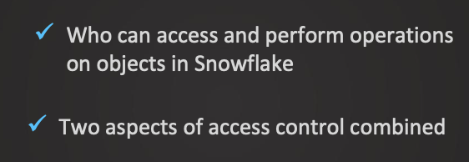 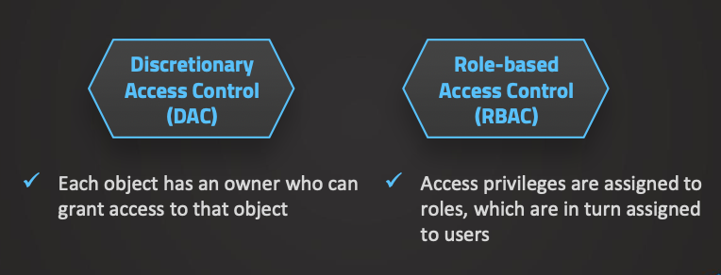

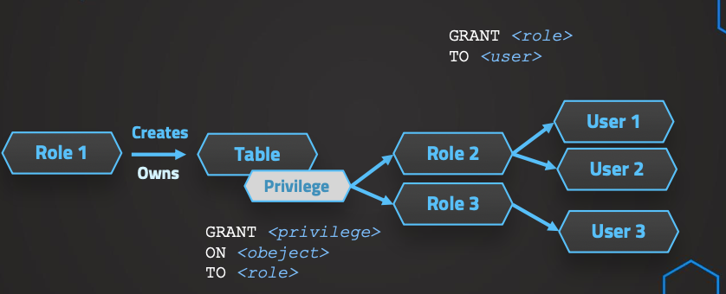

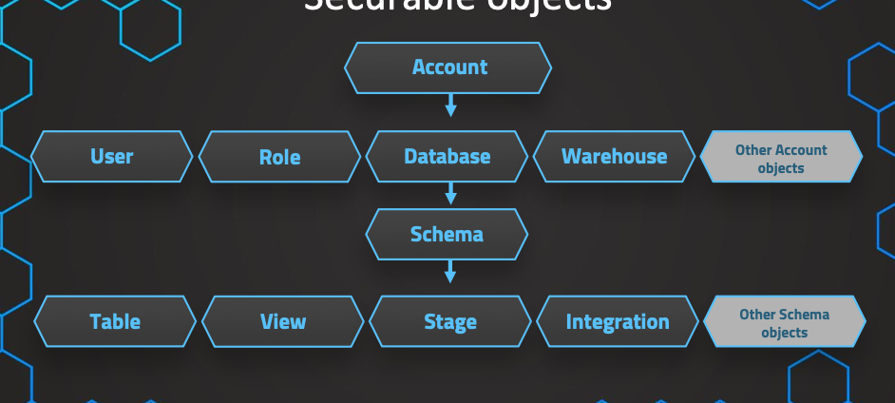

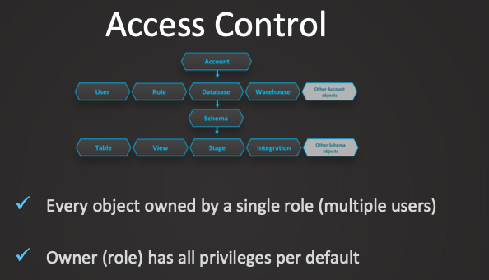

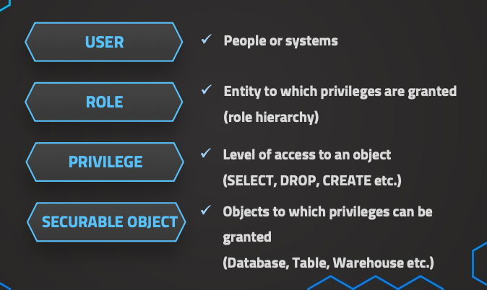

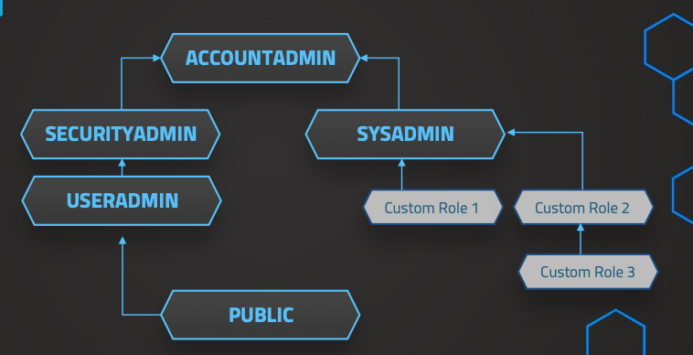

Account Admin: So this account admin, the purpose of this is of course to set up the account initially or do some account operations. So it's the most powerful role.

Create User:

--- User 1 ---

CREATE USER maria PASSWORD = '123'

DEFAULT_ROLE = ACCOUNTADMIN

MUST_CHANGE_PASSWORD = FALSE;

show users;

GRANT ROLE ACCOUNTADMIN TO USER maria;

--- User 2 ---

CREATE USER frank PASSWORD = '123'

DEFAULT_ROLE = SECURITYADMIN

MUST_CHANGE_PASSWORD = FALSE;

GRANT ROLE SECURITYADMIN TO USER frank;

--- User 3 ---

CREATE USER adam PASSWORD = '123'

DEFAULT_ROLE = SYSADMIN

MUST_CHANGE_PASSWORD = FALSE;

GRANT ROLE SYSADMIN TO USER adam;

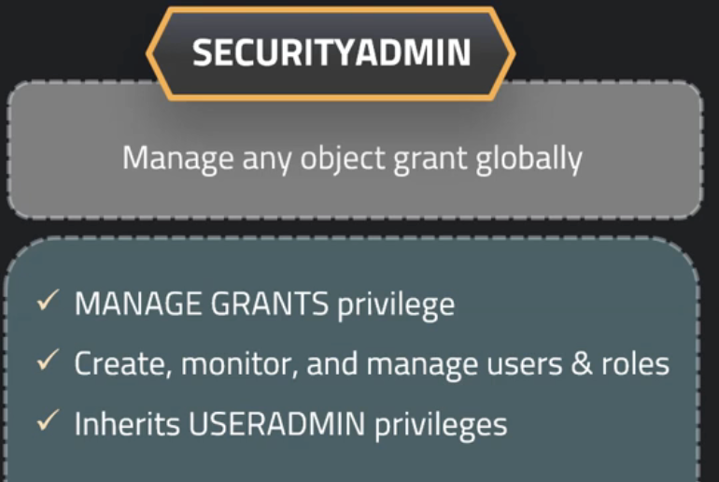

-- SECURITYADMIN role --

-- Create and Manage Roles & Users --

-- Create Sales Roles & Users for SALES--

create role sales_admin;

create role sales_users;

-- Create hierarchy

grant role sales_users to role sales_admin;

-- As per best practice assign roles to SYSADMIN

grant role sales_admin to role SYSADMIN;

-- create sales user

CREATE USER simon_sales PASSWORD = '123' DEFAULT_ROLE = sales_users

MUST_CHANGE_PASSWORD = FALSE;

GRANT ROLE sales_users TO USER simon_sales;

-- create user for sales administration

CREATE USER olivia_sales_admin PASSWORD = '123' DEFAULT_ROLE = sales_admin

MUST_CHANGE_PASSWORD = FALSE;

GRANT ROLE sales_admin TO USER olivia_sales_admin;

-----------------------------------

-- Create Sales Roles & Users for HR--

create role hr_admin;

create role hr_users;

-- Create hierarchy

grant role hr_users to role hr_admin;

-- This time we will not assign roles to SYSADMIN (against best practice)

-- grant role hr_admin to role SYSADMIN;

-- create hr user

CREATE USER oliver_hr PASSWORD = '123' DEFAULT_ROLE = hr_users

MUST_CHANGE_PASSWORD = TRUE;

GRANT ROLE hr_users TO USER oliver_hr;

-- create user for sales administration

CREATE USER mike_hr_admin PASSWORD = '123' DEFAULT_ROLE = hr_admin

MUST_CHANGE_PASSWORD = TRUE;

GRANT ROLE hr_admin TO USER mike_hr_admin;

SYS ADMIN:

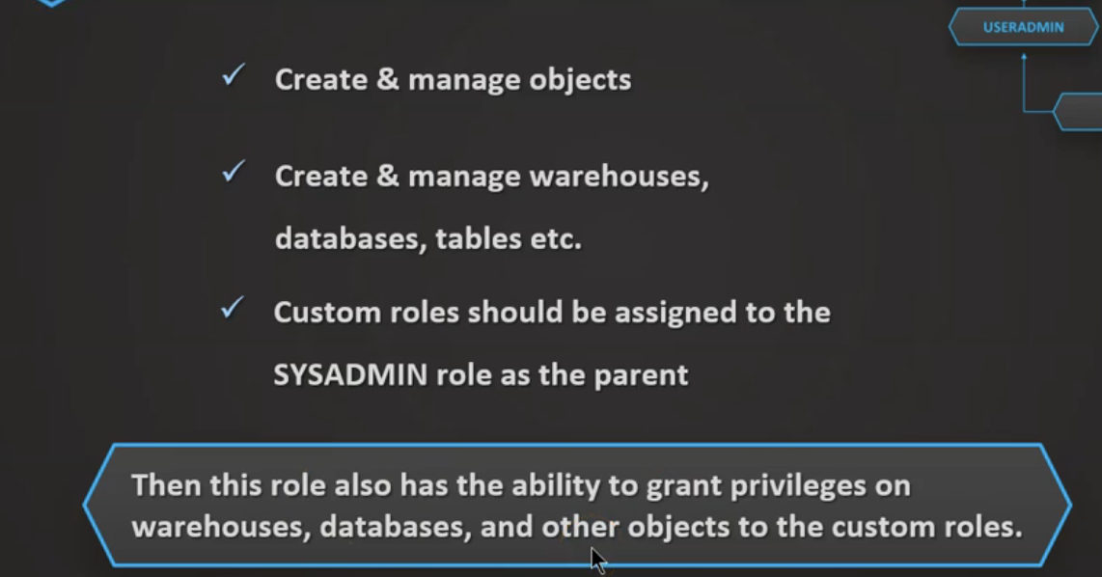

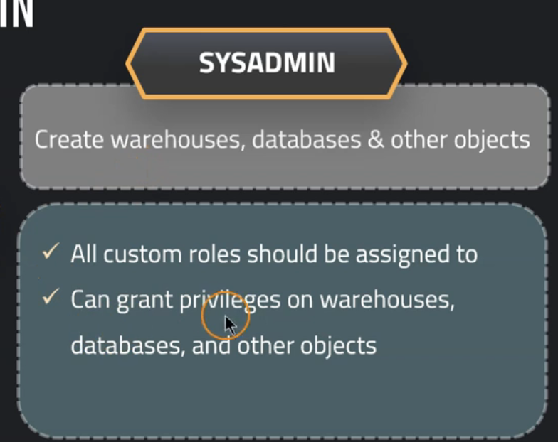

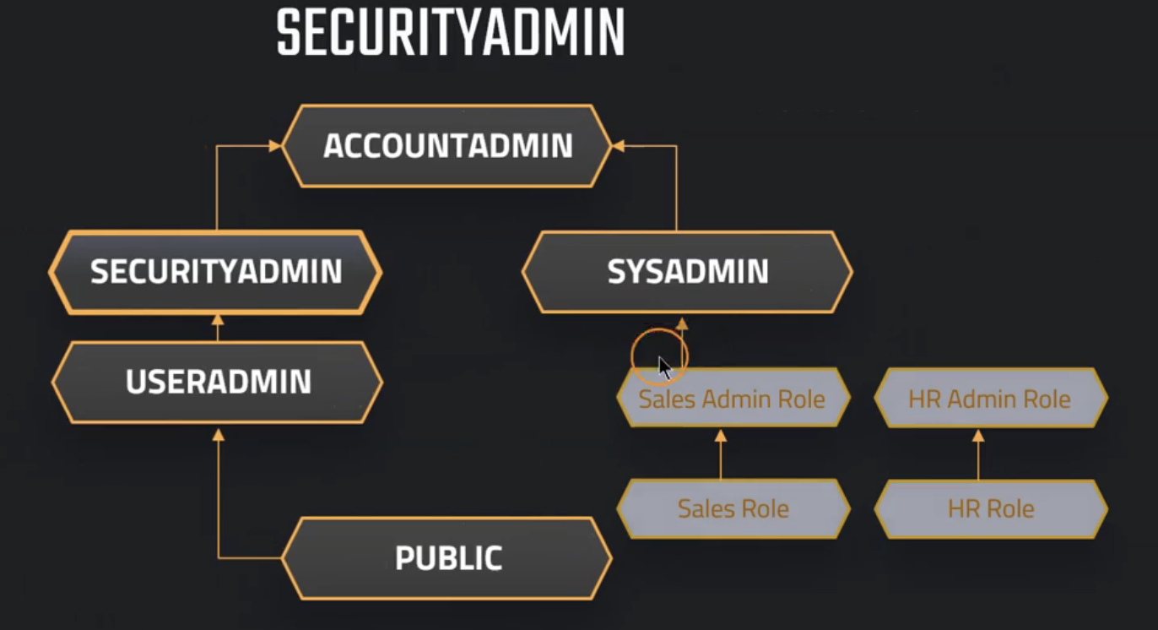

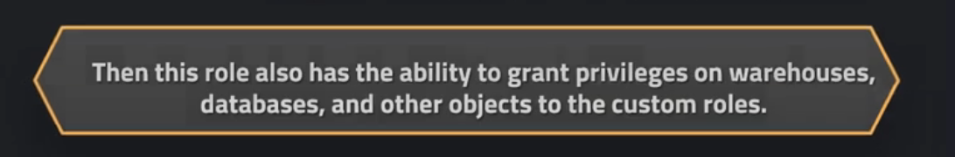

-- SYSADMIN --

-- Create a warehouse of size X-SMALL

create warehouse public_wh with

warehouse_size='X-SMALL'

auto_suspend=300

auto_resume= true

-- grant usage to role public

grant usage on warehouse public_wh

to role public

-- create a database accessible to everyone

create database common_db;

grant usage on database common_db to role public

-- create sales database for sales

create database sales_database;

grant ownership on database sales_database to role sales_admin;

grant ownership on schema sales_database.public to role sales_admin

SHOW DATABASES;

-- create database for hr

drop database hr_db;

grant ownership on database hr_db to role hr_admin;

grant ownership on schema hr_db.public to role hr_admin

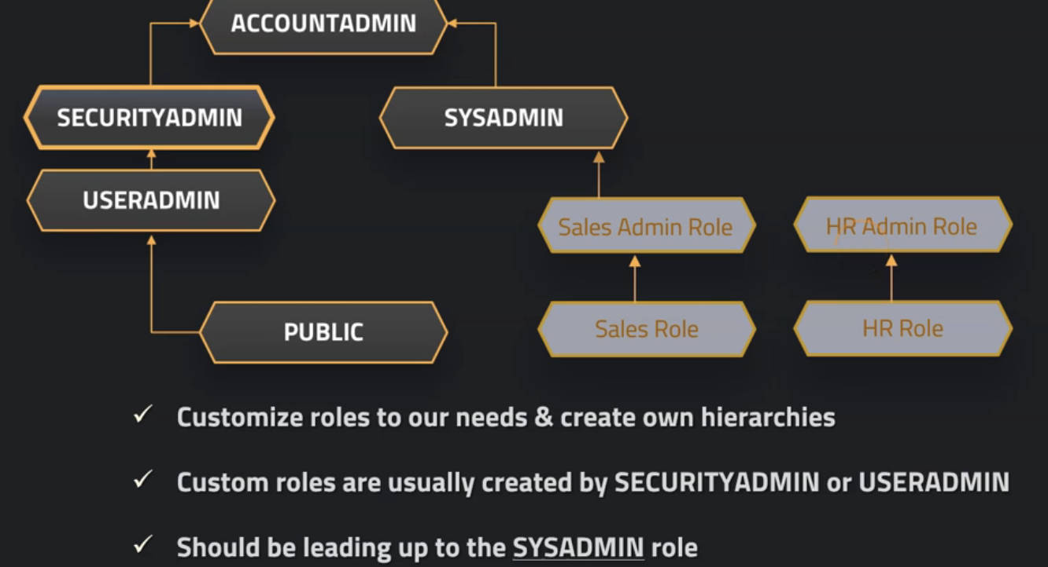

USE ROLE SALES_ADMIN;

USE SALES_DATABASE;

-- Create table --

create or replace table customers(

id number,

full_name varchar,

email varchar,

phone varchar,

spent number,

create_date DATE DEFAULT CURRENT_DATE);

-- insert values in table --

insert into customers (id, full_name, email,phone,spent)

values

(1,'Lewiss MacDwyer','lmacdwyer0@un.org','262-665-9168',140),

(2,'Ty Pettingall','tpettingall1@mayoclinic.com','734-987-7120',254),

(3,'Marlee Spadazzi','mspadazzi2@txnews.com','867-946-3659',120),

(4,'Heywood Tearney','htearney3@patch.com','563-853-8192',1230),

(5,'Odilia Seti','oseti4@globo.com','730-451-8637',143),

(6,'Meggie Washtell','mwashtell5@rediff.com','568-896-6138',600);

SHOW TABLES;

-- query from table --

SELECT* FROM CUSTOMERS;

USE ROLE SALES_USERS;

-- grant usage to role

USE ROLE SALES_ADMIN;

GRANT USAGE ON DATABASE SALES_DATABASE TO ROLE SALES_USERS;

GRANT USAGE ON SCHEMA SALES_DATABASE.PUBLIC TO ROLE SALES_USERS;

GRANT SELECT ON TABLE SALES_DATABASE.PUBLIC.CUSTOMERS TO ROLE SALES_USERS;

-- Validate privileges --

USE ROLE SALES_USERS;

SELECT* FROM CUSTOMERS;

DROP TABLE CUSTOMERS;

DELETE FROM CUSTOMERS;

SHOW TABLES;

-- grant DROP on table

USE ROLE SALES_ADMIN;

GRANT DELETE ON TABLE SALES_DATABASE.PUBLIC.CUSTOMERS TO ROLE SALES_USERS;

USE ROLE SALES_ADMIN;

USERADMIN:

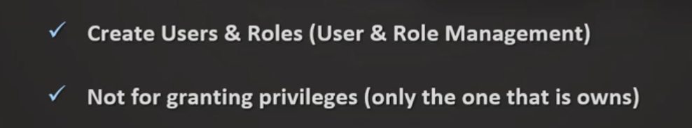

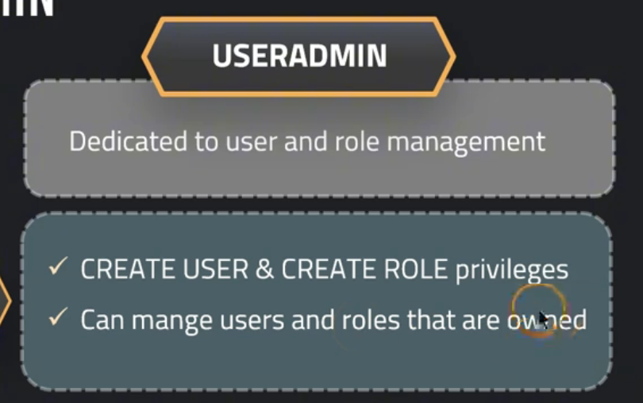

-- USERADMIN --

--- User 4 ---

CREATE USER ben PASSWORD = '123'

DEFAULT_ROLE = ACCOUNTADMIN

MUST_CHANGE_PASSWORD = FALSE;

GRANT ROLE HR_ADMIN TO USER ben;

SHOW ROLES;

GRANT ROLE HR_ADMIN TO ROLE SYSADMIN;

PUBLIC:  
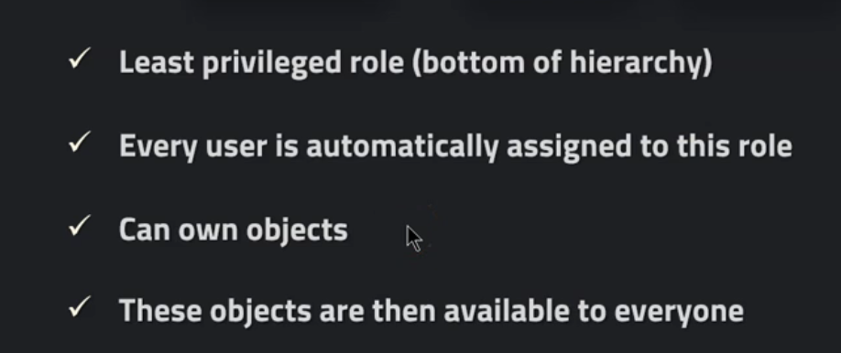

Best Practise:

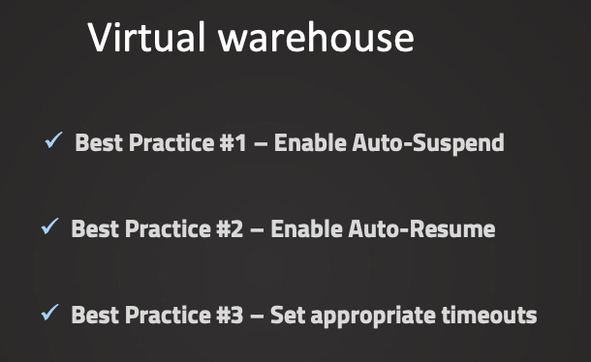

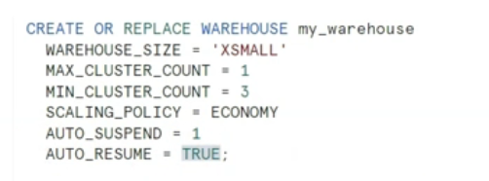

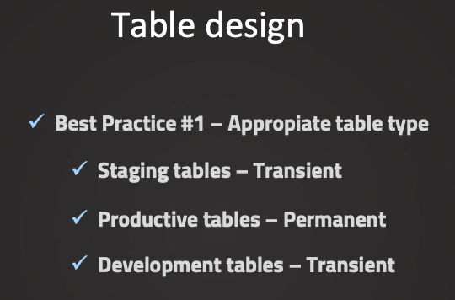

-- Table Storage

SELECT * FROM "SNOWFLAKE"."ACCOUNT_USAGE"."TABLE_STORAGE_METRICS";

-- How much is queried in databases

SELECT * FROM "SNOWFLAKE"."ACCOUNT_USAGE"."QUERY_HISTORY";

SELECT

DATABASE_NAME,

COUNT(*) AS NUMBER_OF_QUERIES,

SUM(CREDITS_USED_CLOUD_SERVICES)

FROM "SNOWFLAKE"."ACCOUNT_USAGE"."QUERY_HISTORY"

GROUP BY DATABASE_NAME;

-- Usage of credits by warehouses

SELECT * FROM "SNOWFLAKE"."ACCOUNT_USAGE"."WAREHOUSE_METERING_HISTORY";

-- Usage of credits by warehouses // Grouped by day

SELECT

DATE(START_TIME),

SUM(CREDITS_USED)

FROM "SNOWFLAKE"."ACCOUNT_USAGE"."WAREHOUSE_METERING_HISTORY"

GROUP BY DATE(START_TIME);

-- Usage of credits by warehouses // Grouped by warehouse

SELECT

WAREHOUSE_NAME,

SUM(CREDITS_USED)

FROM "SNOWFLAKE"."ACCOUNT_USAGE"."WAREHOUSE_METERING_HISTORY"

GROUP BY WAREHOUSE_NAME;

-- Usage of credits by warehouses // Grouped by warehouse & day

SELECT

DATE(START_TIME),

WAREHOUSE_NAME,

SUM(CREDITS_USED)

FROM "SNOWFLAKE"."ACCOUNT_USAGE"."WAREHOUSE_METERING_HISTORY"

GROUP BY WAREHOUSE_NAME,DATE(START_TIME);